How to Create a Screen Recording with PowerPoint on PC

Overview:
This guide is aimed at PC users and covers the steps needed to make a screen recording using PowerPoint.

Instructions:
- Open a brand new PowerPoint presentation on the app.

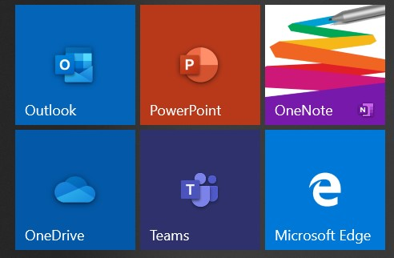

- Once the new presentation is open go to the tab options and go to Insert.

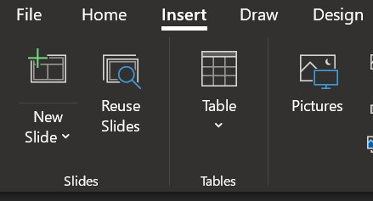

- Under Insert are a series of different options. There are a series of options labeled Media on the right side, select the Screen Recording button (indicated with a camera icon).

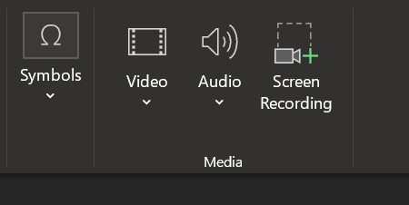

- Once Screen Recording is selected a rectangle will appear at the top of the screen. In that rectangle there are a series of different options. Firth you will want to make sure that the Audio and Record Pointer button are enabled. They are indicated as on or enabled when there is a light grey box around each of those options.

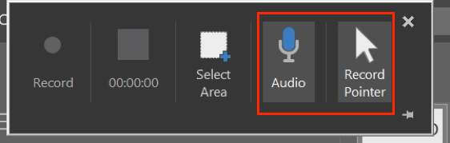

- Within that same rectangle is an option labeled as Select Area. Once selected you will drag your cursor over the area of the screen you wish to record (we recommend doing the full screen to ensure nothing gets cut out).

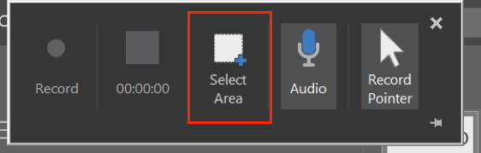

- In that same rectangle you can select Record on the far left side to begin your screen recording.

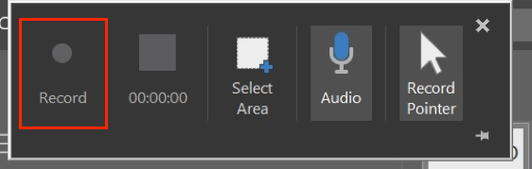

- Once you are done you can select the Stop button in the upper rectangle indicated by a large square icon with the timecode of the video running underneath.

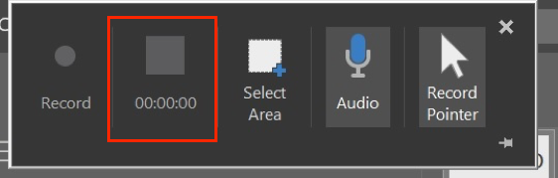

- The screen recording will now appear as a video on the first slide of the presentation.
  - There will be a play bar on the bottom of the video that will allow you to watch it back.
  - On each of the four corners of the video recording are squares which will allow you to resize the video to fit the screen. Try to match the video size to the top and bottom of the slide and leave blank space on the left and right side to ensure the video does not get distorter.

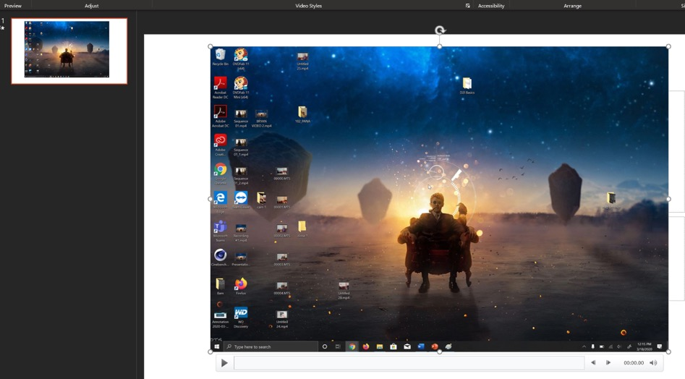

- To save your screen recording as a video in an MP4 format you will first go to the File tab on the top right.

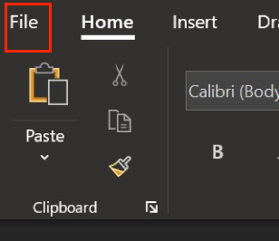

- Next you will select Export that has appeared in the File options menu.

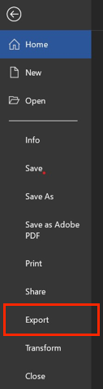

- There will be a series of options on the left-hand side, select the Create a Video option.

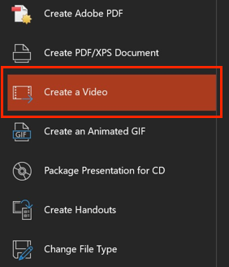

- Under the Create a Video tab there are a series of options you have to check.
  - The first to appear in the window is file size and quality. When selected there are a series of options that appear for the video quality you want to export, it is best practice to use the default which appears which is Full HD (1080p).
    - If you are having a lot of issues with exporting time you can take it down to 720p but this should be a last resort option.
  - The second option directly below deals with timing. For exporting a Screen Recording only, the program usually identifies this and nothing in this box needs to change. If you are having issues then make sure that Use Recorded Timings and Narrations is selected before reaching the next step.

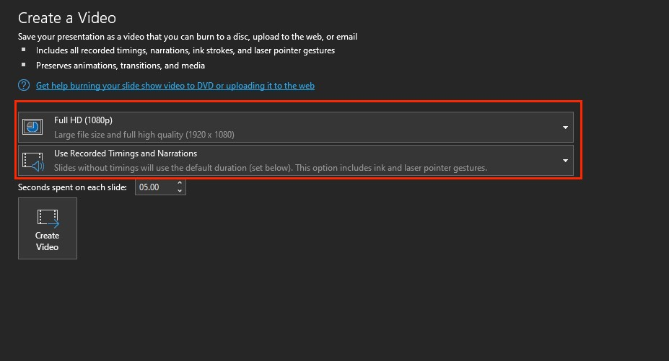

- The final option is a Create Video button on the bottom which when selected will start the exporting process.

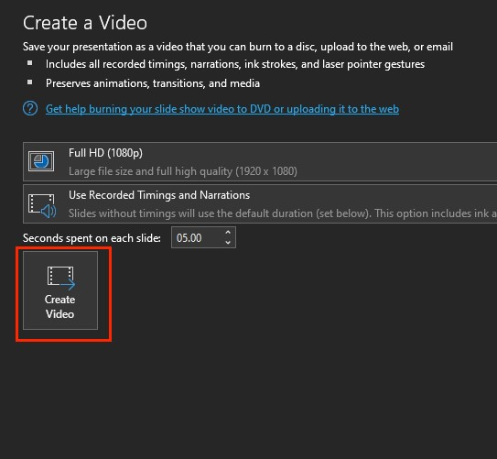

- On the bottom of the PowerPoint program is a progress bar which displays the progress of the video exporting from PowerPoint. When the video is done this bar will disappear.

- Your video is now complete and ready to be uploaded to MS Stream.

Here are some Best Practice Tips when recording videos (some options vary):
- Make sure your laptop setting have the camera and microphone enabled
- Turn off notifications on your laptop, otherwise it will show up in the video
- Record in a quiet room and avoid outside interruptions
- When on camera:
  - Use a room with adequate lighting- don't film in front of a bright window and make sure your face is lit up (so no filming in an extremely dark room)
  - Keep your clothing in mind- be careful of what words or phrases that may be on your clothing
  - Check the room- make sure there is no inappropriate content in the background
- If recording on a cellphone always record Horizontally and not Vertically.
- Try and keep your videos to under 10 minutes as this will save on processing and upload time when you’re creating the videos as well as when you add them to Stream. If your content takes longer than that then consider splitting up your presentations into a few parts.

