707 Building

The 707 building houses the offices of: Financial Aid, Student Employment, Service Learning, Air Force ROTC, the College of Professional Studies, and several other administrative offices.

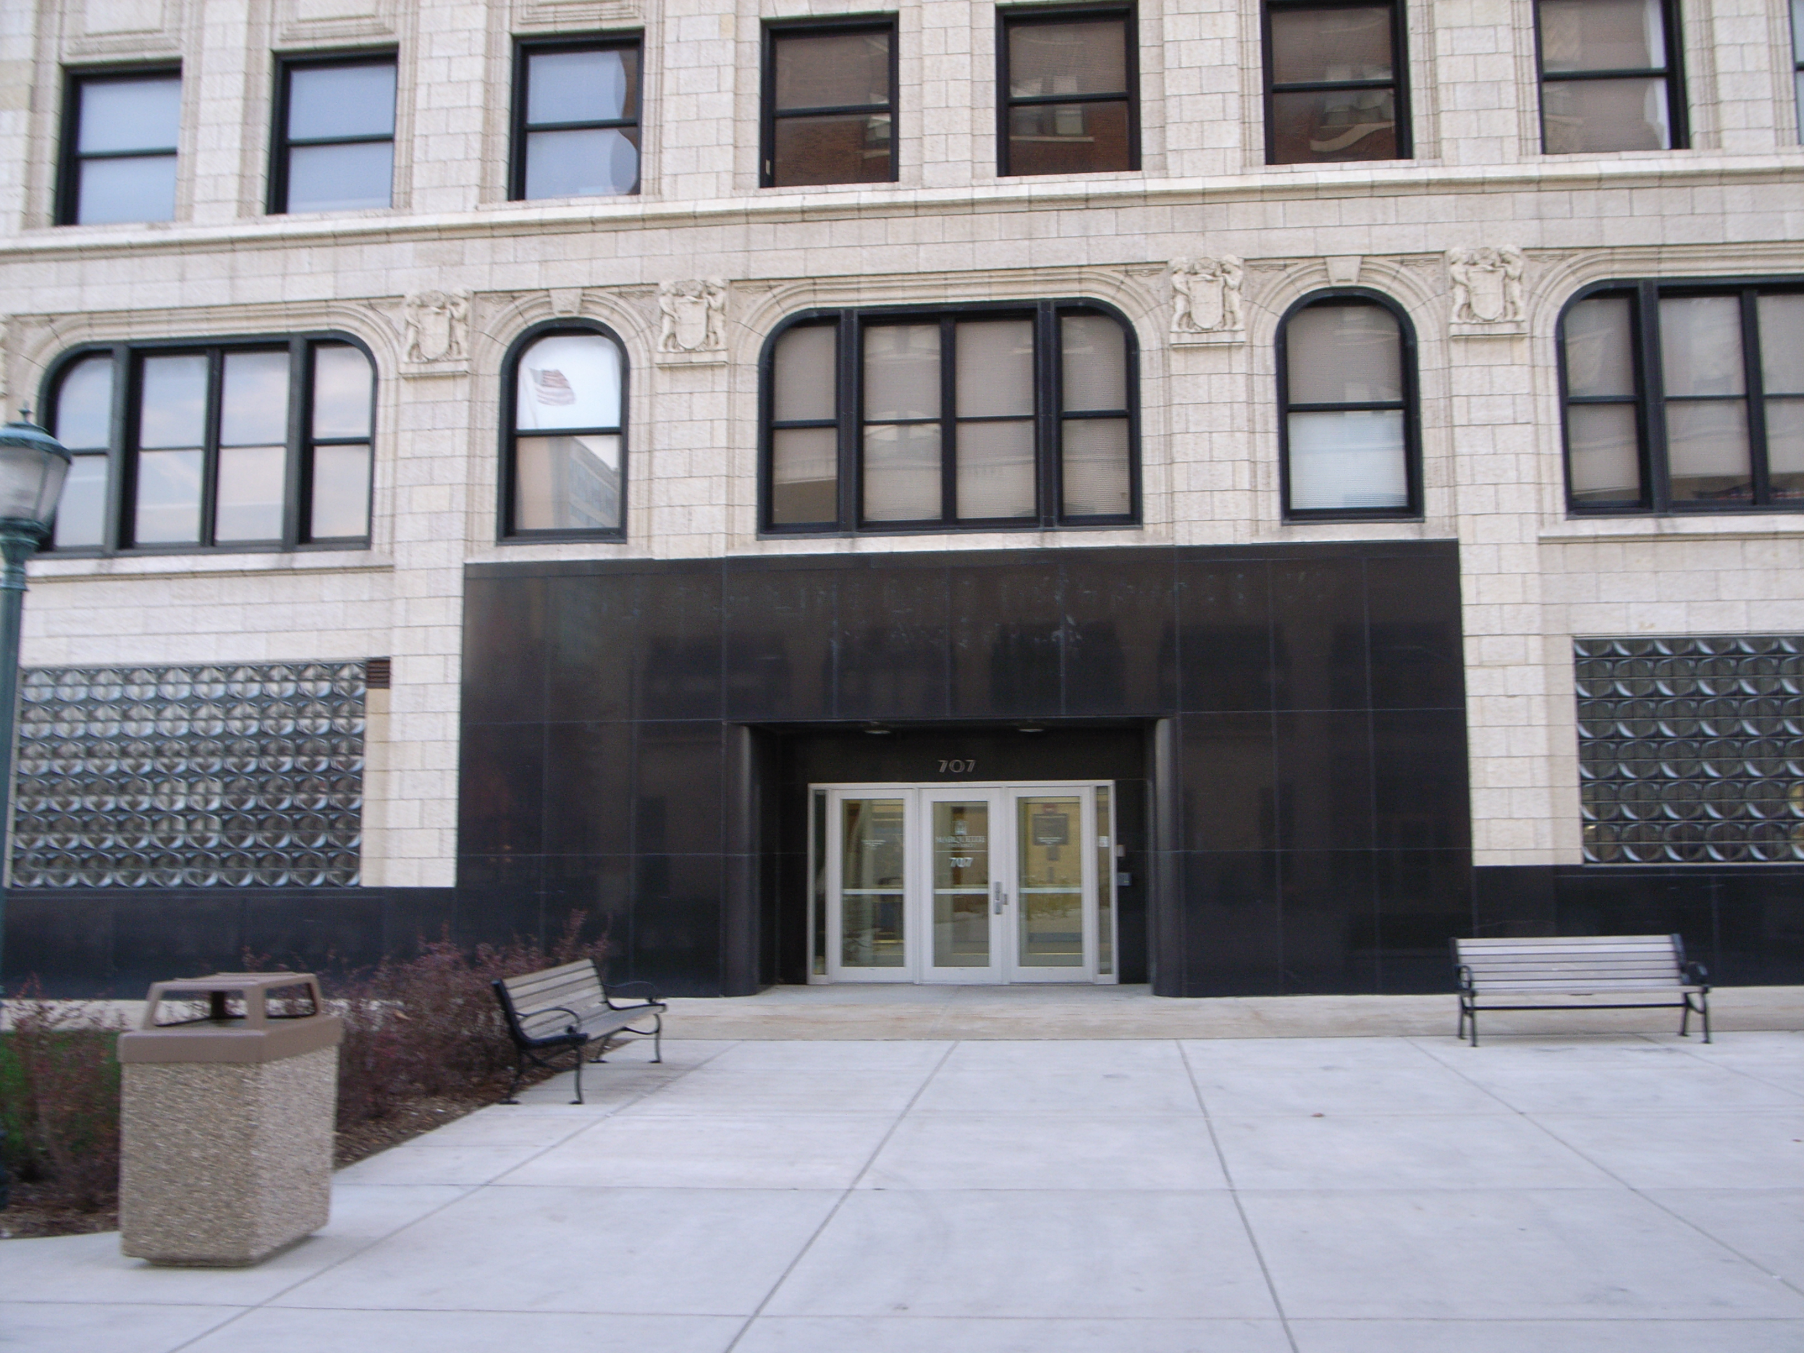

(Arrow points North)

Accessibility

Entrance
Wheelchair accessible, Automatic Doors
(Pictured)

Women’s Bathrooms
To the right of the elevator, down the hallway
Rooms 237, 337, 437, 537
Men’s Bathrooms
To the right of the elevator
Rooms 223, 323, 423, 523
Elevator Location
Directly inside main door

