Alumni Memorial Union

The AMU houses dining facilities for students as well as others on campus, banking services, mail services, a chapel, student government, student organizations’ offices, meeting spaces, common areas, and several other campus services

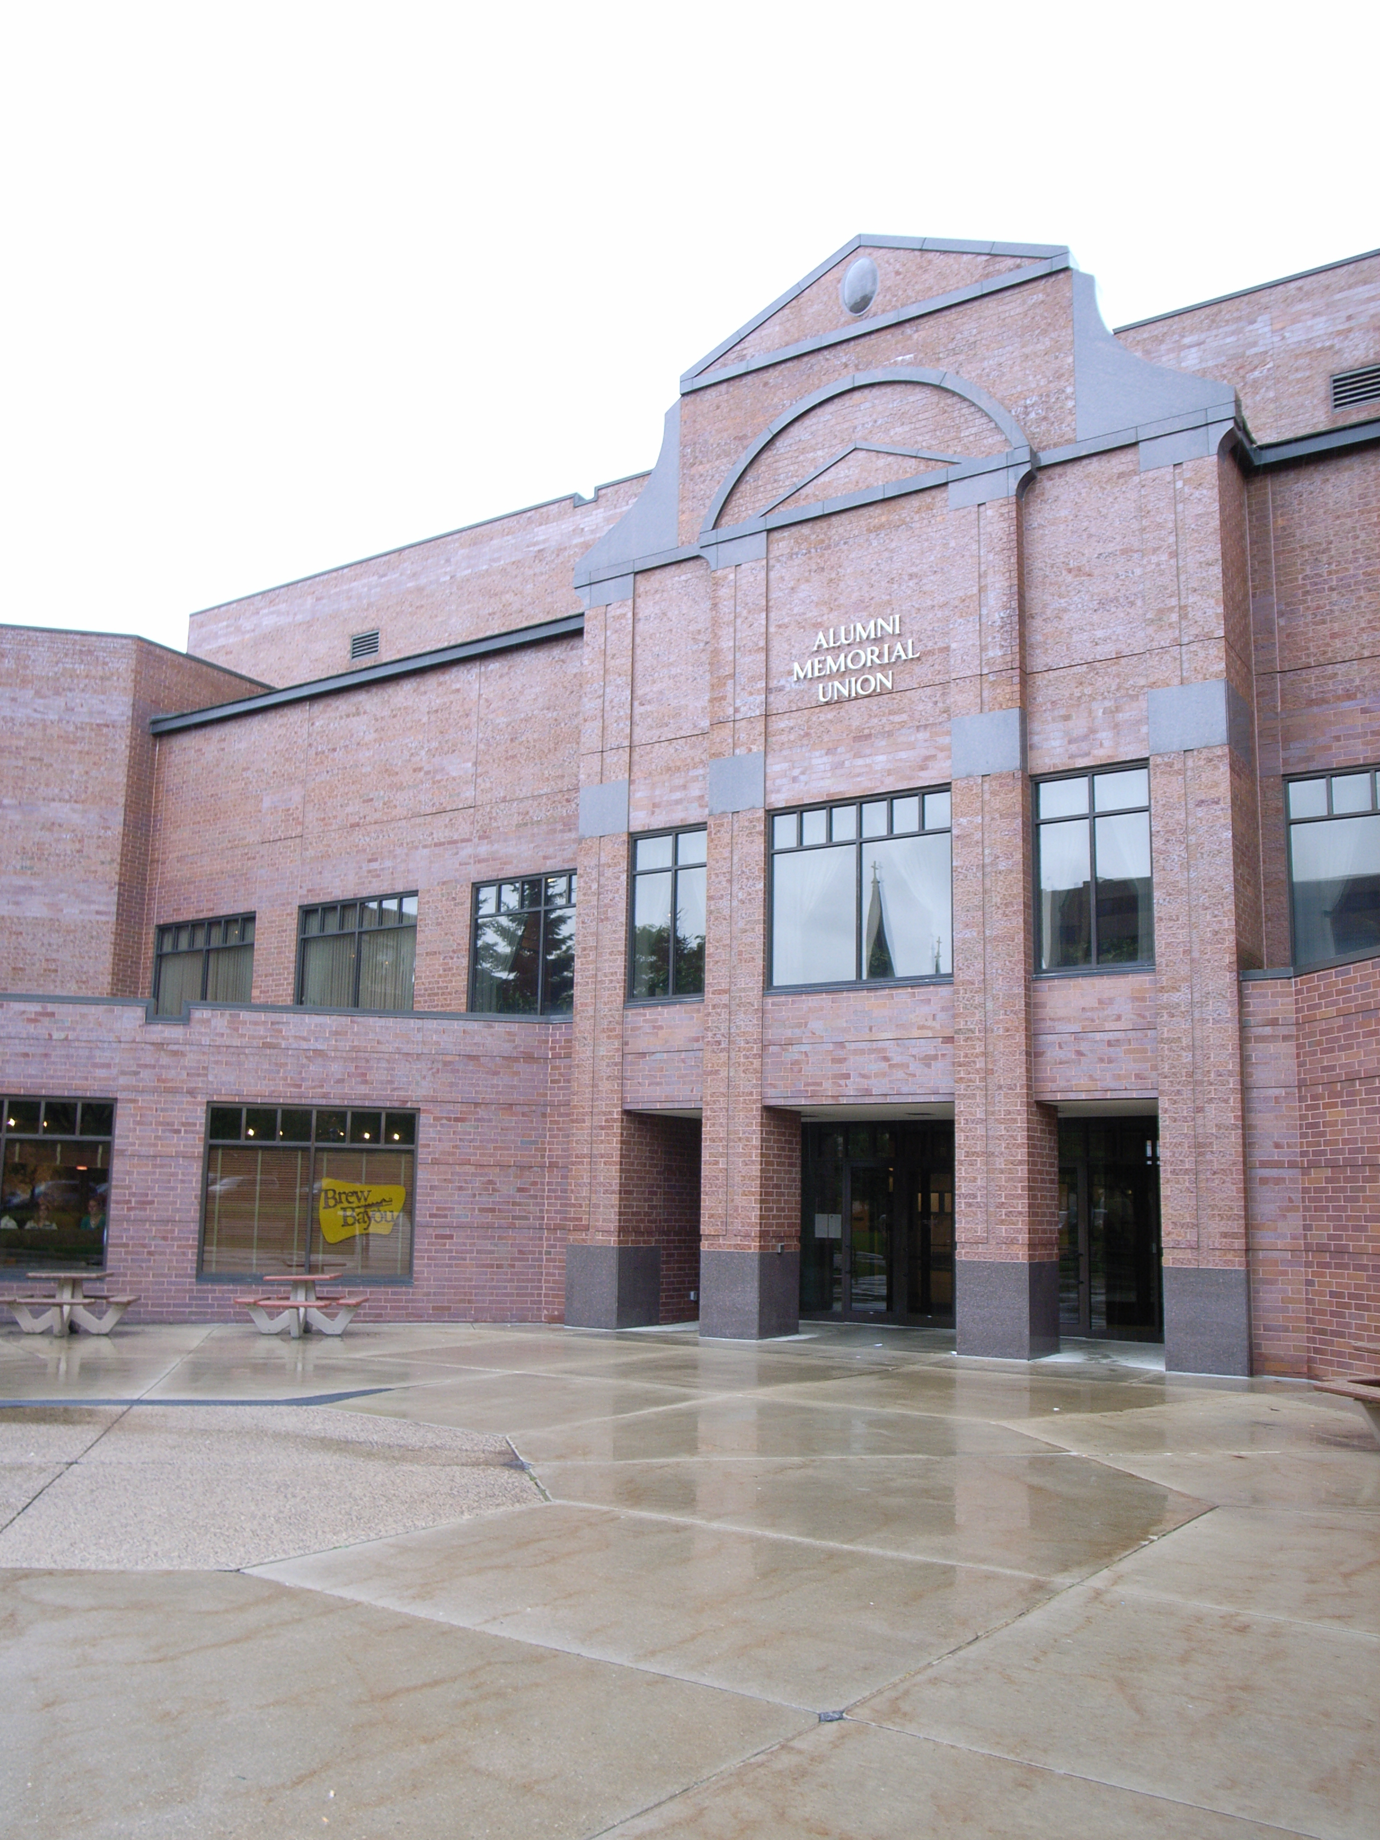

(Arrow points North)

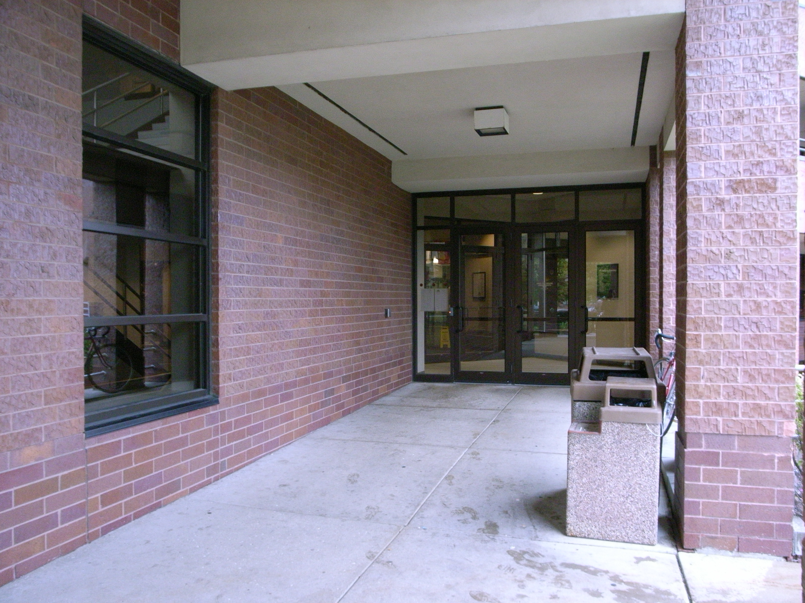

(Arrow points North)

Accessibility

Entrance
All Wheelchair accessible, Automatic Doors

Women’s Bathrooms
Located near the North and South stairwells

Men’s Bathrooms
Located near the North and South stairwells

Elevator Location
Located adjacent to the North Stairwell, outside of Marquette Place on the 2nd floor and Union Station on the 1st floor

