Holthusen Hall

Holthusen Hall is home to the Graduate School offices as well as Marquette’s Counseling Center and the Office of Research and Sponsored Programs along with several other administrative offices.

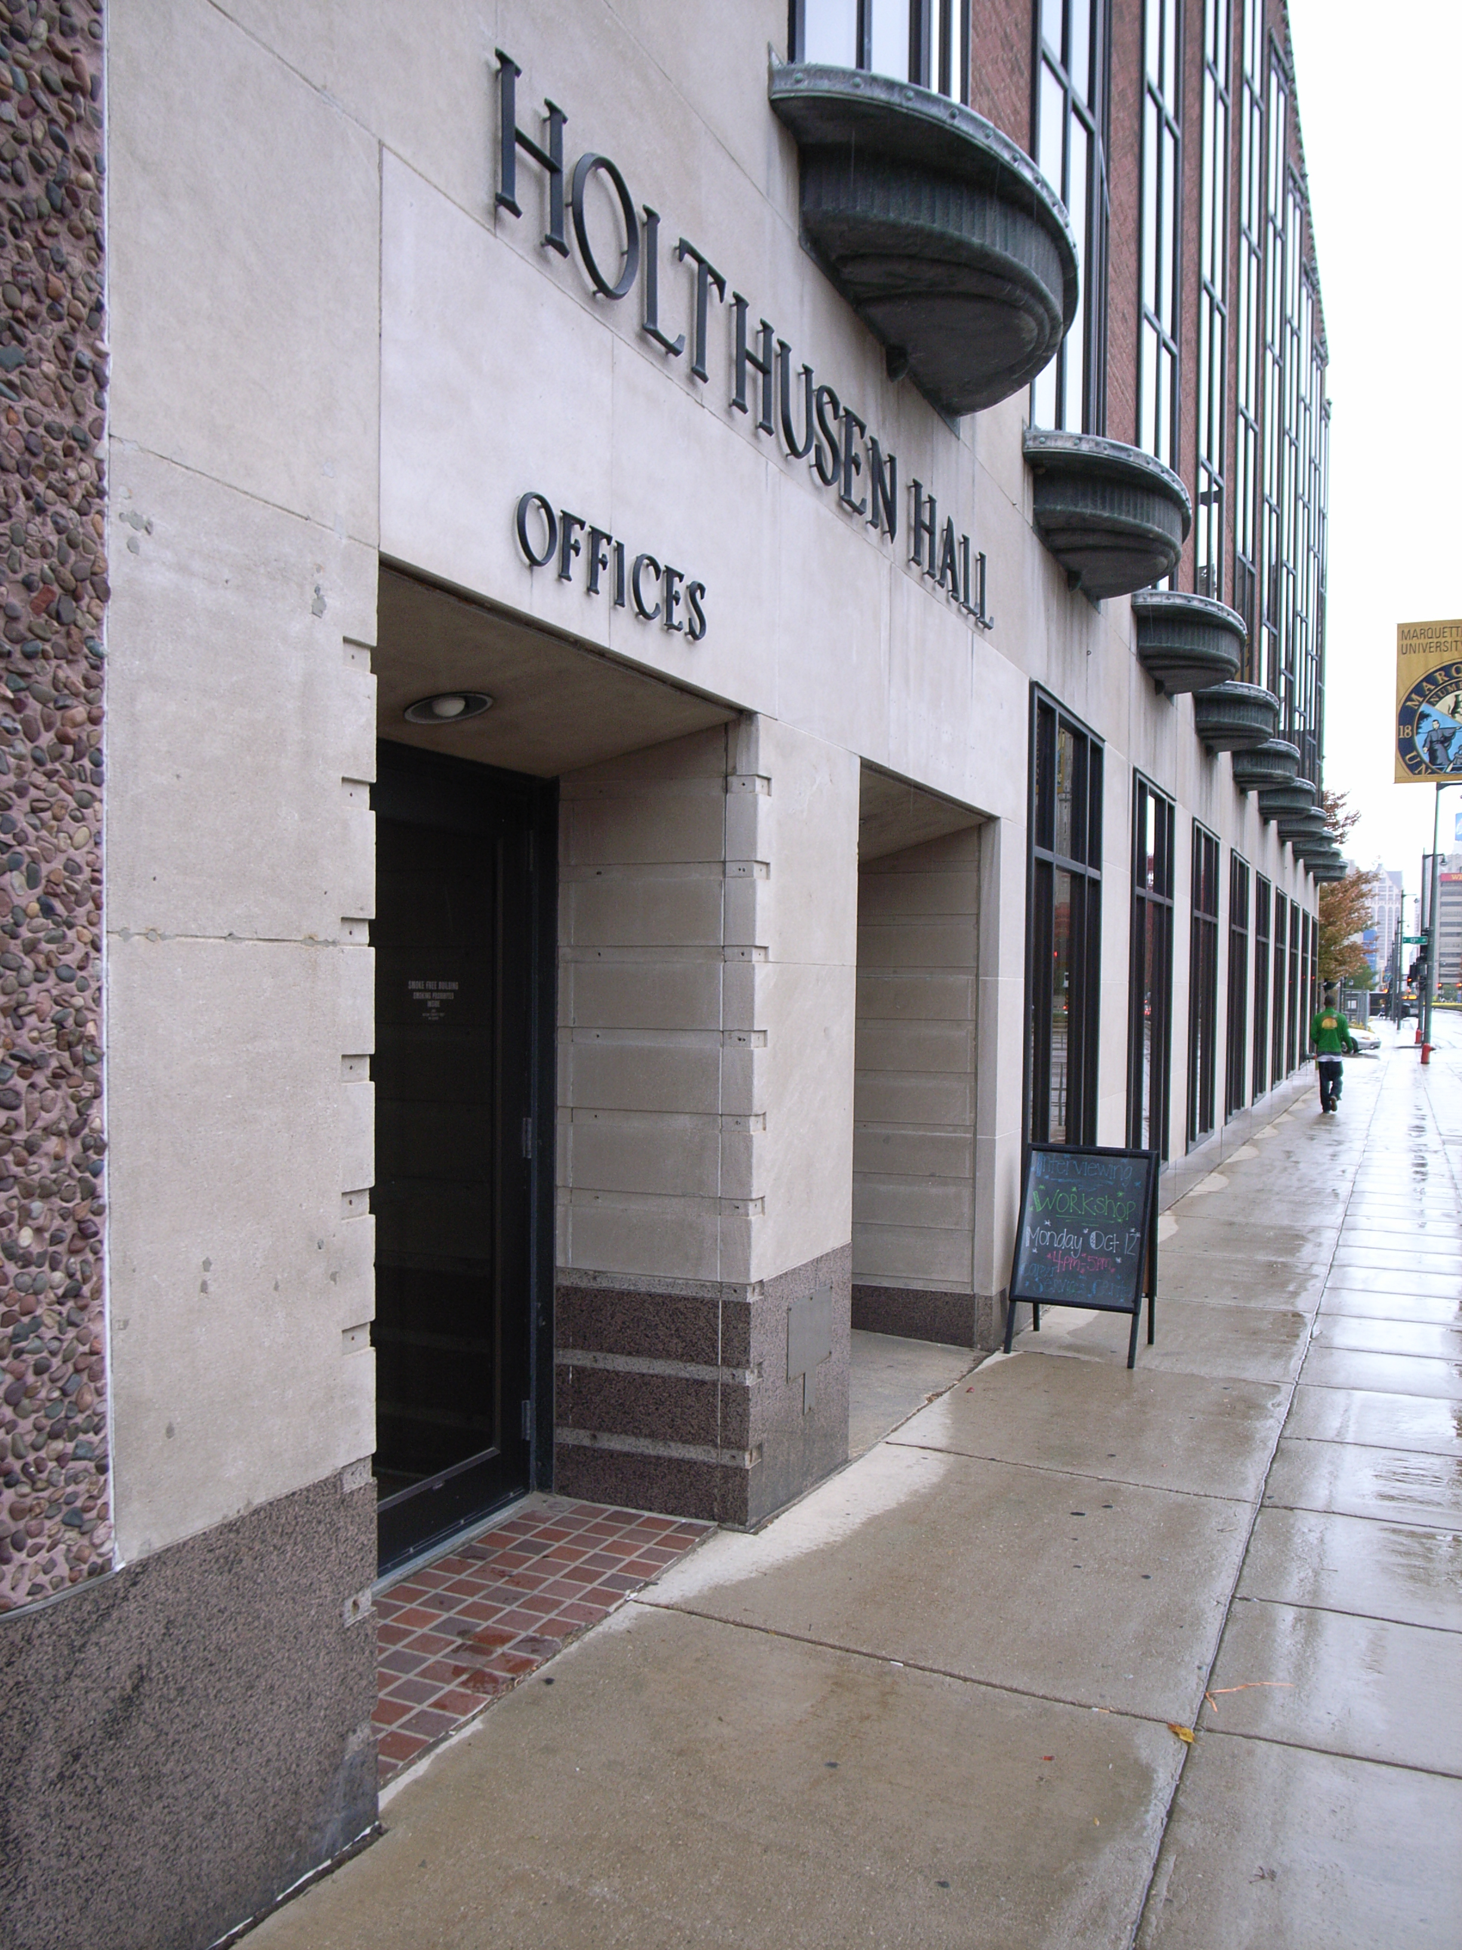

(Arrow points North)

Accessibility

Entrance
Wheelchair accessible, Automatic Doors
(Pictured)

Women’s Bathrooms
Rooms 368 & 268
Men’s Bathrooms
Rooms 348 & 260
Elevator Location
Directly inside main door

