Helfaer Rec Center

The Rec Center is one of two fitness center on campus. It has tennis courts, workout equipment, a swimming pool, volley ball courts and other fitness services. The main floor can be accessed via wheel chair with 2 graded ramps to the main entrance. Entrance to the building is controlled by a manned card swipe station with both a turnstile and an auxiliary gate.

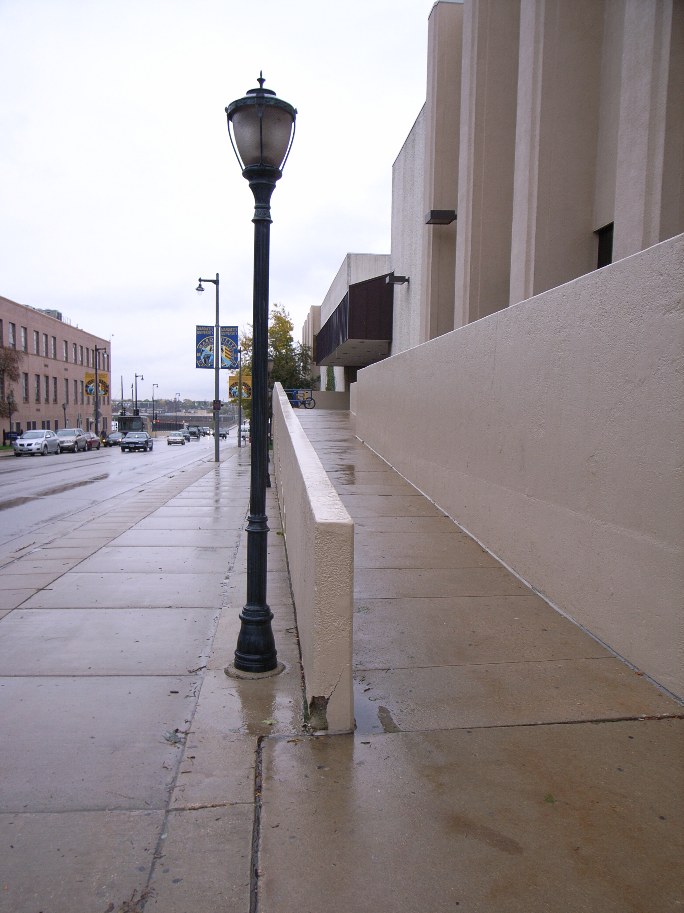
(Arrow points North)

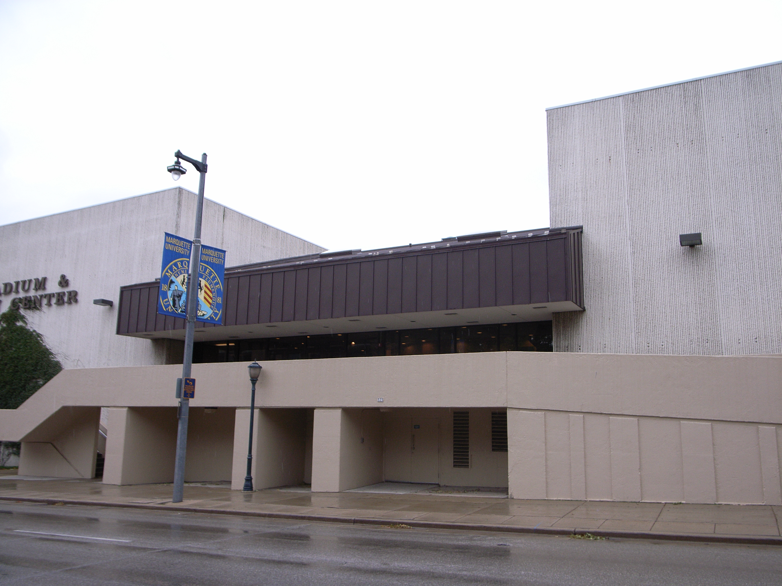

(Arrow points North)

Accessibility

Entrance
Wheelchair Accessible, Manual Doors
(Pictured)

