Parking Structure 2

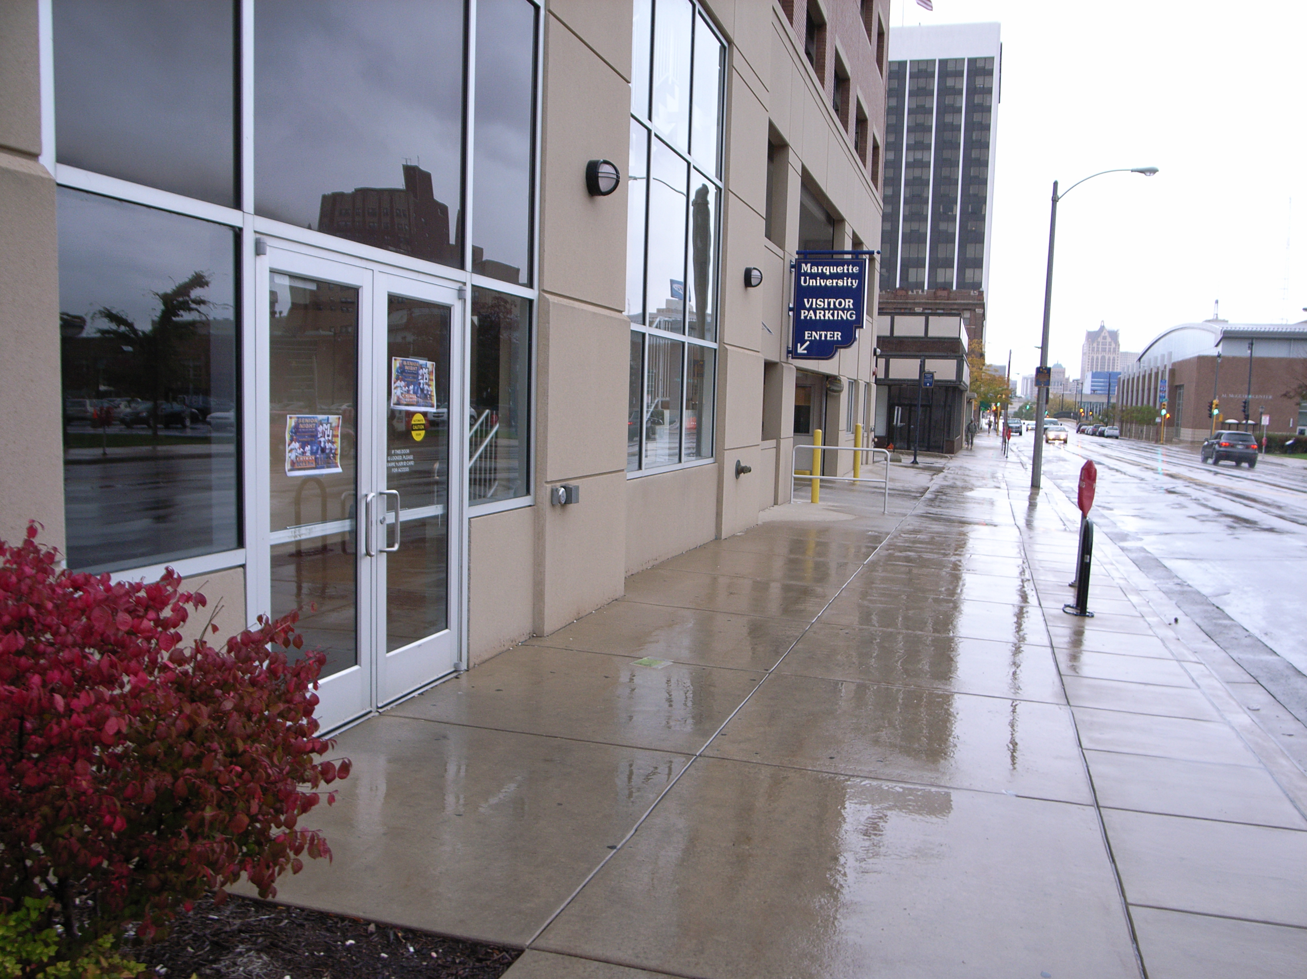

(Arrow points North)

Accessibility

Entrance
Wheelchair Accessible, Automatic Door
(Pictured)

Women’s Bathrooms
N/A

Men’s Bathrooms
N/A

Elevator Location
Through doors, to the left

