Instructions for Students:
How to Accept and View Test Definitions
in the Access ODS Portal

Accommodations Process Recap:
1) Student delivers Accommodation Letters to instructors via Access ODS.
2) Student talks to instructor about where and when tests will be taken.
3) If instructors utilize the ODS Test Proctoring Center, then they log in to Access ODS and schedule the test first (must be scheduled 7 calendar days prior to exam).
4) Once the instructor has scheduled the test, student will follow the process in this packet to accept/confirm the test (must be scheduled 5 calendar days prior to exam).
5) Final Exams have a different, single deadline. Please pay attention each semester for that different published deadline.
Use the chart at the end of this packet for helpful deadlines.

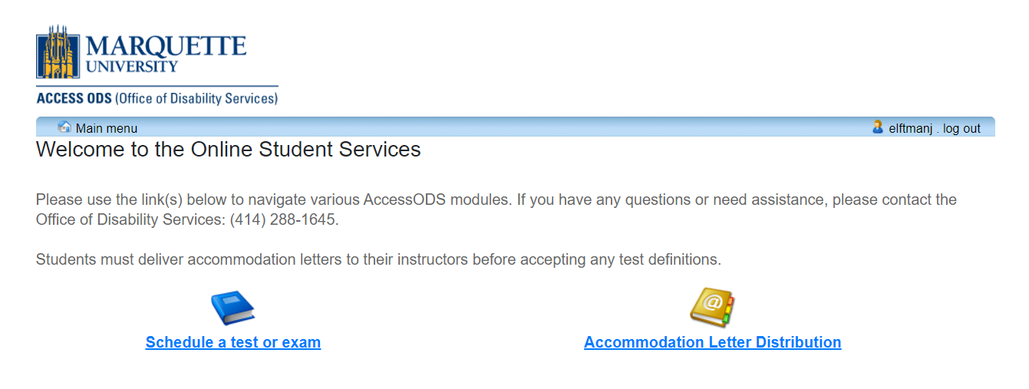

Click on the “Schedule a test or exam” icon to begin.

If you are having problems accepting a test definition, take a screenshot of the page and email us immediately at odstesting@marquette.edu.
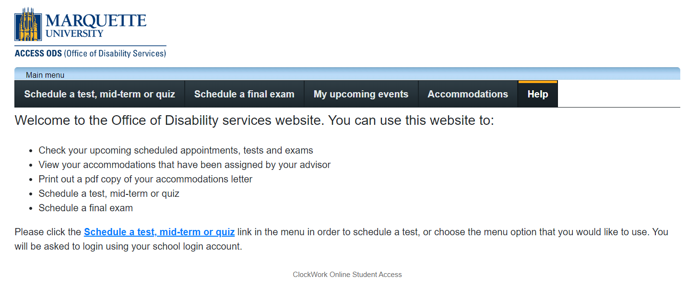
Schedule a Test, Mid-term, or Quiz: To accept/confirm any test/mid-term/quiz occurring during the regular academic session, NOT finals week. Deadlines: instructors must schedule exam 7 calendar days prior to exam; students accept/confirm exam 5 days prior. NO EXCEPTIONS WILL BE MADE.
Schedule a Final exam: To accept/confirm any exams occurring during finals week. NOTE: there is a SINGLE deadline date for instructors to schedule final exams and a single date for students to accept/confirm final exams, no matter the day of the week on which they occur. Check our website and your email for updates.
My Upcoming Events: where you can see a list of tests/exams that you have accepted/confirmed and are on the schedule to be taken in the ODS Test Proctoring Center.
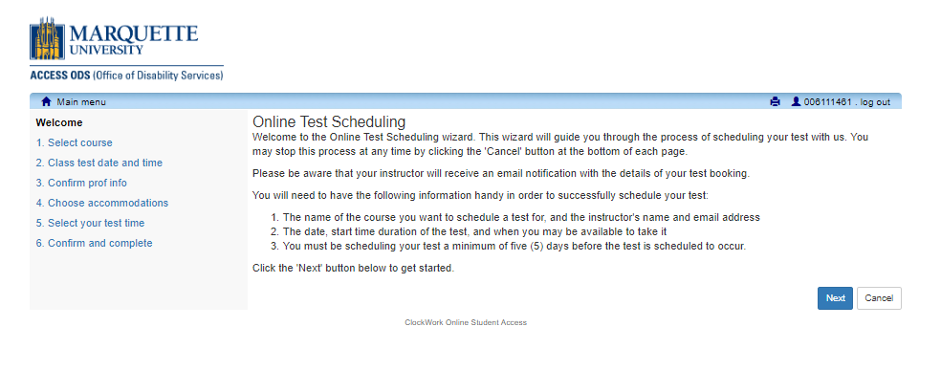

When you are ready to begin, click the Next button.

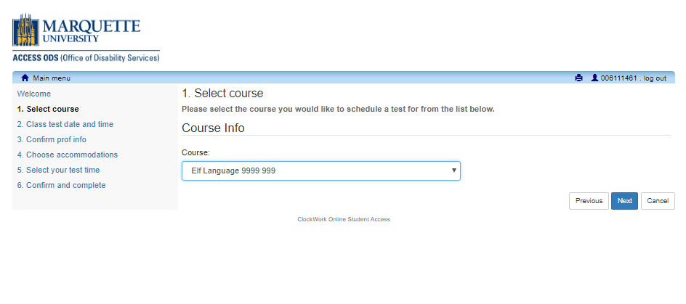
Access your classes here. Use the drop-down list to choose the class for which you want to schedule a test.
Click the Next button.

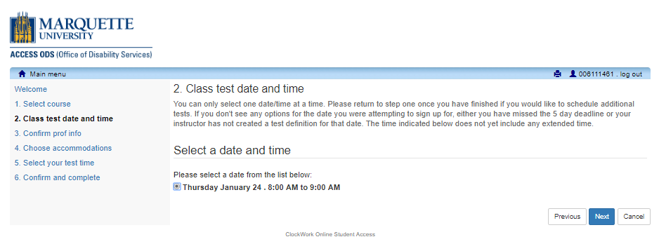
These are the test definitions that the instructor has created for this class.
- If none of the options listed above fit you class schedule, click “cancel” and contact your instructor. You will need to speak directly with your instructor for additional test definitions.
- If there are no test options listed, either your instructor has not created a test definition, or you missed the 5-day deadline.
- You can only accept ONE test definition at a time. However, if dates for multiple tests are available, you can repeat this process to accept all test definitions for tests later in the semester.

The time above DOES NOT include your extended time, that is calculated later.

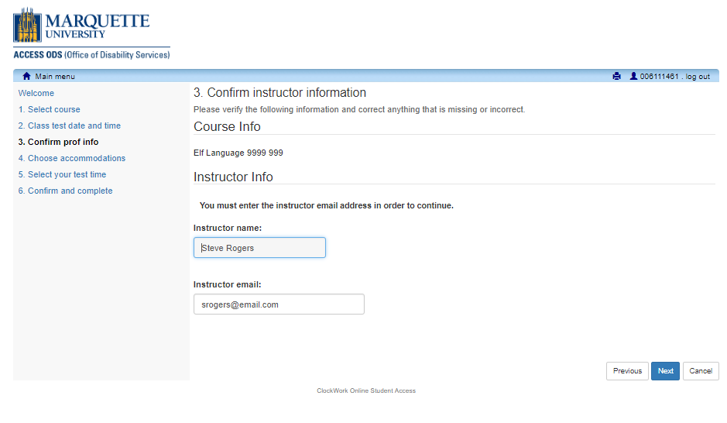

This information auto-populates. Click Next.

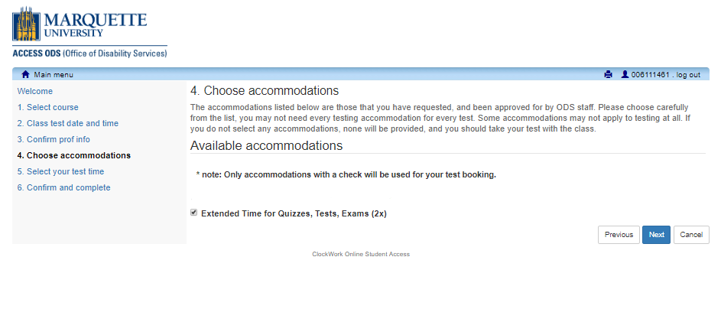
Select the accommodations needed for THIS TEST ONLY. You may not need all your approved accommodations for every test.

Please ignore accommodations that do not apply to test taking (consideration for missed classes, flexible deadlines, Glean, housing, etc.).

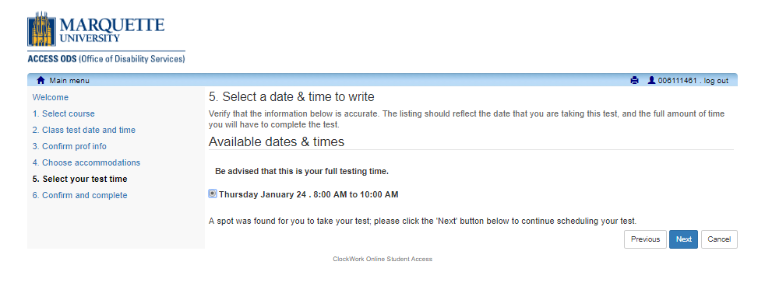
This page reflects the date and time you have selected AND includes your extended time.
If you receive an error message on this step, it is because the test you are trying to schedule conflicts with another class once your extended time is added OR it extends outside of our office hours of 8:00-4:30. Keep in mind, our test scheduling system uses your class schedule as listed in Checkmarq; we are not made aware of any single class cancellations or temporary schedule changes.
Either choose a different available date/time for this test or contact your instructor if there are no available options which fit your schedule. Our office cannot create test definitions for you.
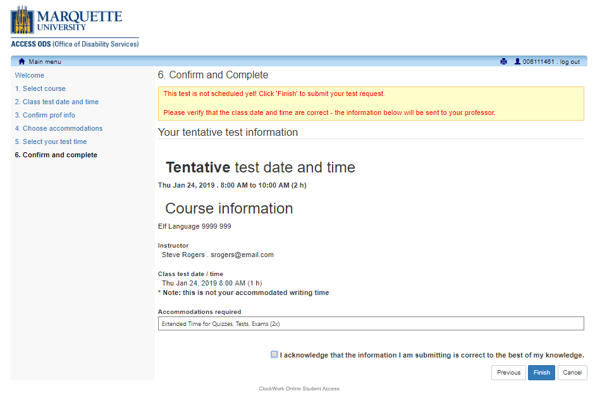
Verify all information and put it in your calendar. Check the box to acknowledge the information is correct and click Finish to confirm and schedule this test.

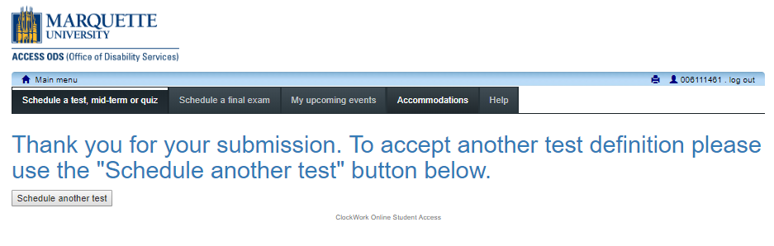

You have just scheduled your test. You should receive an automated email, and you will be able to see this test in the “My upcoming events” tab.
If you don’t get the email or cannot see it in “My upcoming events”, it is NOT scheduled, and ODS will not proctor the test.
If you need to schedule additional tests, click the ‘Schedule a test, mid-term or quiz’ button above.

If you have any questions or concerns, or have issues with scheduling a test, contact our office immediately: odstesting@marquette.edu. If you do not contact our office when you have a concern and you miss the 5-day deadline, we cannot assist you.

Use this chart to assist you in meeting your deadline

Final Exams have a different, single deadline.
Pay attention each semester for that published different deadline.

To schedule Test Proctoring services through ODS:
- Instructors must create the test definitions at least 7 calendar days prior to the actual test date.
- Students must accept & confirm the test definitions at least 5 calendar days prior to the actual test date.
If the test is on a: | INSTRUCTORS must create test definitions by 11:59pm: | STUDENTS must accept test definitions by 11:59pm:
Monday | Monday  of the week before | Wednesday  of the week before
Tuesday | Tuesday  of the week before | Thursday  of the week before
Wednesday | Wednesday  of the week before | Friday  of the week before
Thursday | Thursday  of the week before | Saturday  of the week before
Friday | Friday  of the week before | Sunday  of the week before
IF YOU HAVE ANY PROBLEMS, PLEASE CONTACT US ASAP AT odstesting@marquette.edu

