Varsity Theater

The Varsity Theater hosts reduced priced movies for students on the weekends, as well as several performances/talks throughout the academic year.

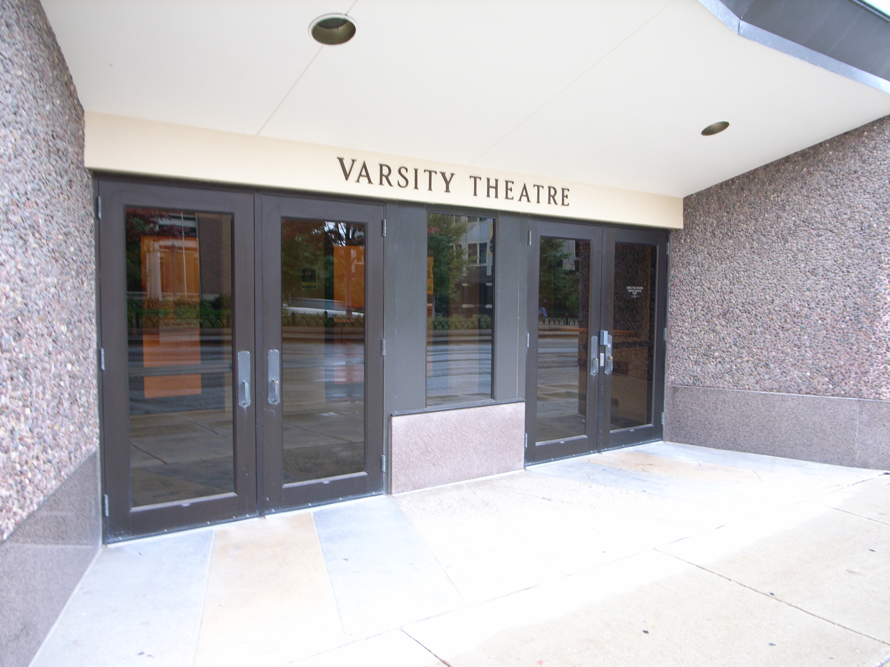
(Arrow points North)

Accessibility

Entrance
Wheel Chair Accessible, Automatic Door
(Pictured)

Women’s Bathrooms
Located to the Right of the Theater doors

Men’s Bathrooms
Located to the right of the Theater doors

