Electronic Dossiers
Step by Step Process for Preparers
of Regular Promotion & Tenure Dossiers

Access the Electronic Dossier SharePoint site by clicking on the web address that was sent to you from Dale Kaser. This should take you directly to your department’s “library.” This is where the dossiers for your candidates will be uploaded and kept.

If you use a PC and it does not automatically open Internet Explorer when you click on the link (from Dale Kaser), right-click the URL or web address in the e-mail message from Dale and click Copy. Open Internet Explorer. Right-click in the address bar and click Paste.

If you need to enter a user name and password, enter marqnet\username and your eMarq password.

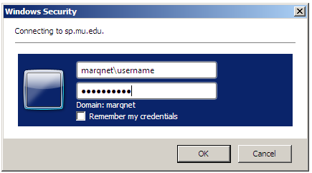

If you are often being prompted to enter your password, or are experiencing issues accessing PDFs, it is suggested you run the Marquette Internet Explorer and Windows firewall configuration tool that is available for download online at http://www.marquette.edu/its/help/software/configure.shtml

You may need to navigate to access the site where you will click on Shared Documents.
Click the down arrow to see more sub sites. Click Promotion and Tenure to navigate back to this site.
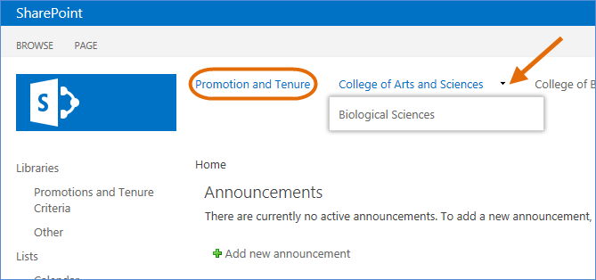

When you have navigated to your site, for example Biological Sciences, click Shared Documents.
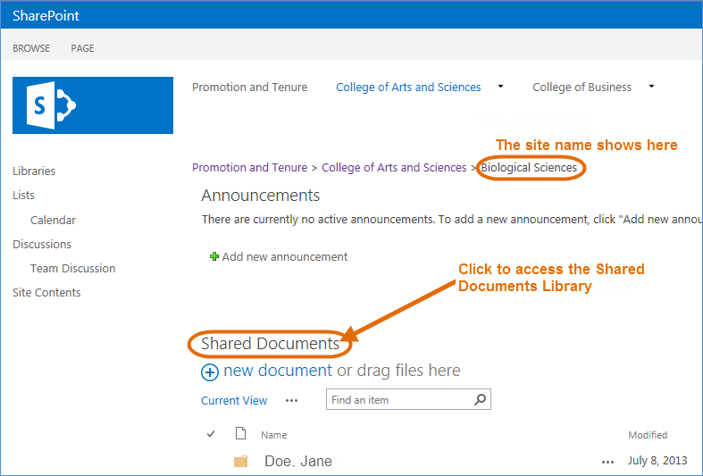

- Make a new folder/s and name it after the candidate/s:
Click +new document > New Folder.
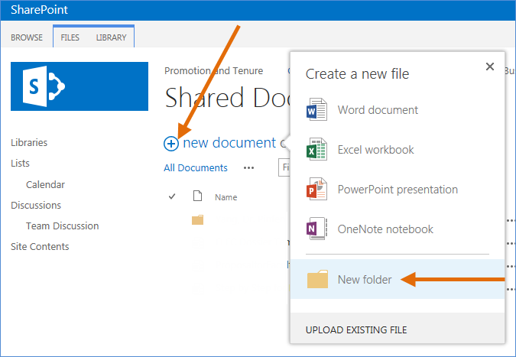

Enter the candidate’s name and click Save.

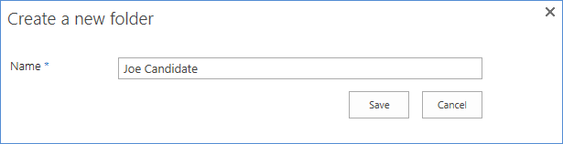

The folder will appear in Shared Documents. The site name shows in the URL.

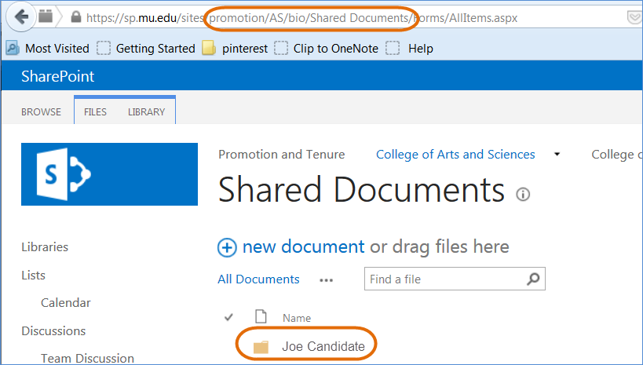

- Name all the documents/files you want to upload for your candidate/s with the exact same names, including double digit numbers, which are in the Checklist/Table of Content, which lists all required and optional documents. This will make it easier to locate documents. You may have some documents in Word or PDF form that you can add to the candidate’s folder/dossier. (PDF is preferred when possible/practical). You may also have hard copy documents, such as letters mailed to you that will need to be scanned in and uploaded to the folder/dossier. Scanned items will result in PDF documents that are not searchable. Word documents that are saved as PDFs however, will be searchable.
- Add the documents for this candidate to the folder you have made in the Shared Documents library:
Click the Library tab > Open with Explorer. (You may need to maximize your window to see this icon.)
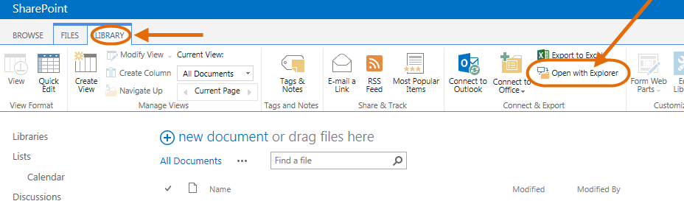
This is an enlarged view of the Open with Explorer icon.
The Explorer window will open on top of the SharePoint window. Click on the SharePoint window and minimize it to place it in the Taskbar.
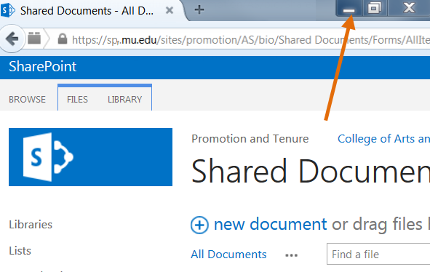
Click on the Explorer window and click the Restore Down button to resize it so that you can see your desktop and drag files in. You can drag in a folder that contains multiple files.
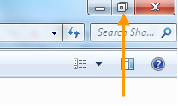
Close the Explorer window and click on SharePoint in the taskbar to return to the Document Library.

Below see a sample of the inside of a candidate’s dossier:

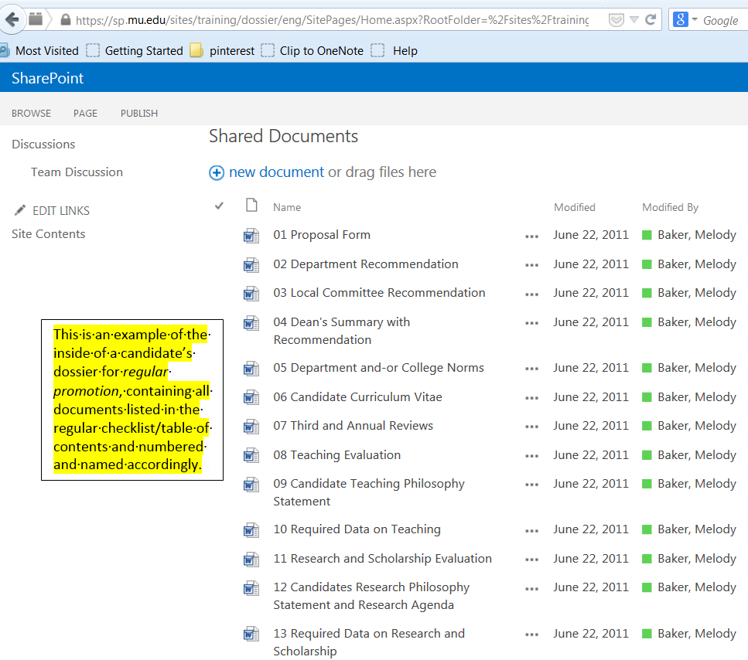

Items for which there are more than one document, such as letters, should be scanned into one continuous document and labeled accordingly, per the Checklist/Table of Contents, ex: “17 Faculty Letters” or “18 Student Letters”:
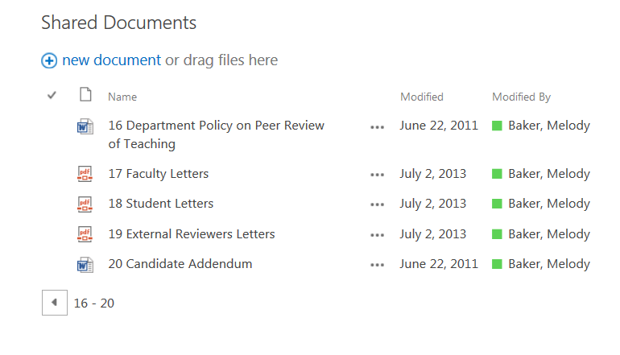

- All required documents should be in the dossier, making it complete, before October 1, 2015. Dale Kaser will send the web address for each candidate dossier to only those areas/college committee members that will need to review them (they are the only ones who will be able to access the dossiers anyway).
- Before October 30, 2015, your chair and/or dean should have signed the proposal form, which should then be scanned and uploaded to the dossier on the SharePoint site. One original, hard copy of the complete dossier should be delivered to the Provost’s office by this date also.
- On November 4, 2015 the Office of the Provost will make all dossiers available electronically to the University Promotion and Tenure Committee.
Sometime after December 5, 2015, when the University has met to consider all dossiers for emeritus and their votes have been submitted to the provost, all dossiers will be deleted from the SharePoint site (i.e., electronically shredded).
If you have any technical questions during preparation of the electronic dossier please call or e-mail:

Ms. Pam Lewis – 288-3756 pamela.lewis@marquette.edu
The Help Desk – 288-7799 helpdesk@marquette.edu

Checklist/Table of Contents
Please name all electronic files as listed below, including 2 digit numbers (but not items in parentheses)
TITLES, ORDER, AND CHECKLIST OF MATERIALS TO BE INCLUDED IN DOSSIER
Key:  R=Required  O=Optional | Case Type | Uploaded to Electronic Dossier  √
Item | Regular
01 Proposal Form (use form on Provost’s webpage: http://www.marquette.edu/provost/promotion-tenure.shtml ) | R
02 Department Recommendation Including Department Vote (Chair’s Summary) | R
03 Local (Area - College) Committee Recommendation | R
04 Dean’s Summary with Recommendation | R
05 Department and/or College Norms | R
06 Candidate Curriculum Vitae (current work first) | R
07 Third Year and Annual Reviews | R
08 Teaching Evaluation | R
09 Candidate Statement on Teaching Philosophy | R
10 Required Data on Teaching | R
11 Research and Scholarship Evaluation | R
12 Candidate’s Research Philosophy Statement & Research Agenda | R
13 Required Data on Research and Scholarship | R
14 Service Evaluation | R
15 Listing of Service Activities | R
16 Department Policy of Peer Review of Teaching | R
17 Faculty Letters (please scan all letters into a single file) | R
18 Student Letters (please scan all letters into a single file) | R
19 External Reviewers Letters (please scan all letters into a single file) | R
20 Candidate Addendum | O

