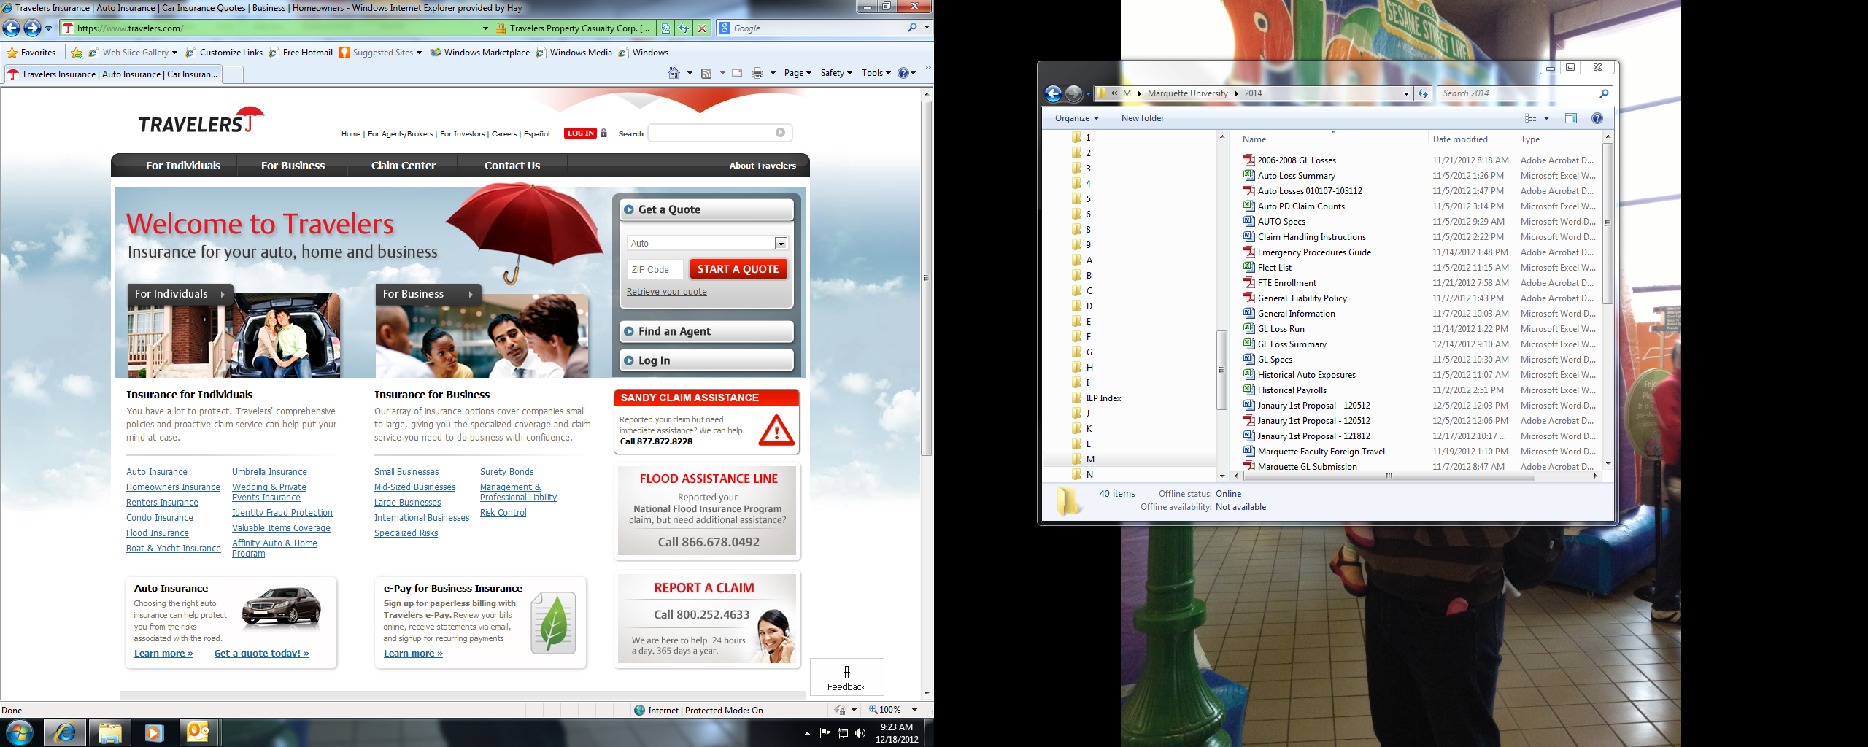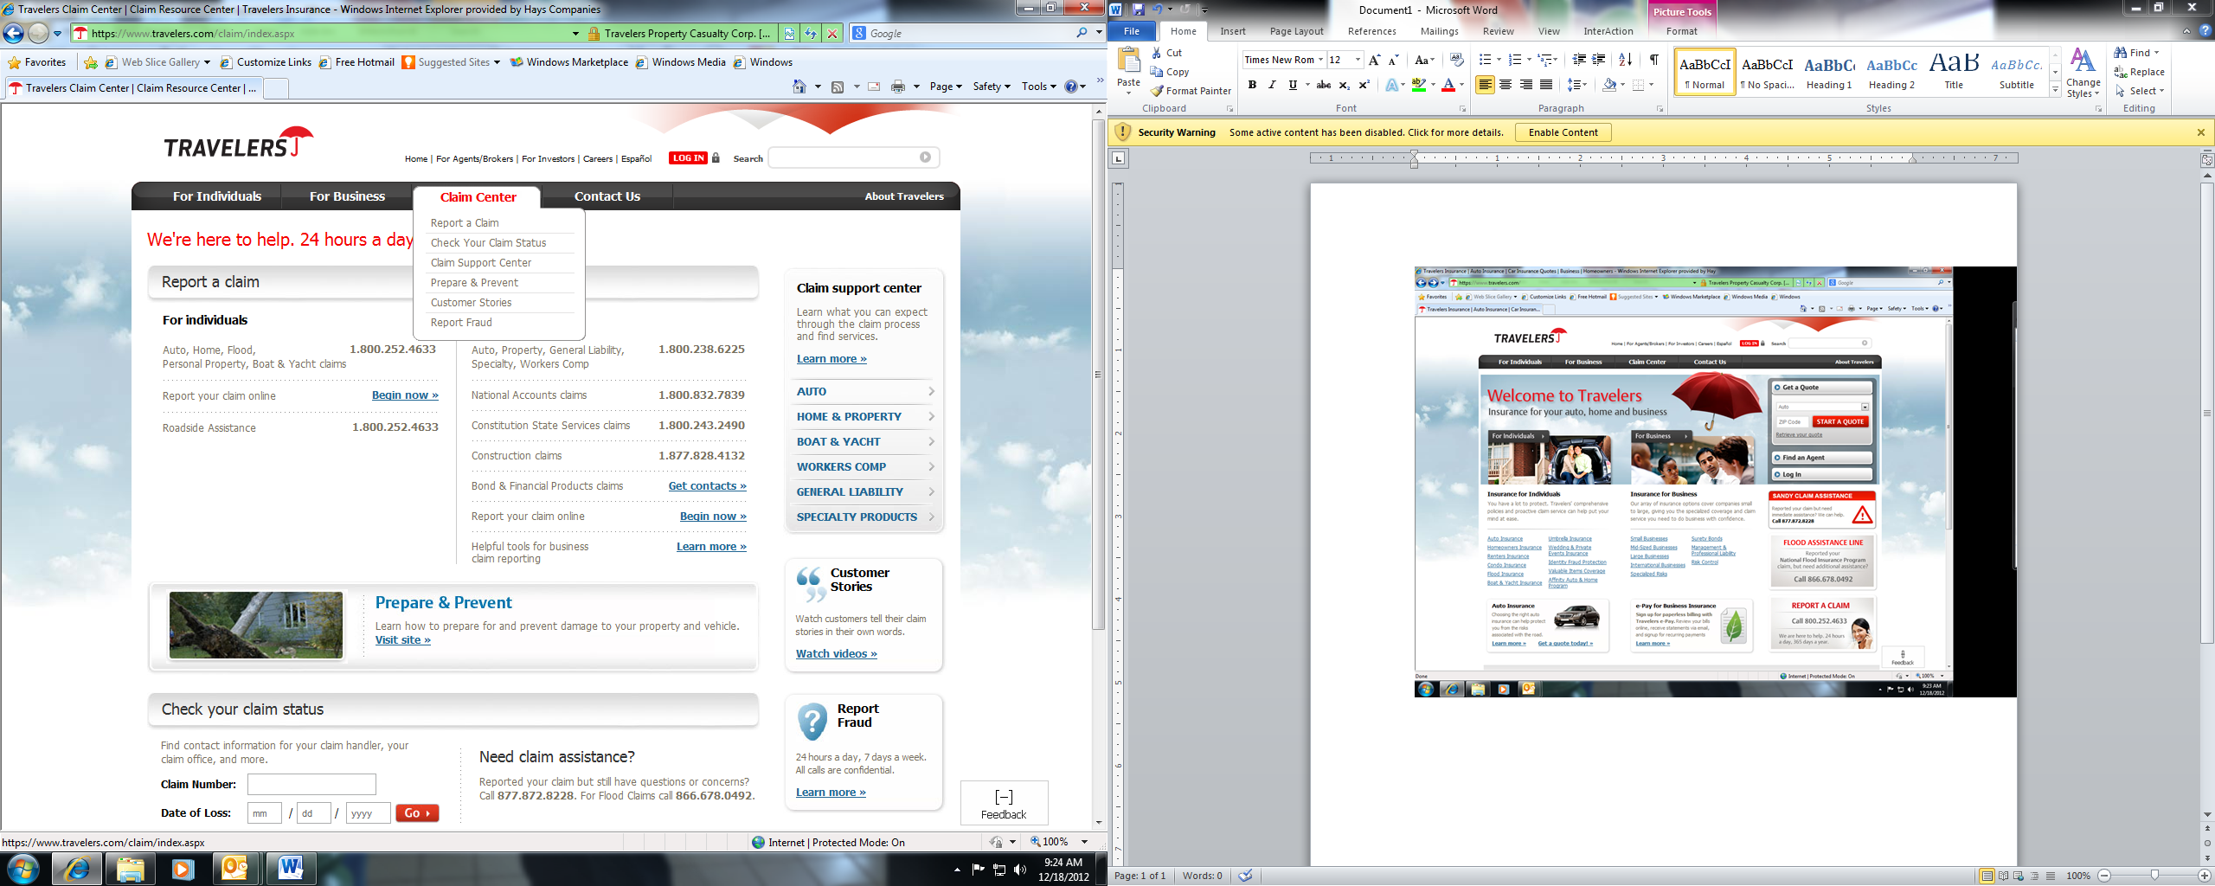

Go to [www.travelers.com](http://www.travelers.com)

Select “Claim Center”

Select “Report your claim online”

Select “Continue”

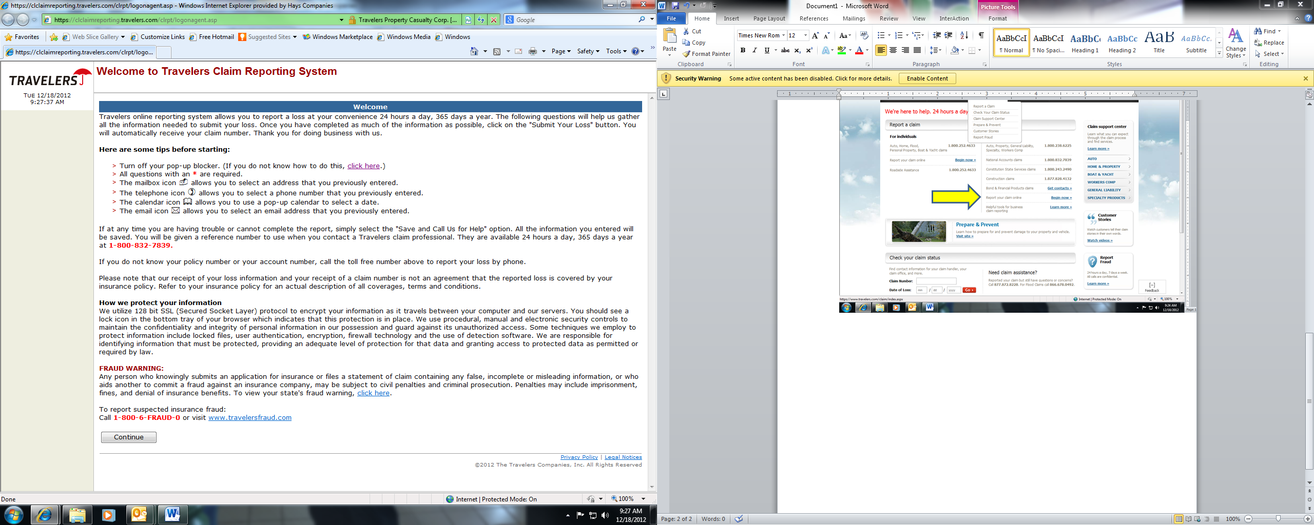

Select “Continue”

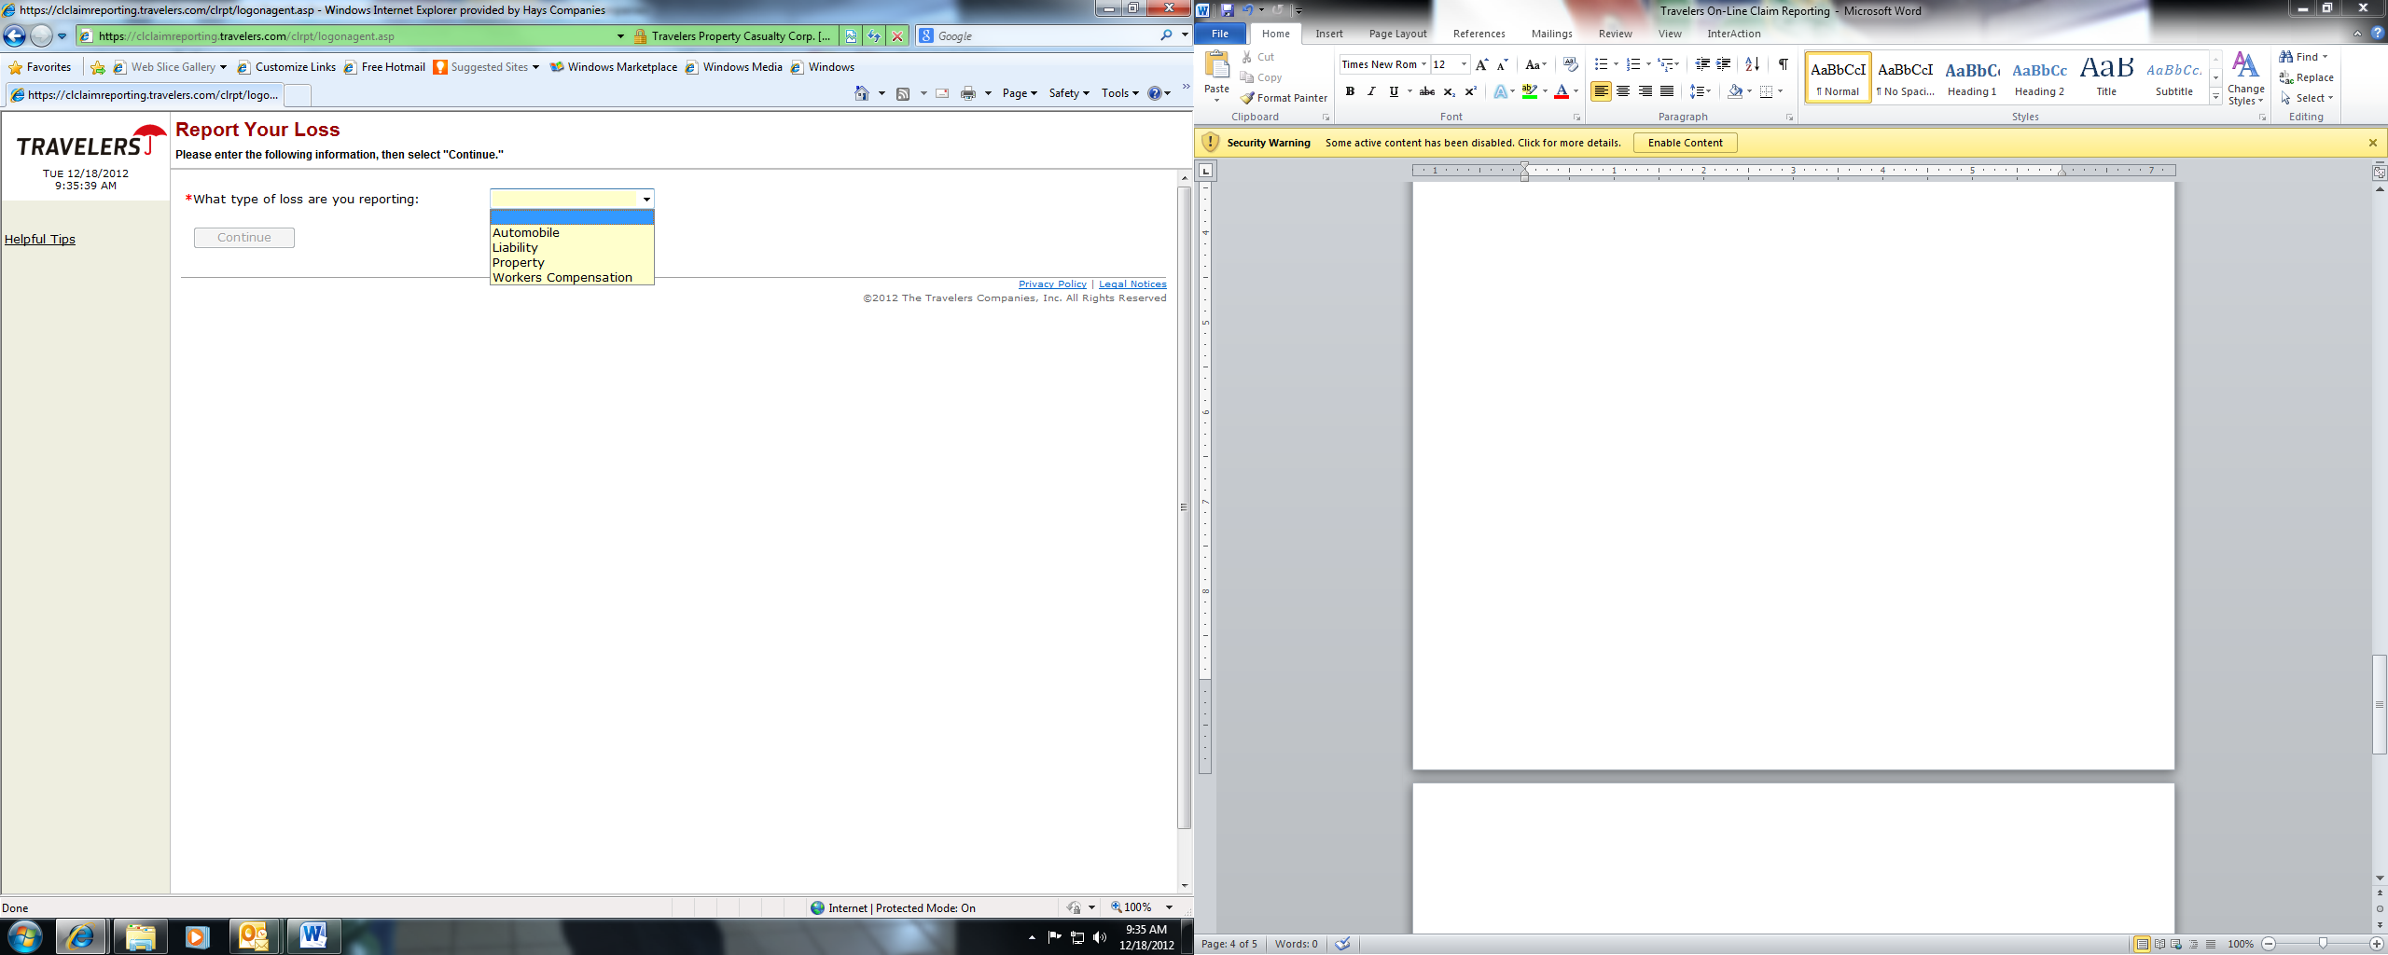

From the drop-down box select the type of claim you are reporting.

Answer preliminary questions that will generate after the type of claim is selected.

Select “Continue”

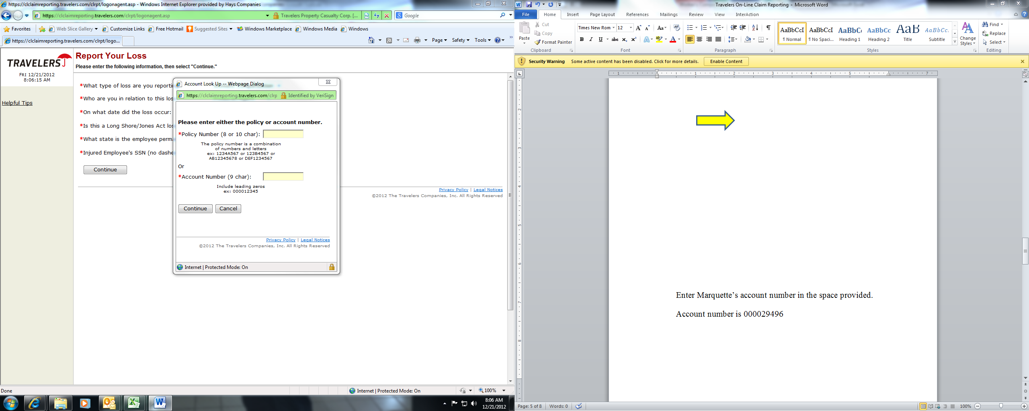

Enter Marquette’s account number in the space provided.

Account number is 000029496

Enter Marquette’s account number in the space provided.

Account number is 000029496

Select “Continue”

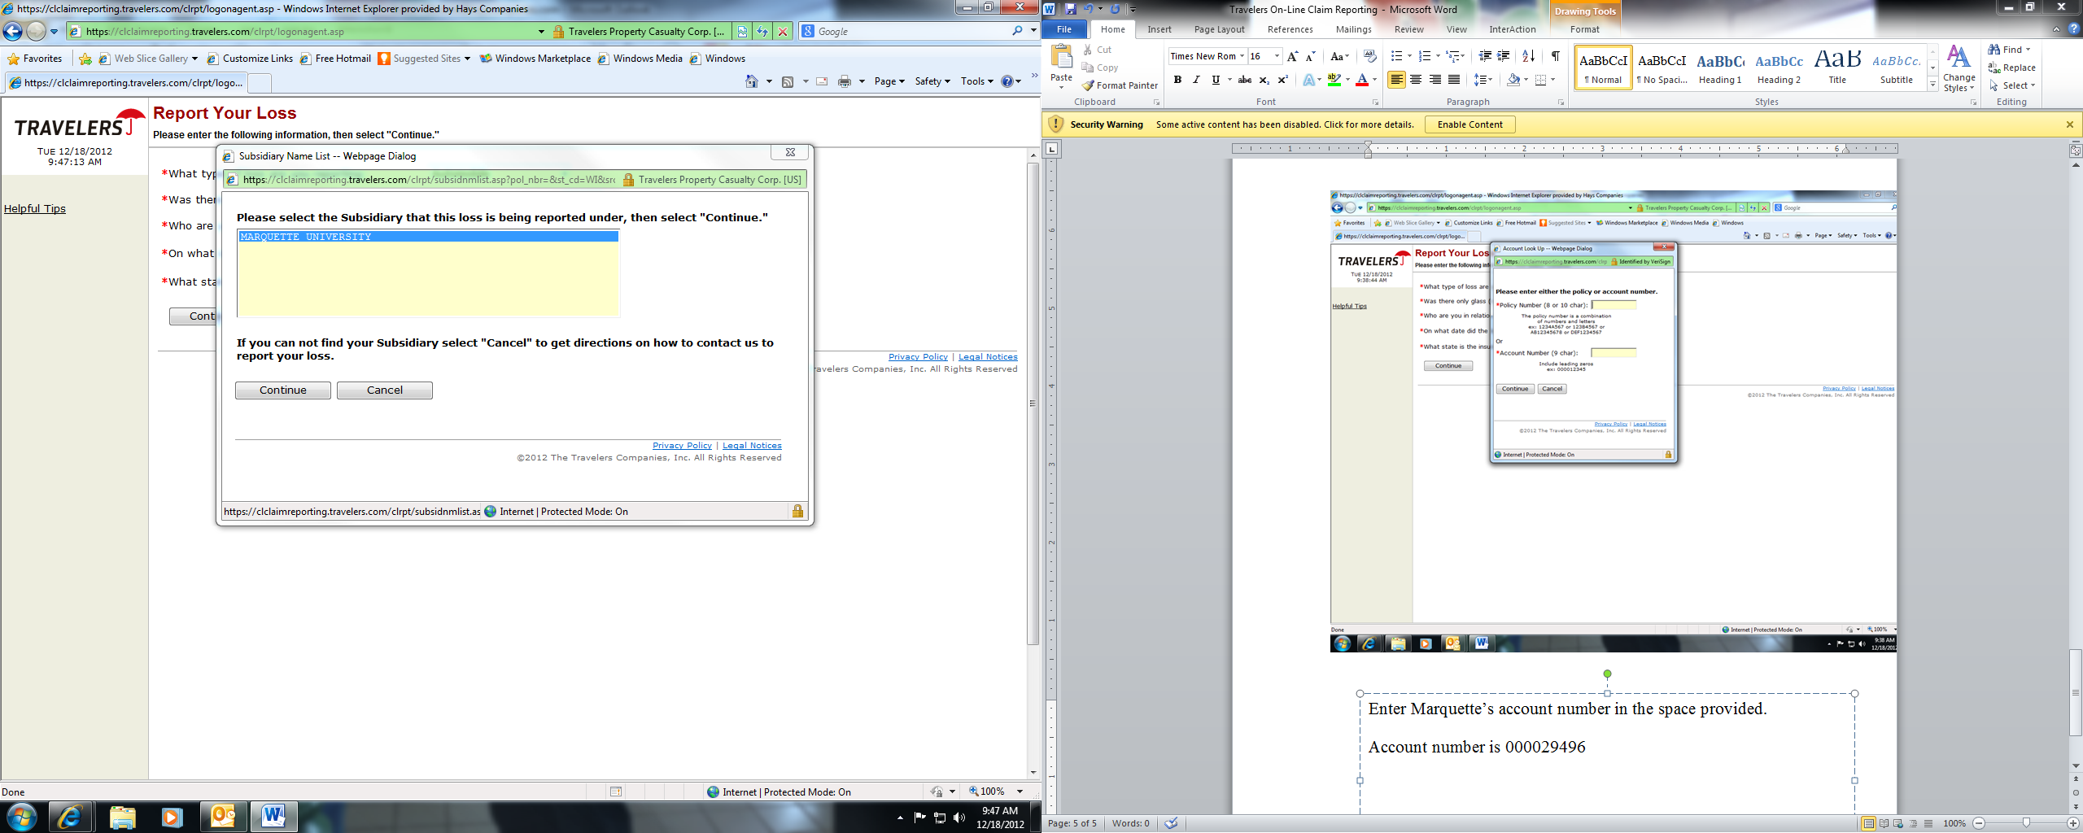

Select “Marquette University”

Select “Continue”

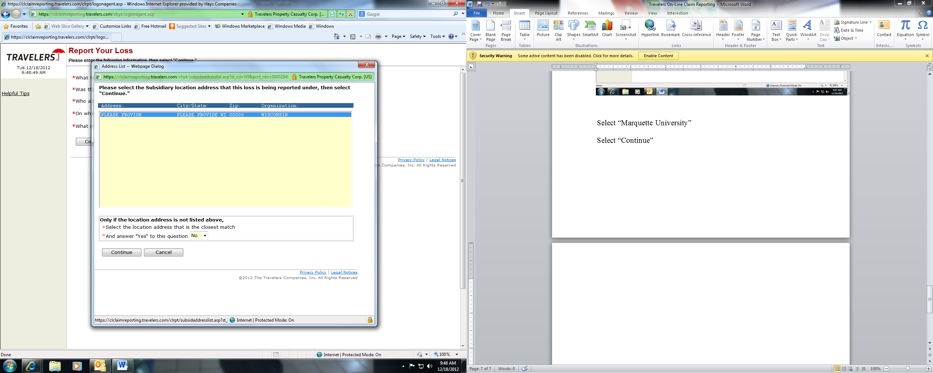

Select “Continue”

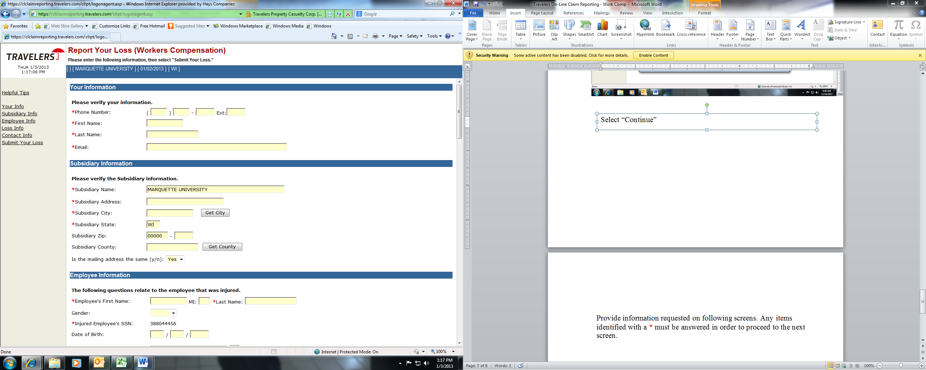

Provide information requested on following screens. Any items identified with a **\*** must be answered in order to proceed to the next screen.