Marquette University Alumni Association
National Board of Directors
Speaker Biographies
Winter 2020

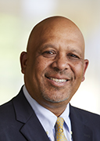
Dr. Kimo Ah Yun is the provost and executive vice president for academic affairs. He previously served as the dean of the J. William and Mary Diederich College of Communication. Prior to joining Marquette University, he was associate dean of the College of Arts and Letters at California State University, Sacramento, where he also served as chair of the department of communication studies, director of the Center for Teaching and Learning, and professor of communication studies. During his 20-year tenure at Sacramento State, he co-chaired the President’s Committee to Build Campus Unity, which programmed and executed campuswide conversations on topics such as discrimination, identity and privilege.

Ah Yun has received teaching awards from California State University, Sacramento, and the International Communication Association. He also received the President’s Research Award from California State University, Sacramento, and the Jack Hunter Meta-Analysis award from the International Communication Association. He has published in Communication Education, Journal of Early Childhood Teacher Education, Communication Research, Wisconsin Medical Journal, Communication Studies, Journal of Applied Communication Research, Journal of the Association for Communication Administration, Metropolitan Universities Journal, and The National Teaching and Learning Forum. His research has been supported with grants from the Centers for Disease Control, Wisconsin Department of Public Health, California Criminal Justice Cabinet, California Department of Transportation, and the Henry J. Kaiser Family Foundation.

Ah Yun earned his bachelor’s degree in communication studies from California State University, Sacramento, his master’s degree in communication studies from Kansas State University, and his doctorate in communication from Michigan State University.
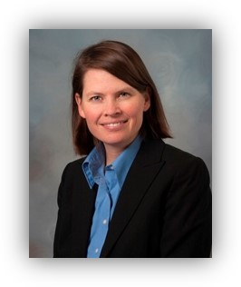
Mary Czech-Mrochinski serves as the Associate Vice president for Public Affairs at Marquette University and has been with the Catholic, Jesuit University for nearly twenty years. Mary received both her bachelor’s and master’s degrees from Marquette University.
On behalf of the university, Mary works to build and strengthen relationships with elected officials, agencies, and staff with a concentration on federal and state government. Mary also works closely with organization and community partners such as the Association of Jesuit Colleges and Universities, Ad Hoc Tax Group, National Association of Independent Colleges, Wisconsin Association of Independent Colleges and University, Wisconsin Dental Association, and Near West Side Partners, Inc. Governmental Teams. Mary also engages in special projects, such as the university’s non-partisan voter registration, voter education and Election Day efforts. Additionally, Mary is currently serving as the university Co-Chair of the Convention Steering Committee as Milwaukee plays host to the Democratic National Convention in July 2020.

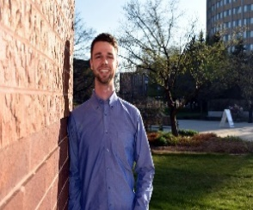
Isaac Feil, Bus Ad ’19, Digital Marketing, Confidence Box
As a college transfer student, a large part of my social perspective in recent years has focused on reputation, because your actions and words develop your reputation regardless of where you go. And I think people don’t realize exactly how much positive influence they can provide others with every day. It’s always during the small moments. I’ve never understood why people feel entitled to judge, criticize, gossip about others, or treat people like objects without any second thoughts.
My point is there are plenty of outside forces that can bring you down every day. But if you surround yourself with the right people and prioritize personal growth and development, you can still find so much joy in every week to combat the stresses of daily life.
My goal with Confidence is to make people realize they are cared about. They just need to know that they are ultimately in control of their own path and reputation.
Respect yourself and others. Be kind. Listen. Do not judge, insult, or cut others off. Work until 3am and get up at 6 every once in a while, just to keep yourself in check in realizing the beauty of life is never to be taken for granted, no matter what life may throw at you.

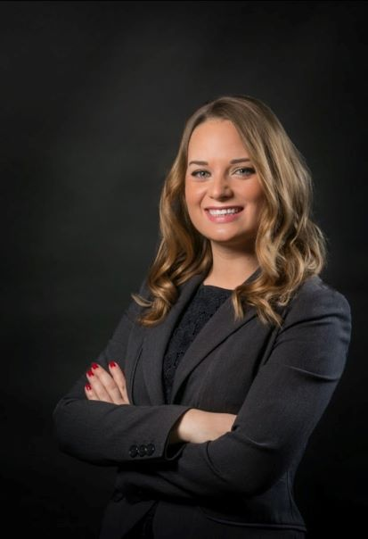
Lynn Griffith serves as the senior director of university communication. In this role, Lynn manages a team of five communications professionals responsible for all internal and external communication for the top-10 Catholic university, including high-profile issues management situations. Through an integrated, multi-channel approach, Lynn’s team leads communication efforts for the university’s 15,000 employees and students, and manages local and national media relations activities on behalf of the university.

Lynn earned both her bachelor’s and MBA degrees from Marquette University. She is a member of the TEMPO Emerging Women Leaders Program and is the professional advisor to the Marquette Public Relations Student Society of America. As a trusted advisor to senior leadership, Lynn has led critical communication events at Marquette, including the inauguration of the Catholic university’s first lay president.

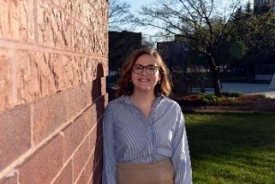
Mae Haggerty, Bus Ad, 19, Idea Founder, Business Development, Confidence Box
Mental health affects everyone. Everyone goes through stress. Everyone goes through pain. Everyone goes through heartbreak. Everyone experiences this negativity yet not many people know how to deal with it. No one talks about all of the tools and resources out there that can help people go through all of this.

No one talks about how they too are experiencing the same things and how they also do not know how to get help.
This was why I never sought help when I got to a point where I felt I no longer knew how to cope. Through an amazing support system of friends, family and finally seeking deeper help through therapy I have been able to see the positive effects of becoming vulnerable and seeking help.
I want to be able to spread this to as many people as possible. I want to provide people the tools that they need to improve not only themselves but to also encourage an open community of positive mental health practices. I hope that this Confidence community will be able to bring the light that people may need in their lives, and I hope that people can spread this positivity to the people who mean the most to them.
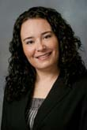
Alyssa Klopatek has been with Marquette’s University Advancement team for nearly eleven years. She helped develop the current iteration of the alumni website and continues to work on developing and launching new webpages and functionality, including an alumni site homepage redesign and alumni user login and directory searching. Alyssa also leads the Engagement and External Relations email marketing strategy as well as supplementary event print material direction and design. She maintains Marquette websites including Alumni & Friend, Giving, Alumni National Awards, nationalmarquetteday.com, Reunion + Homecoming and others. She holds a BA from UW-Whitewater in public relations and information technology and an MA in professional and technical writing from UW-Milwaukee.
Michael Zimmer, PhD, is an Associate Professor in the Department of Computer Science at Marquette University. He is co-director of the Social and Ethical Computing Lab, and also co-directs the interdisciplinary Data Science major.
With a multidisciplinary background in communication & Internet studies, science & technology studies, and information policy & ethics, Zimmer studies the social and ethical dimensions of our contemporary digital ecosystem, with particular interest in digital privacy, data ethics, internet research ethics, and how users understand information flows within and across digital platforms. His research agenda has included investigations into web search engines, social media platforms, wearable fitness trackers, intelligent personal assistants, library technologies, autonomous vehicles, and other emerging technologies. Zimmer has engaged in research supported by the National Science Foundation, the National Institute of Health, and the Institute of Museum and Library Services.

Zimmer received his PhD in 2007 from the Department of Media, Culture, and Communication at New York University, where he was also a Student Fellow at the Information Law Institute at NYU Law School. Zimmer was the Microsoft Resident Fellow at the Information Society Project at Yale Law School for 2007-2008, where he remains an Affiliated Fellow. From 2008-2019, he was on the faculty of the School of Information Studies at the University of Wisconsin-Milwaukee, where he also served as Director of the Center for Information Policy Research. Zimmer joined the Department of Computer Science at Marquette University in August 2019.

