02/27/2026
Written by: Alexis Biju – Undergraduate in Exercise Physiology
Mentor: Toni Uhrich
Edited by: Dr. Mike Haischer

Key Points:

- Vitamin A is essential for immune function, vision, and cell development
- Excess vitamin A from supplements can lead to toxicity and decreased bone mineral density
- A balance between adequate intake and over-supplementation is critical

Vitamin A is a fat-soluble vitamin required for vision, immune function, and cellular growth. Unlike water-soluble vitamins which are short-lived in the body, vitamin A is stored in the liver and adipose tissue. Because of this, excess intake of vitamin A, especially from supplements, can accumulate harmful levels over time. While deficiency can lead to severe health issues, recent studies have highlighted that too much vitamin A can also be harmful¹.

According to the National Center for Biotechnology Information, vitamin A toxicity, also known as hypervitaminosis A, can occur with ongoing intake exceeding the body’s storage capacity as it accumulates in the liver and adipose tissue². This means toxic effects emerge gradually, over the course of months to years of consuming doses above the Tolerable Upper Intake Level (3,000 µg/day). Chronic toxicity can lead to symptoms like liver enlargement and eventually liver damage². High levels of retinol, the active form of vitamin A found in supplements and animal-based foods, would interfere with vitamin D’s regulation of calcium metabolism, leading to weakened bone structure over time. Similarly, Harvard Health Publishing claims that excessive vitamin A intake, especially from supplements or animal-based sources, may reduce bone mineral density and elevate fracture risk, particularly among older adults³.

These findings counter the common perception that “more is better” when it comes to vitamins. They underscore the importance of achieving optimal nutrient levels, rather than excessive, through balanced dietary sources like colorful fruits, vegetables, and fortified foods, while avoiding overuse of supplements¹. Good dietary sources include carrots, sweet potatoes, spinach, red peppers, and more. Understanding upper intake limits and prioritizing food-based vitamin A sources may reduce the risk of nutrient toxicity and improve long-term health outcomes.
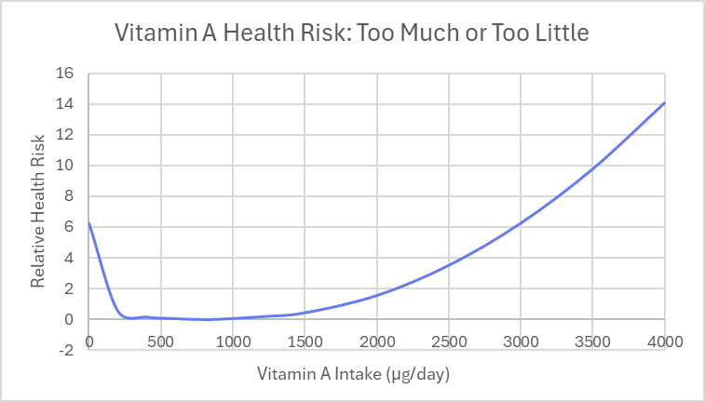
Figure 1: The graph portrays a conceptual U-shaped relationship between vitamin A intake and health risk, modeled using a normalized quadratic function centered at the RDA range (700–900 µg/day). The plotted values are modeled for illustration only and not taken from a specific dataset, showing increased health risk at both deficient and excessive intakes.
References
- “How Much Vitamin A Is Too Much?” Cleveland Clinic, Cleveland Clinic, 21 Apr. 2023, health.clevelandclinic.org/vitamin-a-toxicity.
- Olson, Jazmine M. “Vitamin A Toxicity.” StatPearls [Internet]., U.S. National Library of Medicine, 2 Sept. 2023, www.ncbi.nlm.nih.gov/books/NBK532916/.
- “Vitamin A and Your Bones.” Harvard Health, 9 Mar. 2014, www.health.harvard.edu/newsletter_article/vitamin-a-and-your-bones.

