04/21/2026
Written by: Caroline Donahue – AHPRC Student Research Initiative Awardee; Undergraduate in Exercise Physiology
Mentor: Dr. Marie Bement
Edited by: Dr. Mike Haischer

Key Points:

- Most U.S. adults fail to meet weekly exercise recommendations, which contributes to poor societal health outcomes.
- Improving exercise valence—how a person feels toward exercise—promotes exercise engagement.
- Reducing pain by modulating exercise intensity is a promising strategy to improve exercise valence.

Despite well-known benefits, only one in four adults in the U.S. meets aerobic exercise recommendations (150 minutes/week), contributing to poor societal health¹. While the factors related to exercise participation are complex, interventions aimed at improving feelings towards exercise (i.e., exercise valence) have been shown to contribute to long-term adherence². Adjusting exercise intensity to promote positive feelings towards exercise is a potential strategy that could influence exercise motivation as people tend to adhere to pleasant behaviors and avoid behaviors that are not pleasant³.
The timing of adjusting the exercise intensity to increase exercise valence is related to the peak-end rule; this is an unconscious bias in which individuals judge an experience based on how they felt at the most intense and end moments⁴. Specific to exercise valence, this rule suggests ending the exercise session in a way that promotes pleasant feelings. For example, individuals who struggle with high-intensity workouts should end with a lower intensity to make them feel more positive about the overall experience⁴. Thus, the timing of how a person feels towards exercise, especially at the end of the session, increases the likelihood of repeating the exercise.
Within the Pain PhysioLab at Marquette under the direction of Dr. Marie Bement, we investigate ways to decrease pain and improve feelings during exercise, particularly in local retirement communities where people often experience more pain and are less physically active. During a leg strengthening exercise task (Figure 1), retirement community residents exercise until reporting moderate pain. Then, we briefly increase exercise intensity (temporarily increasing pain) before quickly returning to the initial intensity (blue line in Figure 2). Our data shows that this creative technique results in less pain and more positive feelings at the end of the exercise session.
Clinically, finding resolutions to reduce pain, improve feelings, and increase physical activity is important for maintaining health for all individuals. Discovering techniques that could improve an individual’s long-term participation in exercise may lead to an improvement in overall physical and mental health.

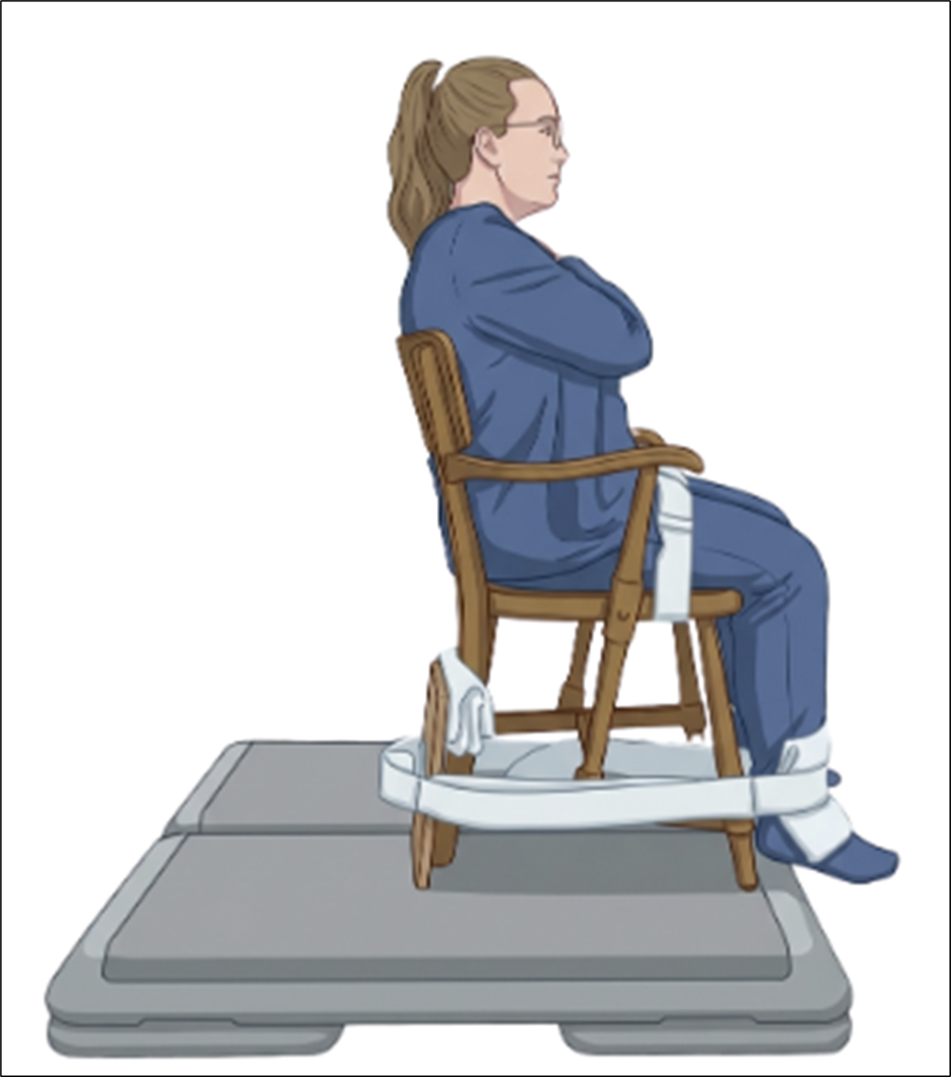
Figure 1: Exercise set up for a leg extension exercise completed at local retirement communities. Participants were seated, with one leg secured with a rigid strap attached to a force gauge. Participants kicked into the strap, as if trying to straighten their leg (isometric knee extension exercise), at 25% of their maximal strength. They held the muscle contraction until reporting moderate pain (5/10). Then, exercise intensity was increased to 50% of maximal strength for just 10 seconds, before quickly returning to the initial exercise intensity (blue line in Figure 2). Photo created with BioRender AI.

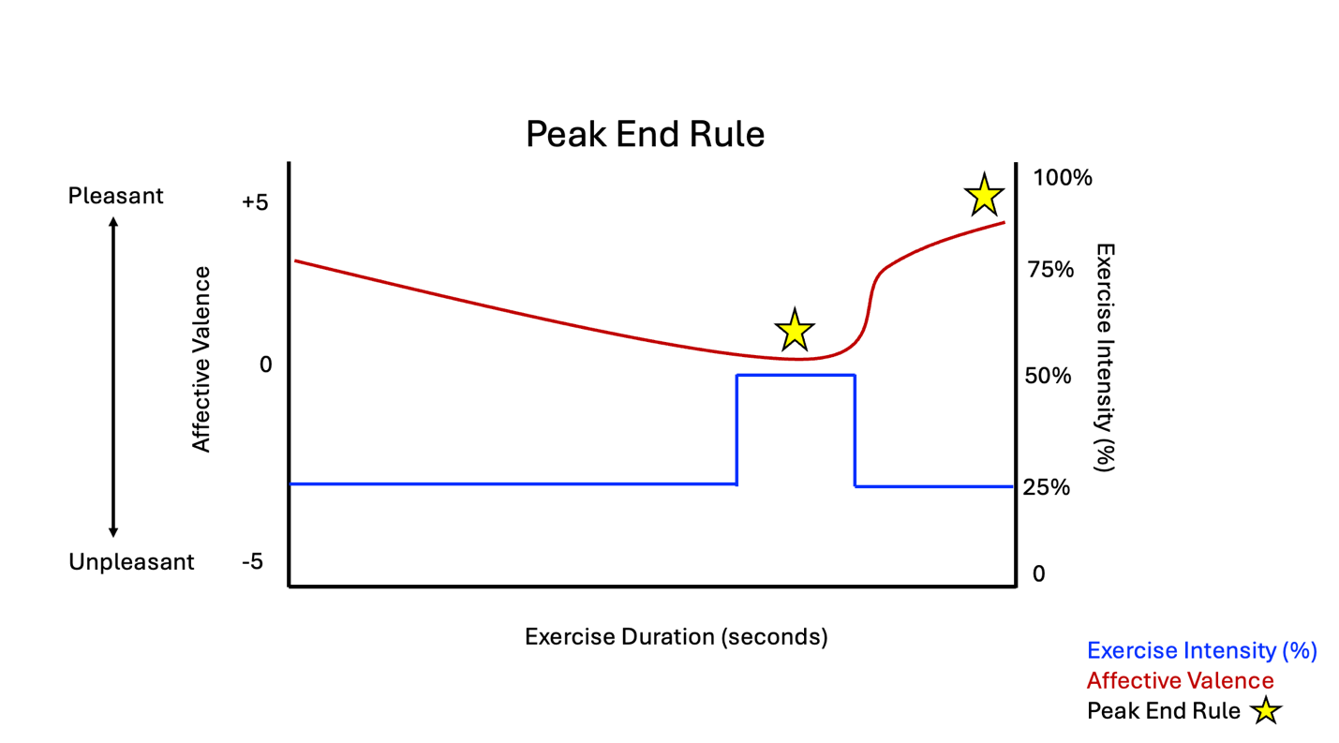
Figure 2: Average reports of affective valence (the feeling of pleasure or displeasure) throughout the duration of a seated isometric leg extension exercise task (N=25, 23 Women). Participants tend to recall experiences by the Peak End Rule (star) meaning they recall their experiences at the most intense part (increase exercise intensity from 25% to 50%) and end of a task (the final 10 seconds of the exercise task kicking at the original exercise stimulus, 25%). Our results show modulating changes in exercise intensity decreases pain and improves exercise valence. Clinically, this could lead to improved exercise adherence and overall quality of life.

References
- Elgaddal N, Kramarow EA, Reuben C. Physical Activity Among Adults Aged 18 and Over: United States, 2020. NCHS Data Brief. 2022 Aug;(443):1–8.
- Teixeira, D.S., Bastos, V., Andrade, A.J. et al. Individualized pleasure-oriented exercise sessions, exercise frequency, and affective outcomes: a pragmatic randomized controlled trial. Int J Behav Nutr Phys Act 21, 85 (2024). https://doi.org/10.1186/s12966-024-01636-0
- Ekkekakis, Panteleimon, et al. “Do You Find Exercise Pleasant or Unpleasant? The Affective Exercise Experiences (AFFEXX) Questionnaire.” Psychology of Sport and Exercise, vol. 55, 2021, https://doi.org/10.1016/j.psychsport.2021.101930.
- Pilat, D., & Krastev, Dr. S. (n.d.). Peak-end rule. The Decision Lab. https://thedecisionlab.com/biases/peak-end-rule

