11/21/2025
Written by: Alexandra Sorenson – Undergraduate in Exercise Physiology
Mentor: Toni Uhrich
Edited by: Dr. Mike Haischer

Key Points:

- Prenatal exercise is safe and even recommended for overall mother and fetal health
- Prenatal exercise improves heart health, reduces gestational diabetes risk, and benefits labor and delivery
- Strength training during pregnancy aids functional mobility, posture, and alleviates low back pain

Despite countless years of scientific evidence, many women are still under the false impression that they should avoid exercise during pregnancy. However, pregnancy is one of the body’s most demanding cardiovascular stress tests, and physical activity plays a crucial role in supporting maternal and fetal health. Exercise during pregnancy provides countless health benefits, including helping the heart and blood vessels work more efficiently, improving how the body uses oxygen, keeping heart rate steady, and pumping more blood with each beat. It can also lower the risk of gestational diabetes and other metabolic conditions⁵.

Pregnancy places significant physiological demands on the cardiovascular system, causing cardiac output, which is the volume of blood pumped by the heart each minute, oxygen consumption, and blood volume to increase⁷. Moderate-intensity exercises support these demands by maintaining cardiovascular fitness, potentially improving VO2 max, the maximal amount of oxygen the body uses during exercise⁹. Resting and submaximal heart rate responses are typically elevated in pregnant women compared to non-pregnant females^{7, 8}. Stroke volume, the blood pumped per ventricle each time the heart contracts, also increases due to larger plasma volume and an increased cardiac output, ensuring that oxygen needs are met^{4, 5}. These adaptations improve systemic circulation, increase endurance capabilities, and prepare the body for the stresses of labor.

Physically active pregnant women often have a shorter labor and less medical intervention, such as cesarean sections or induced labor. A systematic review published by the National Institutes of Health found that prenatal exercise was strongly linked to shorter first-stage labor times, averaging one hour or less, and lower rates of cesarean delivery compared to sedentary pregnant women⁷.

Strength training provides additional benefits by increasing functional mobility and reducing muscular discomfort that is prevalent during pregnancy². Resistance training strengthens the lower back and core, aiding in balance and stability. Additionally, regular physical activity helps to prevent excessive gestational weight gain linked to gestational diabetes³. Exercise improves metabolic regulation while increasing insulin sensitivity and stabilizes blood glucose levels⁶. Preventing excess weight gain also reduces weight retention postpartum and lowers the risk of long-term obesity and cardiovascular disease for both the mother and child³.

Overall, scientific data support that prenatal exercise is safe and beneficial for physiological health. Regular exercise during pregnancy optimizes cardiovascular function, reduces disease risk, and eases the labor process¹.
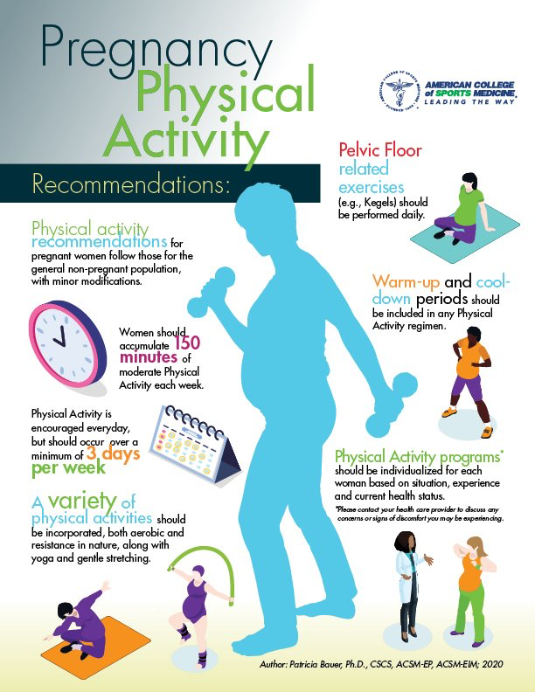
Figure 1: ACSM recommended physical activity during pregnancy, emphasizing 150 minutes minimum of moderate-intensity aerobic exercise per week. Physical activity programs should be individualized, always including warm-ups and cool-downs as well as incorporating a variety of exercise types¹.

References
- American College of Sports Medicine. “Physical Activity Guidelines - ACSM.” ACSM, 17 Feb.2025,acsm.org/education-resources/trending-topics-resources/physical-activity-guidelines/#:~:text=ACSM%20and%20CDC%20recommendations%20state,on%20three%20days%20per%20week.
- Benton, Melissa J., et al. “Progressive Resistance Training during Pregnancy: A Case Study.” PM&R, vol. 2, no. 7, July 2010, pp. 681–684, https://doi.org/10.1016/j.pmrj.2010.04.021.
- Blau, Lauren E., and Julia M. Hormes. “Preventing Excess Gestational Weight Gain and Obesity in Pregnancy: The Potential of Targeting Psychological Mechanisms.” Current Obesity Reports, vol. 9, no. 4, 4 Nov. 2020, pp. 522–529, https://doi.org/10.1007/s13679-020-00415-9. Accessed 7 Dec. 2020.
- Cilar Budler, Leona, and Marko Budler. “Physical Activity during Pregnancy: A Systematic Review for the Assessment of Current Evidence with Future Recommendations.” BMC Sports Science, Medicine and Rehabilitation, vol. 14, no. 1, 16 July 2022, www.ncbi.nlm.nih.gov/pmc/articles/PMC9288689/,https://doi.org/10.1186/s13102-022-00524-z.
- Cooper, Danielle B. “Pregnancy and Exercise.” StatPearls [Internet]., U.S. National Library of Medicine, 17 Apr. 2023, www.ncbi.nlm.nih.gov/books/NBK430821/.
- Kirwan, John P., et al. “The Essential Role of Exercise in the Management of Type 2 Diabetes.” Cleveland Clinic Journal of Medicine, vol. 84, no. 7 suppl 1, July 2017, pp. S15–21. https://doi.org/10.3949/ccjm.84.s1.03.
- Loerup, Lise, et al. “Trends of Blood Pressure and Heart Rate in Normal Pregnancies: A Systematic Review and Meta-Analysis.” BMC Medicine, vol. 17, no. 1, 11 Sept. 2019, bmcmedicine.biomedcentral.com/articles/10.1186/s12916-019-1399-1, https://doi.org/10.1186/s12916-019-1399-1.
- Sanghavi, Monika, and John D. Rutherford. “Cardiovascular Physiology of Pregnancy.” Circulation, vol. 130, no. 12, 2014, pp. 1003–1008, www.ahajournals.org/doi/full/10.1161/CIRCULATIONAHA.114.009029, https://doi.org/10.1161/circulationaha.114.009029.
- University of Virginia. “VO2 Max Testing.” Exercise Physiology Core Laboratory, 2015, med.virginia.edu/exercise-physiology-core-laboratory/fitness-assessment-for-community-members/vo2-max-testing/.
- Zhang, Dingfeng, et al. “Influence of Physical Activity During Pregnancy on Type and Duration of Delivery, and Epidural Use: Systematic Review and Meta-Analysis.” Journal of Clinical Medicine, vol. 12, no. 15, Aug. 2023, p. 5139. https://doi.org/10.3390/jcm12155139.

