FACULTY/INSTRUCTOR DIVERSITY BOOK CLUB 2020
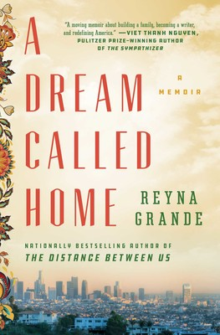
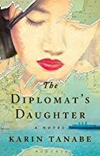
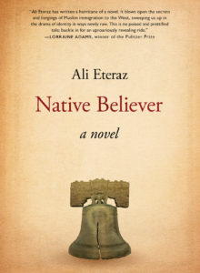
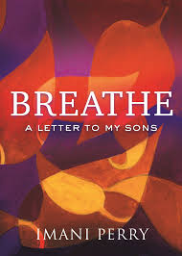
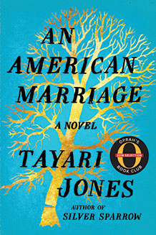
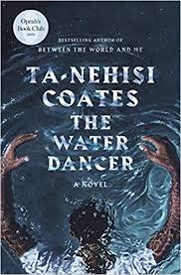
January 24, 2020 *February 28, 2020 **March 20, 2020 April 24, 2020 May 15, 2020 ***June 12, 2020

Join us for the kickoff of a faculty book club series focusing on a wide range of experiences and identities using current literature. This will hopefully lead to other recommendations and other diverse voices into the future.
Purpose: Allow opportunities to meet other Marquette faculty and others who instruct students, read recent literature with cultural meaning, and build community membership across campus.
Meetings will be held Fridays from Noon-1:15. Lunch will be served.
Please RSVP in LibCal through the CTL homepage calendar or by emailing ctl@marquette.edu.
Books will be provided to the first 15 registered.
NOTE: You do not need to attend all of these, you can register individually.
*Author visit at MU March 18, 2020
**Author visit at MU April 2, 2020
***Book available in Spanish (please indicate on registration)
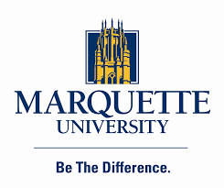

Co-sponsored by the Center for Teaching & Learning,
the Office of Institutional Diversity and Inclusion,
Women’s Innovation Network (WIN), & Raynor Memorial Libraries

The Water Dancer (Ta-Nehisi Coates, 2019)
Young Hiram Walker was born into bondage. When his mother was sold away, Hiram was robbed of all memory of her—but was gifted with a mysterious power. Years later, when Hiram almost drowns in a river, that same power saves his life. This brush with death births an urgency in Hiram and a daring scheme: to escape from the only home he’s ever known. This is the dramatic story of an atrocity inflicted on generations of women, men, and children—the violent and capricious separation of families—and the war they waged to simply make lives with the people they loved. Written by one of today’s most exciting thinkers and writers, The Water Dancer is a propulsive, transcendent work that restores the humanity of those from whom everything was stolen.

An American Marriage (Tayari Jones, 2018)
Newlyweds Celestial and Roy are the embodiment of both the American Dream and the New South. He is a young executive, and she is an artist on the brink of an exciting career. But as they settle into the routine of their life together, they are ripped apart by circumstances neither could have imagined. Roy is arrested and sentenced to twelve years for a crime Celestial knows he didn’t commit. Though fiercely independent, Celestial finds herself bereft and unmoored, taking comfort in Andre, her childhood friend, and best man at their wedding. As Roy’s time in prison passes, she is unable to hold on to the love that has been her center. After five years, Roy’s conviction is suddenly overturned, and he returns to Atlanta ready to resume their life together.
Breathe (Imani Perry, 2019)
Emotionally raw and deeply reflective, Imani Perry issues an unflinching challenge to society to see Black children as deserving of humanity. She admits fear and frustration for her African American sons in a society that is increasingly racist and at times seems irredeemable. However, as a mother, feminist, writer, and intellectual, Perry offers an unfettered expression of love—finding beauty and possibility in life—and she exhorts her children and their peers to find the courage to chart their own paths and find steady footing and inspiration in Black tradition. Perry draws upon the ideas of figures such as James Baldwin, W. E. B. DuBois, Emily Dickinson, Toni Morrison, Ralph Waldo Emerson, and Ida B. Wells. She shares vulnerabilities and insight from her own life and from encounters in places as varied as the West Side of Chicago; Birmingham, Alabama; and New England prep schools.

Native Believer (Ali Eteraz, 2016)
Ali Eteraz is a pen name that means “Noble Protest.” In his darkly funny debut novel, the protest may not be entirely noble, but it is essential—the story follows M., a Philadelphia man who is Muslim by birth but not by belief. When he gets fired for owning a copy of the Quran, his life spirals out of control as he tries to find some semblance of a place in the world.

The Diplomat’s Daughter (Karin Tanabe, 2017)
During the turbulent months following the 1941 bombing of Pearl Harbor, twenty-one-year-old Emi Kato, the daughter of a Japanese diplomat, is locked behind barbed wire in a Texas internment camp. She feels hopeless until she meets handsome young Christian Lange, whose German-born parents were wrongfully arrested for un-American activities. Together, they live as prisoners with thousands of other German and Japanese families but discover that love can bloom in even the bleakest circumstances. When Emi and her mother are abruptly sent back to Japan, Christian enlists in the United States Army, with his sights set on the Pacific front—and, he hopes, a reunion with Emi—unaware that her first love, Leo Hartmann, the son of wealthy of Austrian parents and now a Jewish refugee in Shanghai, may still have her heart.

A Dream Called Home (Reyna Grande, 2018)
From best-selling author Reyna Grande - whose remarkable memoir The Distance Between Us has become required reading in schools across the country - comes an inspiring account of one woman's quest to find her place in America as a first-generation Latina university student and aspiring writer determined to build a new life for her family one fearless word at a time.

