CENTER FOR TEACHING & LEARNING

MID-SPRING PROGRAMMING FOR FACULTY

Contact Jennifer Maney with questions!
Registration available (unless otherwise noted) online or by emailing the CTL.

Spotlight on …
This Photo by Unknown Author is licensed under CC BY-NC-ND

TEACHING ON TAP TUESDAYS
(by and for faculty)

Join us on Tuesdays from 3:00-4:30pm for peer-lead dialogue and conversation. The purpose of Teaching on Tap is to provide opportunities to discuss being a professor at Marquette in the 21st century. Topics can range depending on the will of the group. This will be an informal setting where no one is teacher, and everyone is learner.
All sessions will be held in the Center for Teaching & Learning, third floor of the Raynor Library, room 330B. Questions: Contact Laurieann Klockow, CTL Faculty Fellow
or Jennifer Maney, Interim CTL Director

March 10 – Kickoff theme: Equity and Justice in the Classroom (what does it look like)
March 17 – Responding to Reflection Meaningfully
March 24 – Teaching First Generation Students in STEM
March 31 - Conundrums of Teaching & other group-decided topics
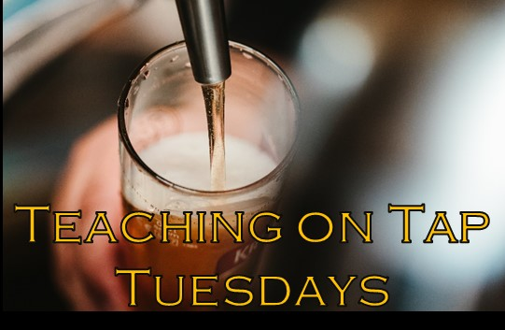
April 7 - Conundrums of Teaching & other group-decided topics
April 14 – Teaching Challenges in STEM
April 21 – Group Work and Building a Learning Community
April 28 - Conundrums of Teaching & other group-decided topics
May 5 – Conundrums of Teaching & other group-decided topics

OTHER WORKSHOPS/PROFESSIONAL DEVELOPMENT

Faculty/Instructor Diversity Book Club 2020

Join us for a faculty book club series focusing on a wide range of experiences and identities using current literature. This will hopefully lead to other recommendations and other diverse voices into the future. (March 20, April 24, May 15, June 12,
Noon – 1:15pm, books and lunch provided)

Book Study: Small Teaching: Everyday Lessons from the Science of Learning
by James Lang
This Photo by Unknown Author is licensed under CC BY-NC
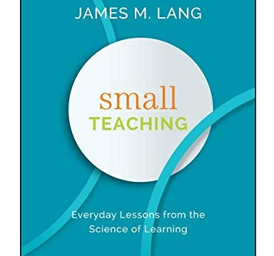
How can we capture students’ attention? How can we more effectively introduce or wrap up learning? How can we help students deepen their understanding and improve their own learning?
(This group will meet Fridays from 1 to 2pm:
March 6, March 20, April 3, April 17, and May 1).

Ignatian Pedagogy in the Classroom – Foundational Principles
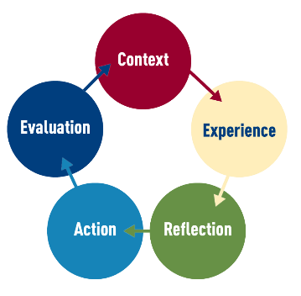
The roots of the Ignatian tradition, grounded in the power of education in order to transform lives, its commitment to social justice, and its care for the whole person (cura personalis), lend themselves to the use of the Ignatian pedagogy paradigm to inform the learning experiences of our students. Come to this introductory session to familiarize yourself with common language, terminology, and the elements of the pedagogical paradigm. (April 3, 1-2pm, lunch provided)

Teaching Students to Care:
A Transformational Way to Create Engaging Learning Experiences
In Dee Fink’s, “Creating Significant Learning Experiences: An Integrated Approach to Designing College Courses” (2013),
he discusses his interactive taxonomy of learning which suggests in order to create a transformational learning experience for students, you must include learning goals that will promote a change in your student. One of the learning dimensions he includes in his taxonomy is the idea of “Caring” and argues that faculty should intentionally teach students to care. But how do you do this, if a student is not intrinsically motivated by the course material? How do you create excitement and enthusiasm for subject matter they just see as a required course they need to check off? How do you set a tone in your class that develops learners as investors and producers of their own learning instead of consumers and receivers? Come join us as we reach into the realm of affective learning and unpack how we might use caring,
excitement, and motivation to develop more engaged learners.

(May 14, Noon-1:15, lunch will be provided)
Article for discussion: “How to Make Your Teaching More Engaging”, by Sarah Rose Cavanagh

Writing Group
Join other faculty colleagues working on various writing projects. Great for support and accountability of current writing projects. Held entire academic year in Raynor Library, R330B. No registration required. Snacks and beverages provided.
(Mondays: 2-3:30pm & Thursdays: 10-11:30am)

CONSULTATIONS:

Faculty Fellow Open Hours
(walk-in hours in Raynor 326C and scheduled 1:1 consults)

Ed de St. Aubin Mondays: 1-3PM
Jenna Green Tuesdays: 10AM-12PM
Deirdre Dempsey Tuesdays: 2-5PM
Melissa Shew Wednesdays: 12:30-2:30PM
Laurieann Klockow Thursdays: 2:30-4:30PM
Jennifer Maney… Available upon request
(available for Ignatian Pedagogy and inclusive practice consultations)

Inclusive Teaching Coming to You
The Center for Teaching & Learning and the Provost Inclusion Pedagogy Fellow are offering a selection of inclusive teaching sessions to fit your department’s needs. Choose a session and schedule a date and time that coordinates with a department meeting, and we will bring the session to you! Contact Jennifer Maney with questions or to schedule a session.

Ott Writing Center Support for Faculty
Are you planning to work with students on revising one or more substantial writing assignments this semester? If so, consider inviting the Ott into your classroom for a course-embedded workshop or CEW. Contact Jenn Fishman for more information at.

