D2L Discussions
Objectives:
- Create a discussion forum and topic
- Edit forums and topics
- Delete discussion forums, topics, and threads
- Assess a topic

Contents
Creating Discussion Forum and Topic 2
Add a Topic via Content Tool 5
Editing and Deleting Discussion Forums and Topics 6
Editing a Discussion Forum or Topic: 6
Deleting a Discussion Forum or Topic: 6
Deleting a Thread 7
Assessing Topics 8
Assigning an Assessment Method to a Topic 8
Steps to Assess a Topic 9

Creating Discussion Forum and Topic

- Click the drop-down menu to select Discussions under Communication on the Main Navigation Bar. By default, the Discussion List page will open.
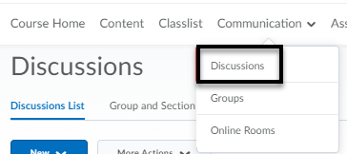

- Click on New and select New Forum from the drop-down menu.
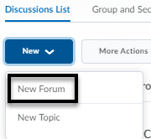
- On the New Forum page, enter the information and settings for the Forum using the Properties Tab (see page 4 for details).

Discussion Forum Properties Tab:
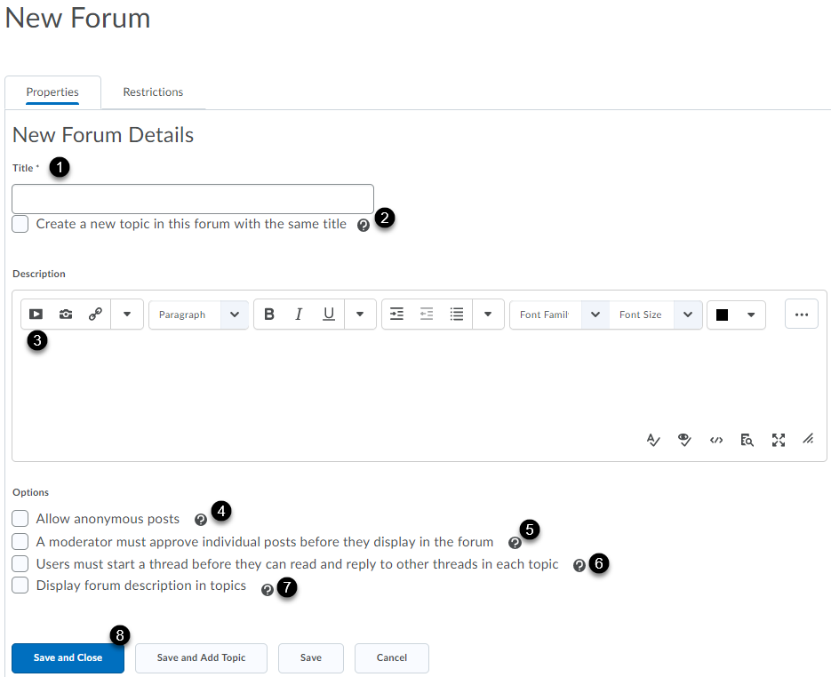
Enter a name for the forum title [1]. Automatically create a topic with the same name as the title [2].
Optional Steps (3-7): Enter a description which will be visible from the Discussions List [3]. Anonymous posts cannot be evaluated [4]. Instructor must approve posts before they are public [5]. For an authentic response, enable Users must start a thread before they can read and reply to other threads in each topic [6]. Adds the forum description in topics [7].
Save and Close (saves and returns to Discussions page), Save and Add Topic (saves and opens New Topic page), Save (saves and user remains on the same page) [8].
- The Restrictions tab allows you to establish Release Conditions for the Forum. A student must complete a task in D2L before having access to the Forum. Under the Group and Section Restrictions you can also decide who in your class has access to this Forum. For example, if you have students working in groups and you want only members of that group working on this Forum to have access to it.
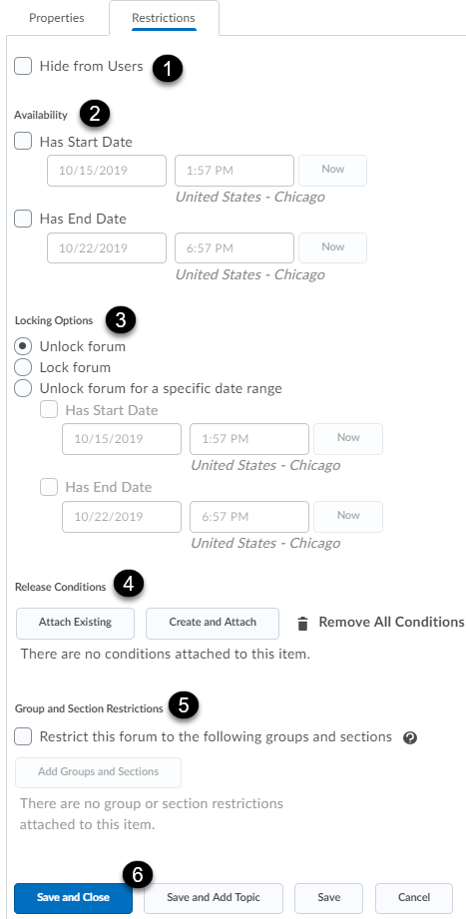
By default, the forum is always visible. However, you can hide the discussion by clicking the Hide from Users checkbox [1]. The availability allows you to hide the forum during a specific time period [2]. Locking option allows you to lock the forum for a specific time period [3]. By default, the forum is always unlocked. Manage release conditions [4]. Give access to specific groups or sections [5]. Save and Close (saves and returns to Discussions page), Save and Add Topic (saves and opens New Topic page), Save (saves and user remains on the same page) [6].

- Save your settings.

Add a Topic via Content Tool

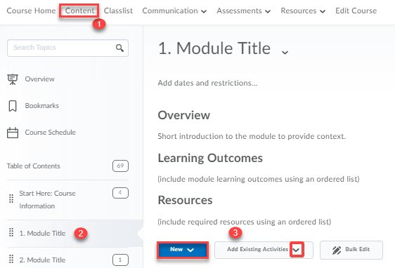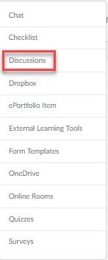

Click on Content in the Main Navigation Bar [1]. Click on the module where you would like to add your discussion Topic [2]. Click on the New button and select New Discussion from the drop-down menu or select Add Existing Activities and select Discussions [3].
If you selected New Discussion, you will be directed to a new page to create the discussion topic and forum. Click on Save.

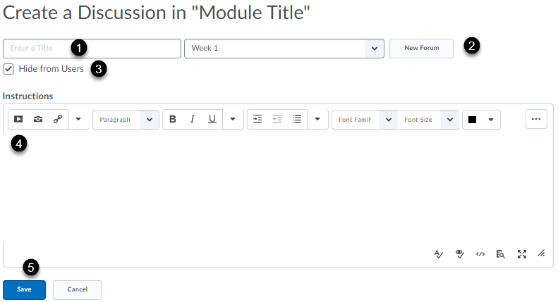

Enter a title for the Discussion [1]. If no forums exist, create a new forum for the topic [2]. Deselect the box if you would like the discussion board visible to students [3]. Enter a discussion prompt and other instructions [4]. Click Save. Dates and restrictions and grade item can then be added under Activity Details.

Editing and Deleting Discussion Forums and Topics

Editing a Discussion Forum or Topic:
- Click on Discussions on the Main Navigation Bar.
- Discussions List opens by default.
- Click on the drop-down menu next to the name of the Forum or the Topic.
- Select Edit Topic or Edit Forum (depending on which one you’re editing).
Edit Topic Edit Forum
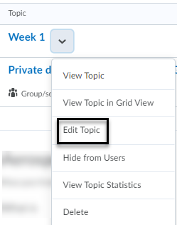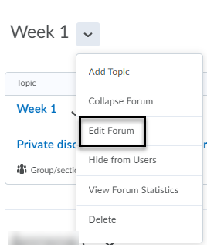
- Once you’re done editing, click on Save and Close.

Deleting a Discussion Forum or Topic:
- Click on Discussions on the Main Navigation Bar.
- Discussions List opens by default.
- Click on the arrow next to the name of the Forum or the Topic.
- Select Delete.
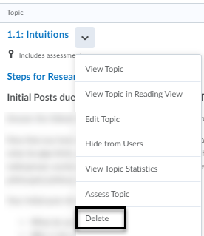

Deleting a Thread
- Click on Discussions on the Main Navigation Bar.
- Discussions List opens by default.
- Click on the Topic where the Thread you want to delete is located.
- Click on the dropdown menu next to the name of the Thread you want to delete.
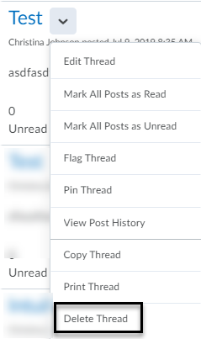
- Select Delete Thread from the dropdown menu.
*Note: When you delete a Thread, the system also deletes any replies to that Thread. The same happens if you delete a Post within a Thread.

Assessing Topics

Assigning an Assessment Method to a Topic
- Click on Discussions on the Main Navigation Bar.
- Discussions List opens by default.
- Click on the arrow next to the name of the Topic and select Edit Topic.
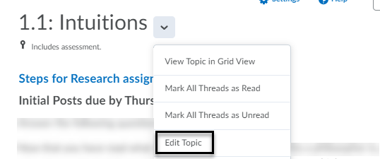
- Click on the Assessment tab on the top of the Edit Topic page.
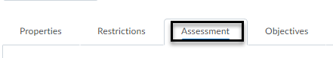
- Select the assessment method you want to use:
  - Associate the discussion Topic with a Grade Item.
  - Assign a score to the Discussion Topic.
  - Add a rubric. (If you decide to use this method, it is not necessary to check Allow assessment of individual posts). Assessing with a rubric will automatically populate the topic score.
  - Various calculation methods are available to assess individual posts (optional):
    - Average post score: Averages all of the post scores included per student.
    - Maximum post score: Identifies the highest score of all the post scores included per student.
    - Minimum post score: Identifies the lowest score of all the post scores included per student.
    - Mode post score - Highest on multiple: Looks at the frequency of scores on posts, then selects the highest occurrence of a score per student. Once it picks the frequency, the system looks to see if multiple scores occur at that frequency. If not, it assigns that score to the user. If there are multiple scores with the same frequency, it will choose the highest of those scores. For example, if a score of 7 occurs 2 times, a score of 8 occurs 3 times, and a score of 9 occurs 3 times, the system will choose the frequency 3 and the score of 9.
    - Mode post score - Lowest on multiple: Looks at the frequency of scores on posts, then selects the highest occurrence of a score per student. Once it picks the frequency, the system looks to see if multiple scores occur at that frequency. If not, it assigns that score to the user. If there are multiple scores with the same frequency, it will choose the lowest of those scores. For example, if a score of 7 occurs 2 times, a score of 8 occurs 3 times, and a score of 9 occurs 3 times, the system will choose the frequency 3 and the score of 8.
    - Sum of post scores – Sums up all the scores on posts within a topic.
    - Include unassessed posts in the calculated topic score as zero – Check this box only if you want unassessed posts included in the topic score.

- Click Save and Close at the bottom of the page.

*Note: When you add an Assessment to a Topic, the option Assess Topic will be added to the dropdown menu.

Steps to Assess a Topic
- Click on Discussions on the Main Navigation Bar.
- Discussions List opens by default.
- Click on the arrow next to the name of the Topic and select Assess Topic.
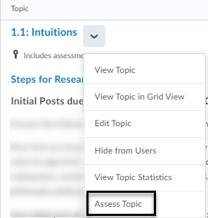
*Note: If you enabled a moderator must approve individual posts, then select Approve Threads before assessing student via Assess Topic.
- Click on Topic Score beneath each user’s name. This opens a window where you can see the student’s posts under that topic (below rubric and general feedback).
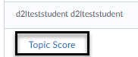
- Assign a score and add any written feedback.

- Check the box next to Publish to export grade automatically to the Gradebook. *Note: The Grade Item must have been created and linked to the Topic already for the Publish option to work.
- Click Save.
*Note: You can choose Publish after scoring each user or you can click on the Publish All Feedback after you’re done scoring all the users. It’s best practice to publish after grading all students.
