D2L Overview
Objectives
- Familiarize yourself with the tools on the main navigation bar
- Create your profile and set up notifications
- Create and delete News Items and modules
- Upload files (e.g. syllabus)

Contents
D2L Overview 1
Getting Started 2
Homepage 2
Pinning a Course 6
Change course image 7
Your Profile: 8
Course Site Overview 9
Creating and Deleting a News Item 11
Creating a News Item 12
Deleting a News Item 14
Notifications 15
Setting Up Email Notifications: 15
Setting Up SMS Notifications: 16
Excluding Courses from Notifications: 17
Adding Content 18
Creating a Module 18
Uploading Documents to a Module 19
Add Existing Activities 20
Deleting Modules 21
Email Classlist 22
Sent Mail 22
Email setup 23

Getting Started
Log into D2L at http://d2l.mu.edu, using your CheckMarq username and password. The D2L homepage will appear to provide access to your course listing and resources. Note: The supported browsers are the latest version of Firefox, Chrome, Safari or Edge. Internet Explorer will no longer be supported starting January 2020.

Homepage

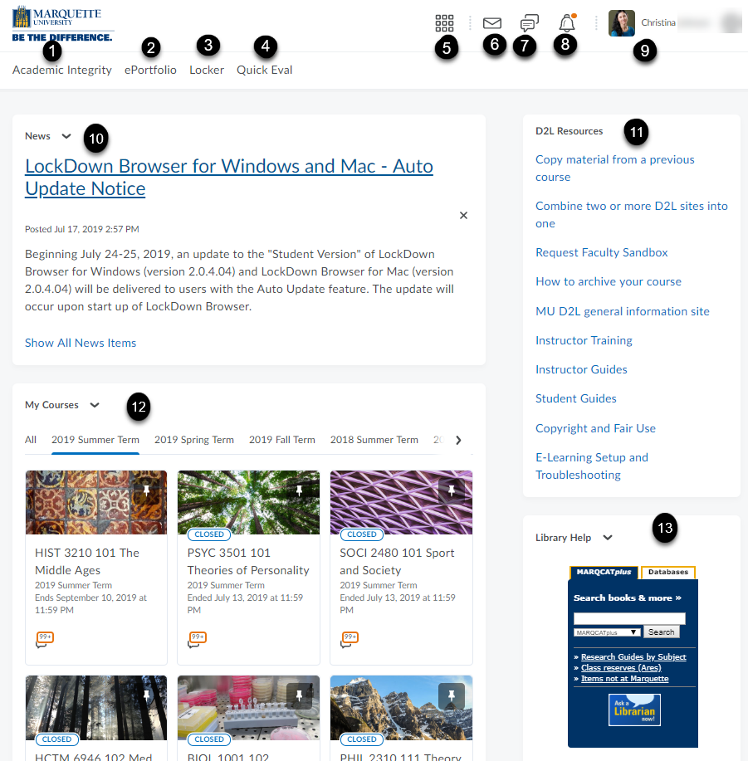
Academic Integrity online tutorial required for new Undergraduate and Graduate students. Law and Dental students are exempt [1].

ePortfolio is a place for students to collect accomplishments and specific artifacts to showcase skills and knowledge acquired. Note: IT will need to create accounts for your students in your class if you choose to allow them to build an ePortfolio [2].

Locker is your own personal (private) storage area. Limited to 70 MB [3].

Quick Eval allows you to access all outstanding assessments for grading [4]. For more details, see the D2L Quick Eval guide.

Course selector or waffle icon is used to select your assigned courses [5].

Read unread emails or texts. View an email sent log. The insert image is only available. (Insert stuff button on the rich text editor toolbar has been removed). [6].

View alerts for subscribed discussion posts [7].

View alerts for announcements, due dates, end dates and grades [8].

Personal menu (profile picture): Edit personal settings which includes Profile, Notifications and Account Settings. If needed, you can change the time zone under Account Settings > Account Settings tab. Under the Email tab, you can change your default email address and set up an e-signature. See page 23 for details [9].

Read announcements regarding updates on D2L tools or other technologies [10].

D2L Resources provides a listing of links to resources such as D2L guides, videos, Library or IT services [11].

My Courses widget lists all courses for each term. Pinning allows the course name to be moved up the list. If you scroll to the bottom of the page, the View All Courses link will display all courses and provide an advanced course search [12].
Library widget is embedded not only on the D2L homepage but in all courses to allow for easy access to Marquette’s library databases and research guides [13].
Searching for Courses

My Courses Widget
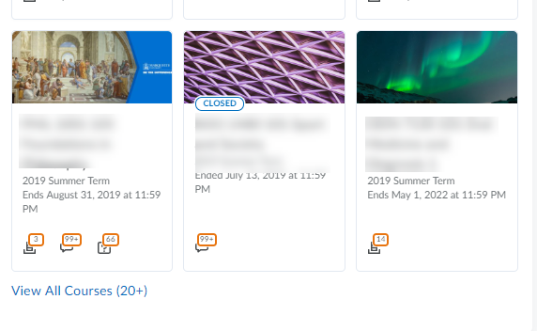

When you click View All Courses, a new window will appear, as shown:

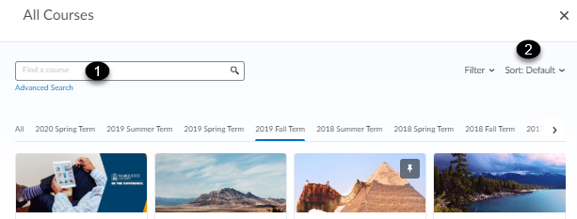

- Find a course allows you to find a specific course with the courses name, number and section.
- Course name allows you to order the appearance of the courses in order of the course name, course code, date pinned or last accessed.

Sort by Course Name
Allows the user to change the order that they will see their courses.

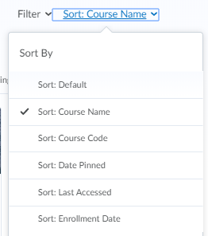

Pinning a Course

Pinning a course allows for the user to see this course on the homepage without the need to search for the course. Hover over the ellipsis to select Pin. The course that is pinned will now appear on the user’s homepage and under the course selector list.
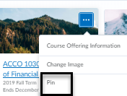

Under the course selector , deselect the pushpin to unpin a course.
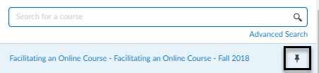

Change course image

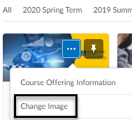

- Hover over the right-hand corner of the present image, click the box with three dots inside (ellipsis) to select Change Image.
- A window will open to give you options to change from a library of images or to upload an image.
  - Enter a general name in the Search box (e.g. outdoors).
    - General pictures will appear to select.
- Select Upload to add a personal computer from your device.

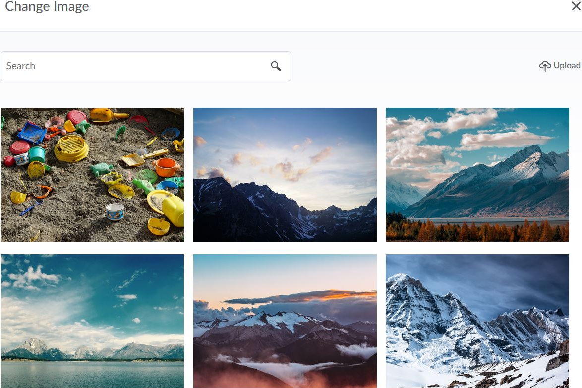
Upload a personal image
Sample images offered
Search for a type of image

Course Navigation
Minibar
Course selector
Return to the D2L Home Page

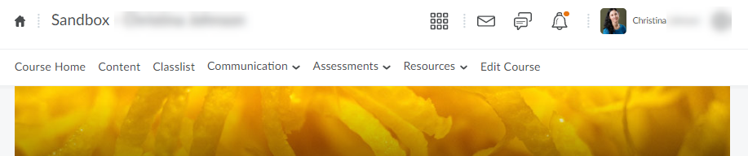
Main Navigation Bar (Navbar)

Your Profile:
- Go to the Minibar on the top right-hand corner of your Course Home Page.
- Click on Profile from the drop-down menu.
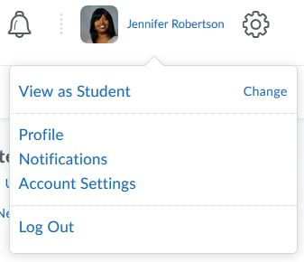
- Edit your information. You can add a profile picture, contact information, links to your webpage or your social network sites.
- Click Save and Close to return to the Course Home Page.
Change: This option allows you to switch your role to student view.
Note: To view someone’s profile, go to Classlist on the Main Navigation Bar and click on the person’s profile picture.

Course Site Overview
- Main Navigation Bar: This is found at the top of the course page. It is always visible. Also known as the Navbar.

- Course Home: This is a space to post messages (with the News item) for your students to see upon logging into D2L. There are other tools found on this page, such as updates, bookmarks, library help, and calendar.
  - News: News is located under the Main Navigation Bar and course image/banner. Any News Item that you create will be displayed in the Course Home. This space allows you to post important updates without having to go through email. You can attach links and videos to a News Item.
  - Calendar: In this area you can add events and view them by date, course, or category (e.g., dropbox assignments, checklists, discussions, etc.). It alerts users to new quizzes, discussion posts, and items in the Dropbox. Any item with a due date entered will populate the calendar.

- Content: The content page is where the course materials should be posted. You can create modules, submodules and topics to organize your content. Use of submodules is discouraged because it adds an additional layer of complexity to finding the content. Modules are like folders; it is a way to group items together. Topics are your links and files for the course found in a module or submodule.

- Classlist: Here you can access your student list and select one, several or all the students to email them.
- Communication (Discussions/Groups/Online Rooms): This space allows for collaboration with the entire class or in small groups. Discussions is asynchronous while online rooms provide for synchronous interaction.

- Assessments (Dropbox/Quizzes/Grades/Rubrics/Surveys/Competencies):

Dropbox: Create digital folders for students to submit work for individual or group assignments. Only the instructor can view the students’ submissions. The Dropbox allows you to grade items and provide written or audio feedback. You can also upload the assignments marked up with your comments or corrections. Files are saved there throughout the semester. Turnitin (plagiarism and grammar checker) can be enabled.
Quizzes: Assess student knowledge of material. These can be high or low stakes quizzes, or a space for students to take practice exams. Both objective and subjective exams can be created in this environment. Lockdown browser can be enabled.
Grades: This feature allows you to keep a running grade book throughout the semester that permits the students to see their individual grades. In addition to a numeric grade, you can also provide timely, formative feedback.

Rubrics: Create holistic and analytic rubrics to attach to assessments so students know specifically how you grade them. This also allows the instructor to provide grading feedback within the rubric.

Surveys: Poll students, whether anonymously or not, and then gather that data to generate a report.

Competencies: Monitor students' completion of competencies and learning objectives within your courses and programs.

- Resources: Other features such as calendar, attendance, locker, are grouped here for those faculty and students.
- Edit Course: This allows you to go behind the scenes of your course and provides access to some of the tools you already find in the Main Navigation Bar. Access Manage Files and Manage Dates to obtain an overall view of the contents and due dates in your course.

Creating and Deleting a News Item

Click on the drop-down menu next to News to see all the options under this item.
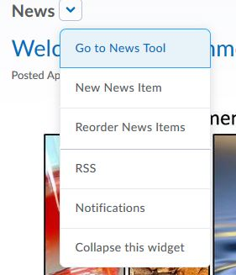
Go to News Tool: Provides a list of all the News Items that you’ve created. You can create, reorder, and delete News Items under this option.
New News Item: Allows you to create a News Item and edit all its settings.
Reorder News Items: Allows you to move News Items up or down the list. Students will see all the active News Items in the same order that they are in your list.
Notifications: Allows you to control how you receive notifications about activity in your course. Notifications can be received via email or SMS.

Creating a News Item

- Click on the drop-down menu next to News and click on New News Item.
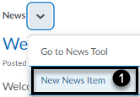
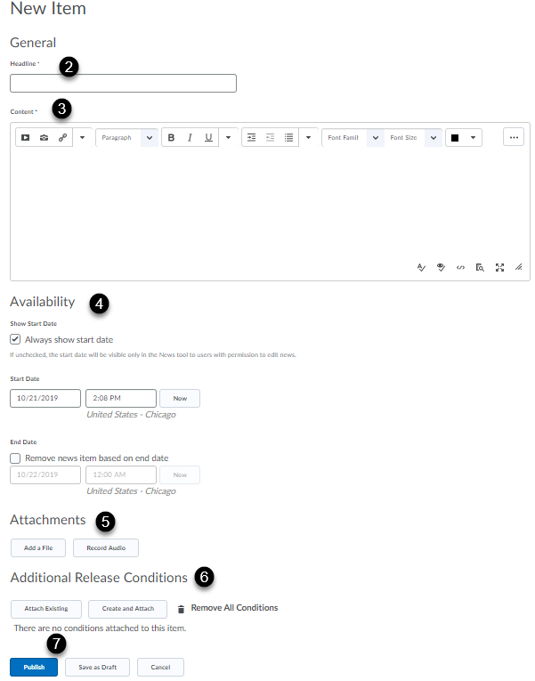

- Type a name for your News Item in the Headline box.
- Type your message in the content box. Use the rich text editor toolbar to edit the content.
- Set up the availability (start and end dates and times).
- Add a file or record audio under Attachments (optional).
- Set up release conditions (optional).
- Publish or Save as Draft.
Rich Text Editor Toolbar:

Insert Button: Allows you to embed videos and media from other sites with their codes, images from Flick, YouTube videos, and upload documents from your courses on D2L and your computer.

Allows you to insert an image.
Allows you to insert a link to a URL and to other content in your course. 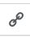
The arrow next to the insert link option will allow you to insert symbols and other letters. You can also insert lines.
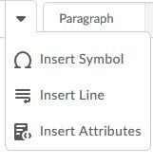
These buttons allow you to edit the font and the paragraph format.
Allows you to insert equations.
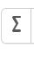
Allows you to insert and edit tables.
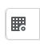
These buttons allow you to cut, copy, and paste text. You also have the options to undo and redo actions.
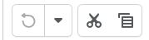
- Once you’re done editing your content, edit the Availability settings found below the content box. Options here let you:
  - Set a start date for the News Item to be visible for students.
  - Set an end date to remove the post from student view.
  - Attach a file or record an audio.
  - Create additional release conditions that hide the News Item from students until they complete something in D2L, such as a quiz or submitting an assignment in the Dropbox.

- Click Publish, Save as draft (News Item isn’t visible for students), or Cancel at the bottom of the page.

Deleting a News Item
- Click on the drop-down menu next to the name of the News Item you want to delete.
- Select Delete.

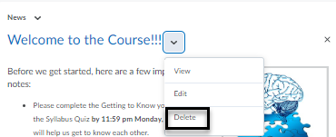

Note: Clicking on the X next to the news item will dismiss it from the Course Home page but will not delete it. Each user must dismiss their own news item. An instructor can set up an end date to remove it for student view.

Notifications
Notifications allows you to control how you receive notifications about activity in your course. You can choose to receive instant notification via your preferred method (email or SMS) or you can choose to receive a summary of activity daily for each of your courses through email. Students can also set up their accounts to receive notifications. (Note: Pulse App is for student use only).
Access the Notifications feature through:
- The News item:
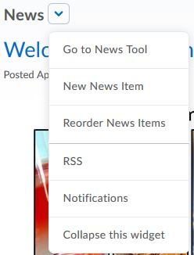

- The personal menu on the Minibar:

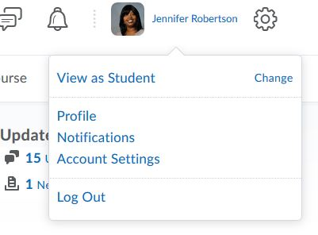

Setting Up Email Notifications:

- Click on Notifications from your personal menu on the Minibar or from the News item.
- Under the Email Address section, click on Change your email settings.
- Select the Use system email OR the Use custom email based on your personal preference.
- Click Save.

Setting Up SMS Notifications:

- Click on Notifications from your personal menu on the Minibar or from the News item.
- Under the Mobile Number section, click on Register your mobile.
- Enter all the required information (country, mobile carrier, and number)
- Click Save.
- After you receive a registration confirmation code on your mobile device, click Confirm your mobile number and enter the code in the Confirmation Code field.
- Click Confirm.
- Select the Instant Notifications you wish to receive via text message by checking the box next to the options.
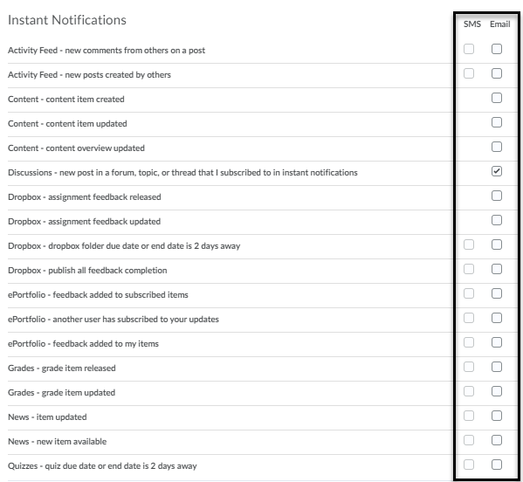
- Click Save.

Excluding Courses from Notifications:
- Click Notifications from your personal menu on the Minibar or the News item.
- Click Manage my course exclusions in the Exclude Some Courses section at the bottom of the page.
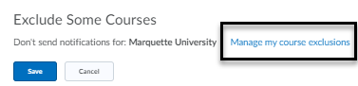
- Click the X next to each course to stop notifications [1]. Click Exclude All Courses [2] to stop all course notifications. Use the search field to find the course you want to exclude [3].
- Click Close and Save.
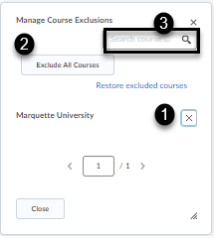

Adding Content

Creating a Module

Modules are like folders into which you can upload or create topics including files, videos, and other D2L content such as checklists, quizzes, and discussions. Topics are items in your module.

- Click on the Content button on the main navigation bar (Navbar).
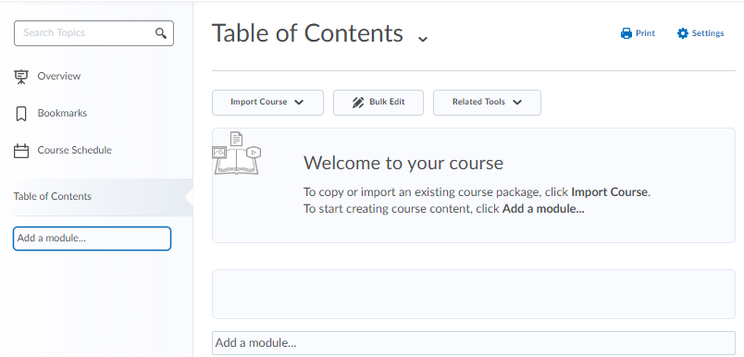
- Click below the table of contents that says Add a Module to enter a name. The module will automatically be visible for students. Click on the eye icon to toggle to hidden (if desired).
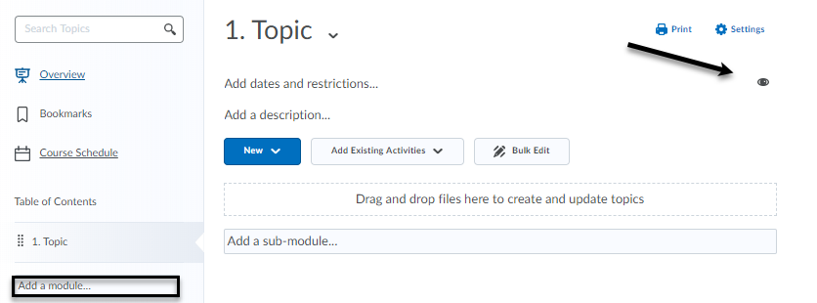

Note: The name of your is like a folder for the students, so the name should be representative of what is in the folder (e.g., Course Documents, Course Information, Readings, etc.).

- To the right you will now see the module where you can add a short description for students and control when the module is visible by adding dates and restrictions. You can also create release conditions so students must complete an activity to have access to this module. This area is where you will add content.

Uploading Documents to a Module

To upload your document, you can do one of two things:
- Drag a file from your computer to the space that says Drag and drop files here and update topics. Your file will now be on D2L. (This functionality will not work in Internet Explorer 9 and older).

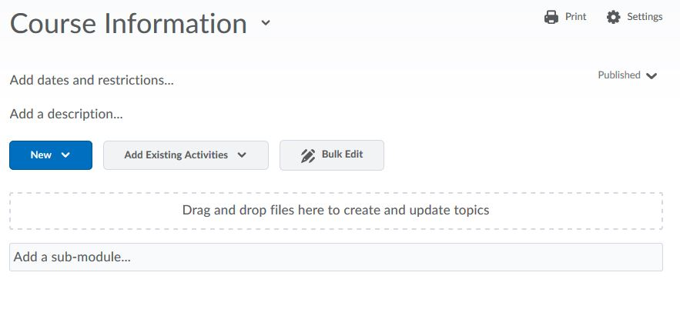

- Upload a file by clicking on the button that says New. Select Upload Files. Again, you can drag the file here or click Upload Files to search your computer or course for the document. Once you’ve selected it, click on Add.
Note: The syllabus is required to be uploaded to D2L for all courses.
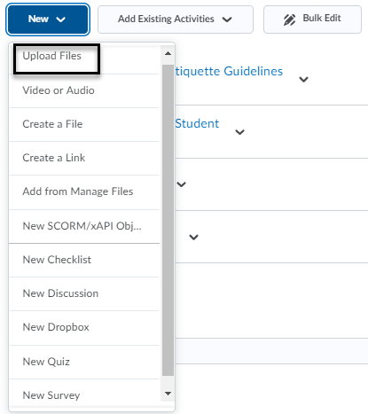

Add Existing Activities

- The activity would need to be created in the tool before inserting into the module. Refer to the D2L dropbox, quizzes, or discussion guide for details.
- Select the activity (e.g. discussion, quiz or discussion) you would like to insert in the module.

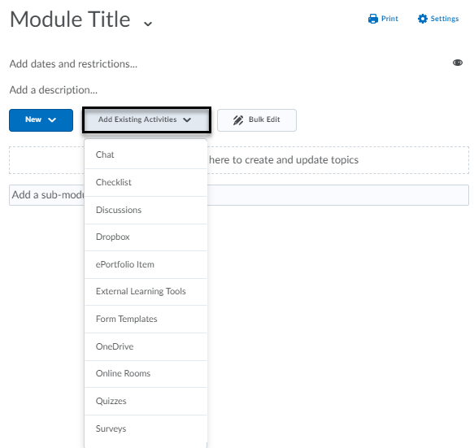

Deleting Modules
Important Note: In this section of the manual, “name of content item” can refer to an entire module, or a component of a module such as discussion, dropbox, quiz, survey, etc.
- Go to the module.
- Click on the drop-down menu next to the name of the content you want to delete.
- Click on Delete “name of content item”.

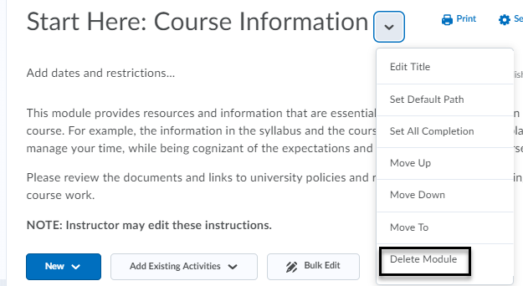

- When you click on Delete, a dialog box will open with two options:
  - Remove the “name of content item” from Content but keep the associated file or activity in the course. This will keep your file on the back-end of your course, but it won’t be visible in the content area.
  - Permanently delete both the “name of content item” from Content and the associated file or activity from the course. This will delete the file in the content area and from the back-end of your course.

Email Classlist

- Select Classlist on the Navbar.
- Click Email Classlist.

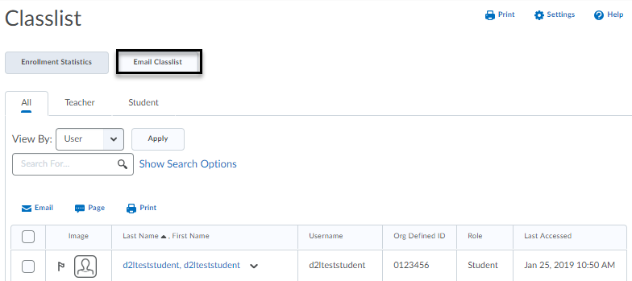
- Click Send Email.
- Add a subject, compose the message, and add any attachments to the email.
- Click Send.

Sent Mail

To view a log of your email messages sent, click the envelope icon to select Email and select Sent Mail.

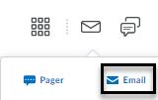

Email setup
If you notice you are not receiving a copy of your outgoing email messages to the Sent Mail folder, please check your email setup in D2L.
- Click your personal menu (profile picture) to select Account Settings.
- Click on the Email tab.
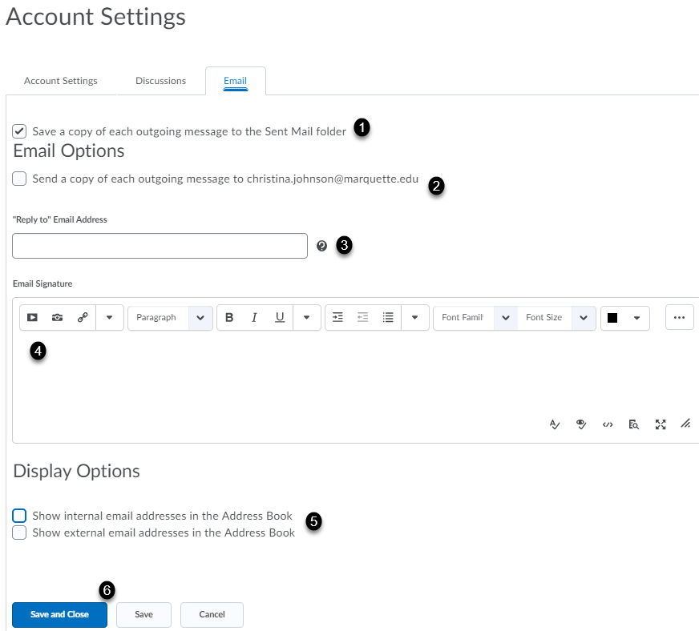
By default, a copy of each outgoing message sent in D2L is saved in the Sent Mail folder [1]. There is an option to send a copy of each message to your Marquette email address [2]. The “Reply to” email address will use the system email (@marquette.edu) if left blank [3]. Add your email signature [4]. Optional to display internal and/or external email addresses in Address Book [5]. Click Save and Close [6].

