Deleting Modules in D2L
Important Note: In this section of the manual, “name of content item” can refer to an entire module, or a component of a module such as discussion, dropbox, quiz, survey, etc.
- Go to the module.
- Click on the drop-down menu next to the name of the content you want to delete.
- Click on Delete “name of content item”.

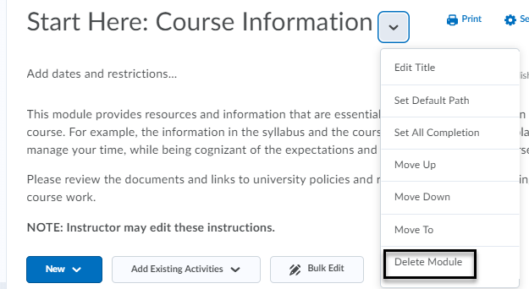

- When you click on Delete, a dialog box will open with two options:
  - Remove the “name of content item” from Content but keep the associated file or activity in the course. This will keep your file on the back-end of your course, but it won’t be visible in the content area.
  - Permanently delete both the “name of content item” from Content and the associated file or activity from the course. This will delete the file in the content area and from the back-end of your course.
- Choose option b to delete the entire module and all the activities within the module.

