CTL FACULTY/INSTRUCTOR DIVERSITY BOOK CLUB
“Women Authors We Should All Read.”

Upcoming Fall 2021 Selections:
September 17, 2021 - October 15, 2021 - November 19, 2021 - December 17, 2021 - January 14, 2022
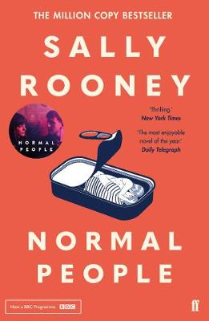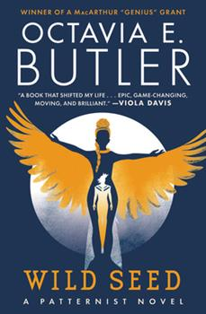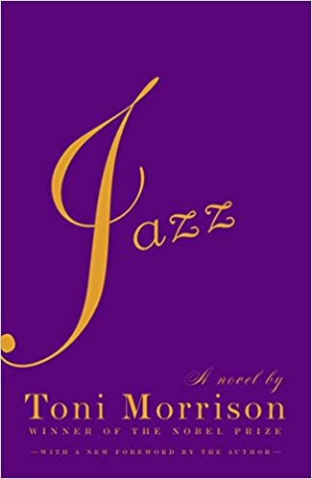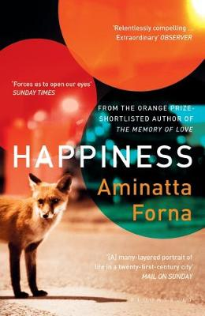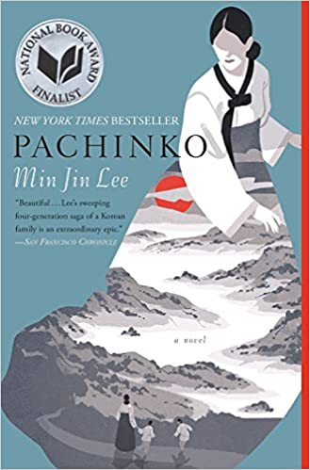

(Each book includes a companion media piece as an added option)

Books will be provided upon request from the CTL. Email to schedule a time to pick up or to provide a mailing address if working remotely.
NOTE: You do not need to attend all of these, you can register individually

Normal People (Sally Rooney)
Connell and Marianne grew up in the same small town, but the similarities end there. At school, Connell is popular and well liked, while Marianne is a loner. But when the two strike up a conversation—awkward but electrifying—something life changing begins.
A year later, they’re both studying at Trinity College in Dublin. Marianne has found her feet in a new social world while Connell hangs at the sidelines, shy and uncertain. Throughout their years at university, Marianne and Connell circle one another, straying toward other people and possibilities but always magnetically, irresistibly drawn back together. And as she veers into self-destruction and he begins to search for meaning elsewhere, each must confront how far they are willing to go to save the other.

Backward to Go Forward (YouTube, free)

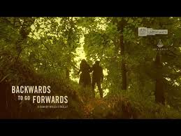

Wild Seed (Octavia Butler)

For a thousand years, Doro has cultivated a small African village, carefully breeding its people in search of seemingly unattainable perfection. He survives through the centuries by stealing the bodies of others, a technique he has so thoroughly mastered that nothing on Earth can kill him. But when a gang of New World slavers destroys his village, ruining his grand experiment, Doro is forced to go west and begin anew. He meets Anyanwu, a centuries-old woman whose means of immortality are as kind as his are cruel. She is a shapeshifter, capable of healing with a kiss, and she recognizes Doro as a tyrant. Though many humans have tried to kill them, these two demi-gods have never before met a rival. Now they begin a struggle that will last centuries and permanently alter the nature of humanity.

Every Galaxy Needs More than Three People of Color (podcast)
Jazz (Toni Morrison)

In the winter of 1926, when everybody everywhere sees nothing but good things ahead, Joe Trace, middle-aged door-to-door salesman of Cleopatra beauty products, shoots his teenage lover to death. At the funeral, Joe’s wife, Violet, attacks the girl’s corpse. This passionate, profound story of love and obsession brings us back and forth in time, as a narrative is assembled from the emotions, hopes, fears, and deep realities of black urban life.

The Piano Lesson (YouTube, free)

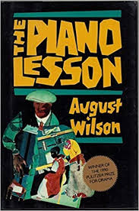

Happiness (Aminata Forna)

London, 2014. A fox makes its way across Waterloo Bridge. The distraction causes two pedestrians to collide—Jean, an American studying the habits of urban foxes, and Attila, a Ghanaian psychiatrist. Attila has arrived in London with two tasks: to deliver a keynote speech on trauma, and to contact a friend’s daughter Ama, his “niece” who hasn’t called home in a while. Ama has been swept up in an immigration crackdown, and now her young son Tano is missing.
Jean offers to help Attila by mobilizing her network volunteer fox spotters. Soon, rubbish men, security guards, hotel doormen, traffic wardens—mainly West African immigrants who work the myriad streets of London—come together to help. As the search for Tano continues, a deepening friendship between Attila and Jean unfolds. Attila’s time in London causes him to question his own ideas about trauma, the values of the society he finds himself in, and a personal grief of his own.

The Black Girl (Prime video $3.99)

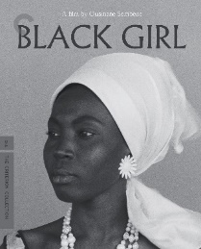

Pachinko (Min Jin Lee)
In the early 1900s, teenaged Sunja, the adored daughter of a crippled fisherman, falls for a wealthy stranger at the seashore near her home in Korea. He promises her the world, but when she discovers she is pregnant--and that her lover is married--she refuses to be bought. Instead, she accepts an offer of marriage from a gentle, sickly minister passing through on his way to Japan. But her decision to abandon her home, and to reject her son's powerful father, sets off a dramatic saga that will echo down through the generations.
Richly told and profoundly moving, Pachinko is a story of love, sacrifice, ambition, and loyalty. From bustling street markets to the halls of Japan's finest universities to the pachinko parlors of the criminal underworld, Lee's complex and passionate characters--strong, stubborn women, devoted sisters and sons, fathers shaken by moral crisis--survive and thrive against the indifferent arc of history.

IL Mare (Prime, free)

