Importing Grades from SharePoint to D2L

Objective:

Move grades from SharePoint into D2L

Follow these steps to import your grades for optically scanned tests from SharePoint into D2L.
When an optically scanned test has been scored, the scores are automatically posted to a SharePoint site. After the site has been created, you receive an email notification with a link to the SharePoint location where the scoring files are stored.

(If you lose this web address, you can email the IT Services Help Desk, to request it again: helpdesk@marquette.edu)

- Click on the link to open the SharePoint web page, and then open the
Shared Documents folder.
- Double-click on the file to open it. It will have a similar name to the one shown below, Scores_1450_ACCO_2030_0101_001

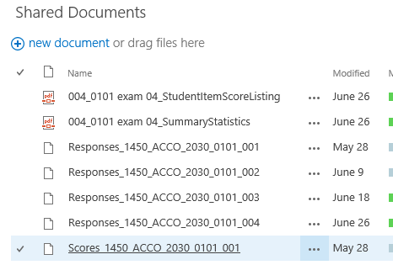

- When you click on it to open it, a dialog box below will open up at the bottom of your browsing window, asking if you want to open or save the file. Click on “Save”, and select the “Save as” option. Save the file to your Desktop or in MyDocuments.
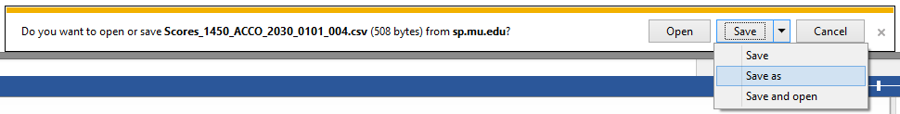

- After you have saved the file, locate it on your computer and open it. The file has a .csv extension and opens like an Excel file.

IMPORTANT
You need to check that the enrollment for the class on the CSV file exactly matches the enrollment for the class in D2L where you want to insert the grades.

If there is a student on the CSV file who is no longer a member of the D2L list
- delete that row in the CSV file:
Click on the row heading to select the row, right-click and click on Delete. (Or use the Delete icon on the Home Tab on the Ribbon)

If there is a student on the D2L list whose name has been added and they are not listed on the CSV file
-insert a row and add their name exactly as it appears in your D2L grade book.
Click on the row heading to select the entire row, right-click and click on Insert. (Or use the Insert icon on the Home Tab on the Ribbon)
Type in the name of the student exactly as it appears in your D2L grade book.

Click on Save to save the changes you have made to the CSV file.

- Check again that the list of student names in D2L matches exactly the ones you have in saved scores file (.csv).
- Open D2L and click on Grades. Then click on Import.
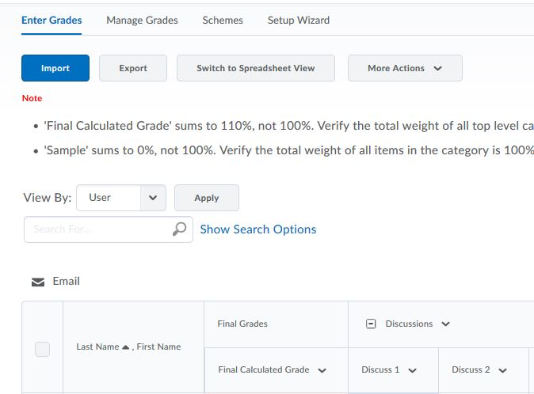
**Please note the Grade Item in D2L (shown above) must have the same name as the test name in the CSV file. This is very important, as the grades will not import if the grade item and test name do not match.**
- For example, the csv file is titled “Scores_1450_ACCO_2030_0101_001”. The grade item in D2L must be match this exactly.

- Click on the Browse button and find the .csv file that was recently saved.
- For example from the .csv file example above, I would want to find the file “Scores_1450_ACCO_2030_0101_001.csv”

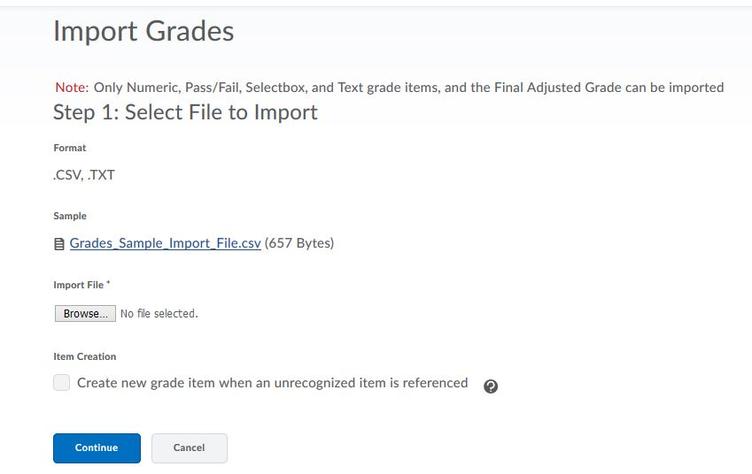
- After finding the correct file, click on the Continue button.

- Click on Grades at the top of the D2L page to view the scores that have been inserted in your Grade book.

