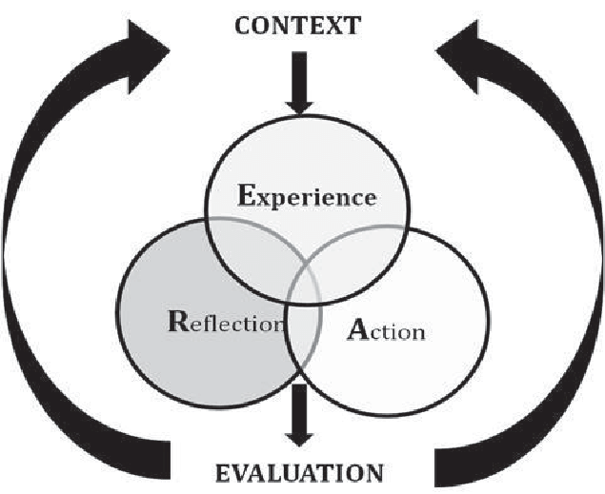

I Teach at a Jesuit University…
So What?
Ignatian Pedagogy and Inclusive Classrooms

Faculty Dialogue Seminar Spring 2019

Session Length (8 sessions, 1 ½ hour).
Purpose (deep understanding of Ignatian pedagogy tenants):
- Context: Historical context and foundations of the Ignatian pedagogy paradigm value.
- Experience: Designing programs and courses that authentically incorporate the IP Paradigm
- Action: Ignatian Pedagogy values by meaningfully serving the community.
- Reflection: Connection to a community of colleagues who are knowledgeable about the IP Paradigm and dialogue opportunities to improve classroom practice and student engagement.
- Evaluation: Using IPP to ensure inclusivity in classroom practice that moves forward social justice identity of a Jesuit university and the value of all students regardless of positionality (cura personalis).

Learning Objectives
- Differentiate the elements of Ignatian pedagogy and synthesize them to provide collective meaning within your own classroom practice.
- Articulate practical ways in which Ignatian pedagogy and inclusivity could manifest in your classroom.
- Identify strategies to form individual relationships with students that could lead to equitable and just classrooms where every voice counts.
To register, email Jennifer.maney@marquette.edu
Sessions: 4:00 – 5:30 p.m. with snacks served.
Dates are 1/31, 2/14, 2/26, 3/7, 3/21, 4/4, 4/25, 5/2*
(Campus location TBD)
*Certificate of completion provided with 6 of 8 sessions attended.

