How to Create a Narrated PowerPoint on MAC

- Open your PowerPoint presentation.
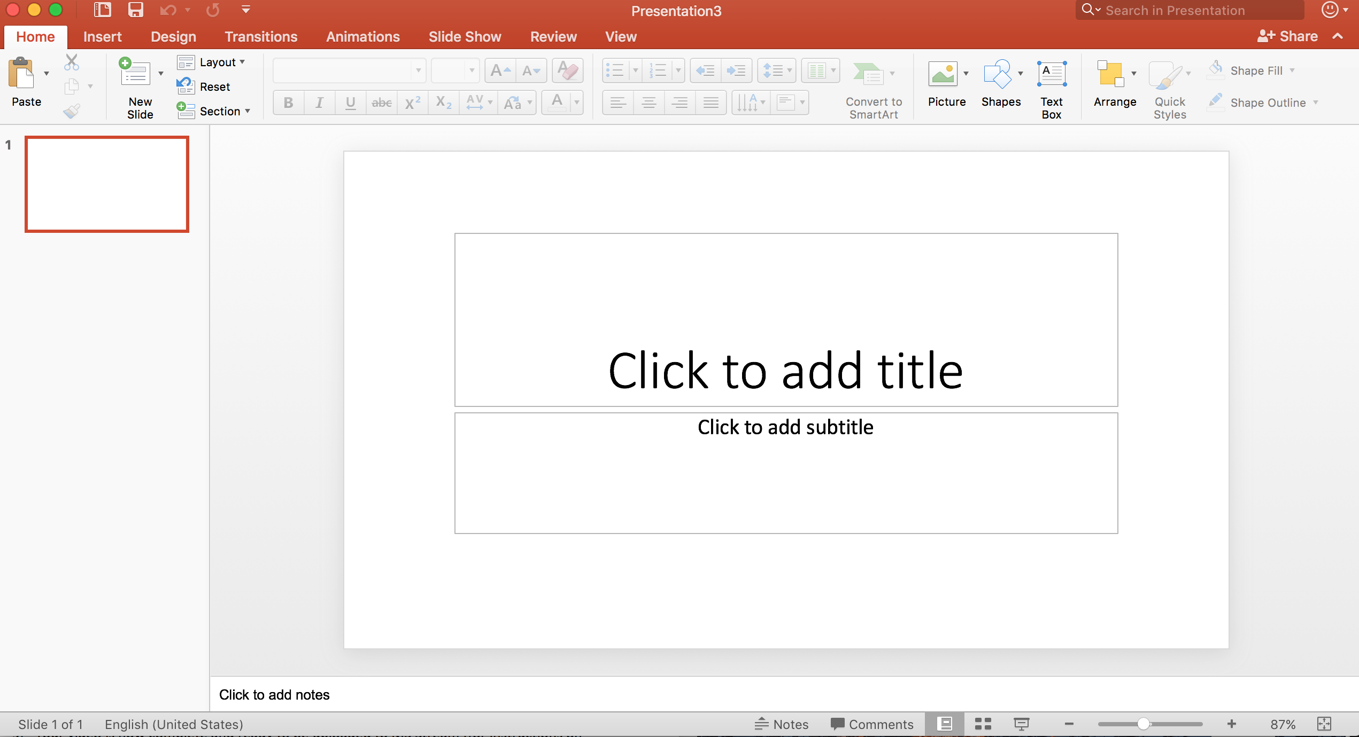

- Go to SLIDE SHOW and then RECORD SLIDE SHOW.
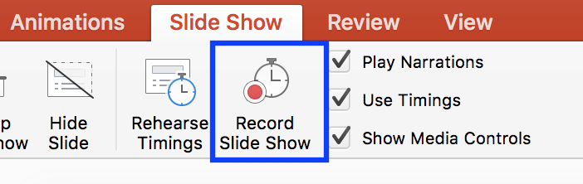

- This will automatically start recording your slideshow and voiceover so do not click that button until you are ready to go. Feel free to give yourself a breath and then start diving into your topic. As you navigate between slides remember to give yourself a breath between each so that the audio does not cut out any words (this can be an issue when recording in PowerPoint).
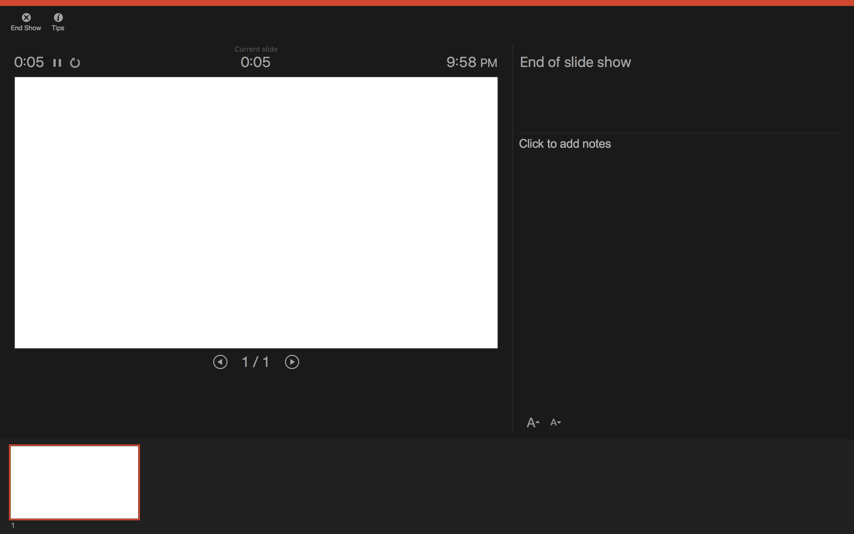
- When you are done click END SHOW and then it will ask you to save your timings. You will select YES.
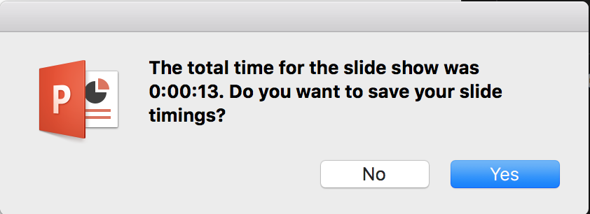

- Navigate back to your normal view and you can now see in the corner of each of your slides is an AUDIO SYMBOL showing that there is an audio recording on each of those slides.
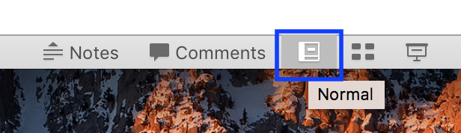

- To export this as an MP4 video you will go to FILE then EXPORT.
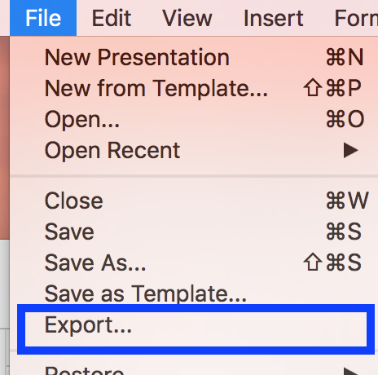

- A menu will show up for you to do so. You will name your video file as well as where you want it stored on your computer. Then the MOST IMPORTANT change you will make is under FILE FORMAT. You will change this to MP4 and then select EXPORT.
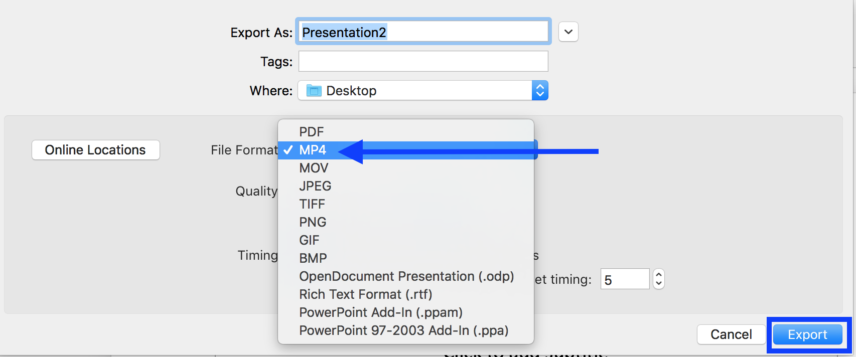

- On the bottom of the PowerPoint you can see the progress of your video exporting.

- Your video is now complete and ready to be uploaded to MS Stream (for instructions on that process please look at the “How to Upload Your Videos to Microsoft Stream” document).
- One Final Note: What if I want to redo a slides voice recording? This can be done in the same way you record the PowerPoint but you should remember to select the slide you want to record and then go into the Record Slide Show option. You can then redo that slide but know that if you move to the next slide it will REWRITE that one as well. So, please stop when you are done with what you want to cover.

Attached here are some Best Practices Tips when recording videos (some options vary):
- Make sure your laptop setting have the camera and microphone enabled
- Turn off notifications on your laptop, otherwise it will show up in the video
- Record in a quiet room and avoid outside interruptions
- When ON CAMERA:
  - Use a room with adequate lighting- don't film in front of a bright window and make sure your face is lit up (so no filming in an extremely dark room)
  - Keep your clothing in mind- be careful of what words or phrases that may be on your clothing
  - Check the room- make sure there is no inappropriate content in the background

