How to Create a Narrated PowerPoint on PC

- Open your PowerPoint presentation that you want to do narration on.

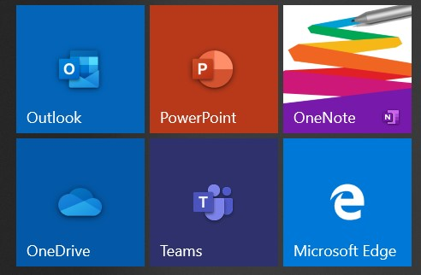

- Go to SLIDE SHOW and then RECORD SLIDE SHOW

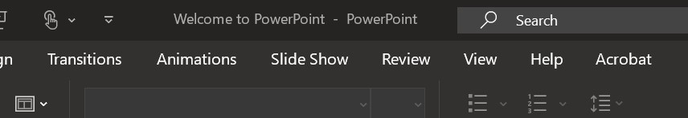

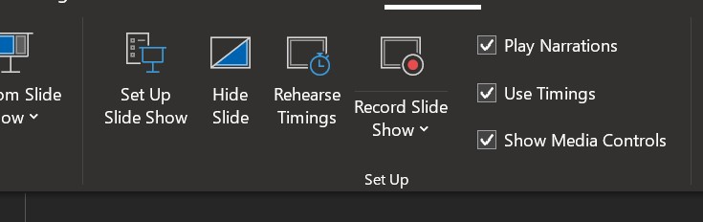

- The following screen will appear

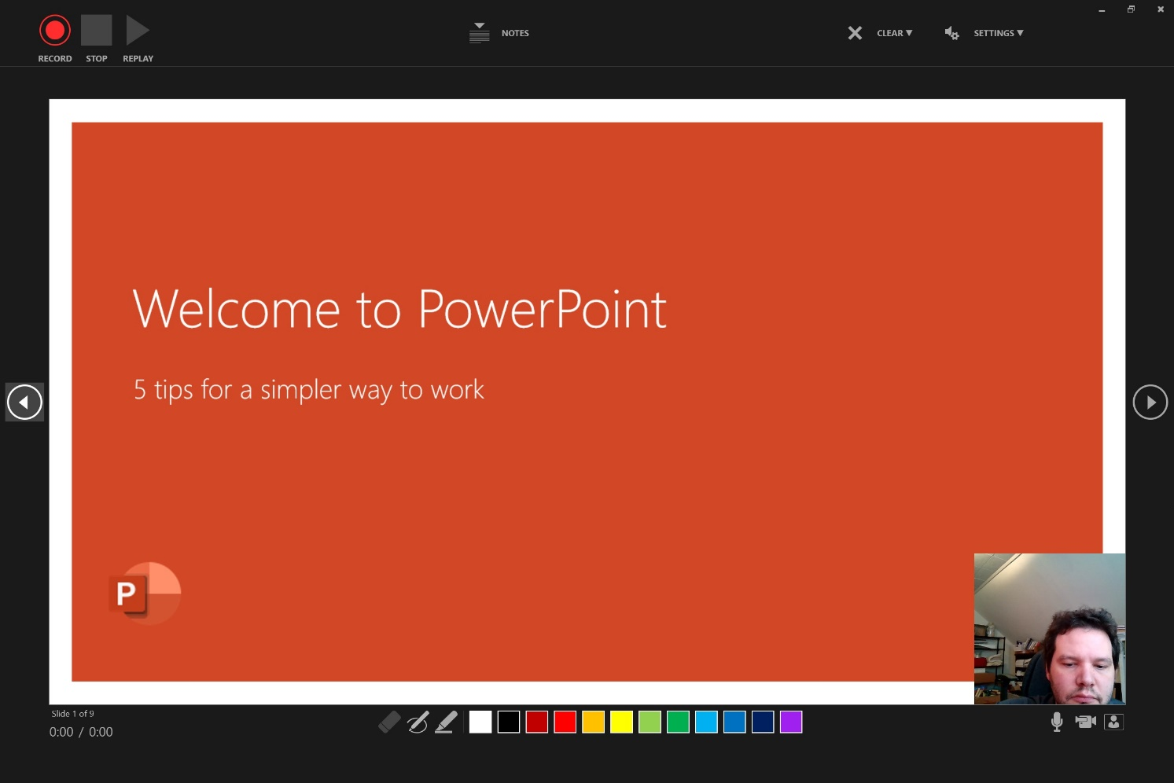

- You can make sure that your MICROPHONE is on by seeing that it doesn’t have a slash through it. You can also turn off the camera option if you do not want it to record video of you as well.

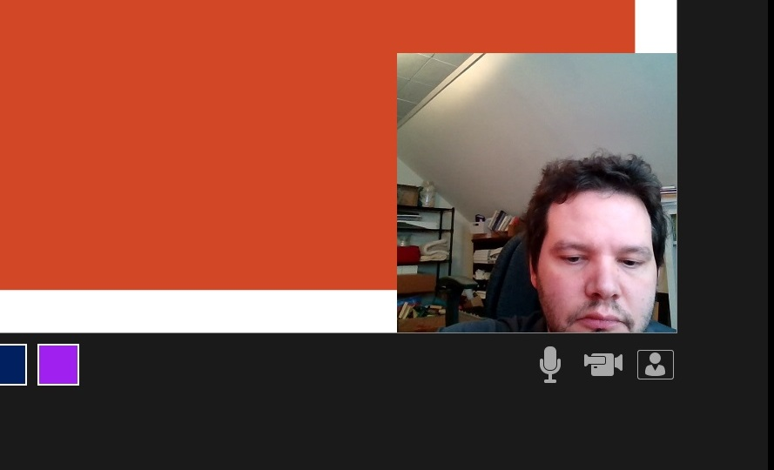

- To begin recording click the RECORD button in the upper left hand corner. It will then count down 3 seconds and begin your recording.

- You can navigate through your slides but remember to give yourself a breath in between transitioning to a new slide.
- If you wish to PAUSE your recording you can do so by selecting the PAUSE button in the upper left hand corner and then starting again when you are ready to resume recording.
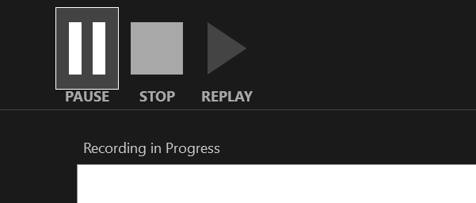

- When you are done recording then click the STOP button and then close out of this view. You will be directed back to the editing version of PowerPoint.

- In the corner of each of your slides is an AUDIO SYMBOL showing that there is an audio recording on each of those slides. If you record video with your PowerPoint it will appear in the lower right hand corner.
- If you need to just rerecord one slide you can choose just to re-record one slide

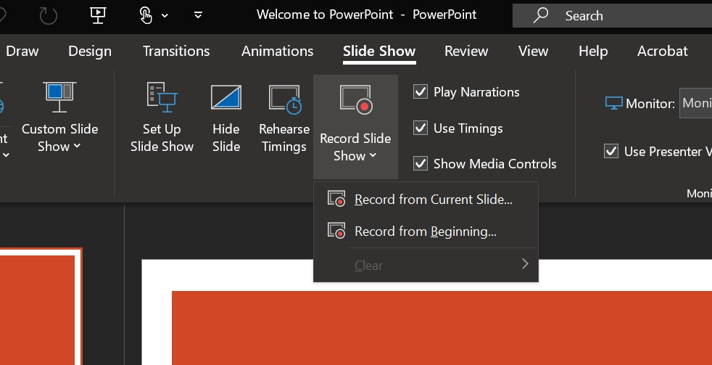

- Now that you’re done you can save this as a VIDEO in MP4 format you go to FILE then EXPORT then CREATE VIDEO and then you select the CREATE VIDEO button again and choose where to save it.

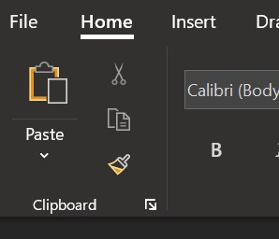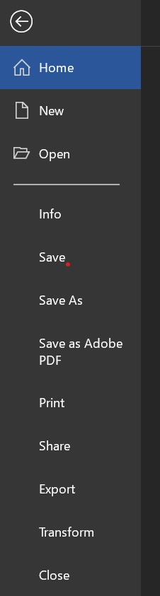

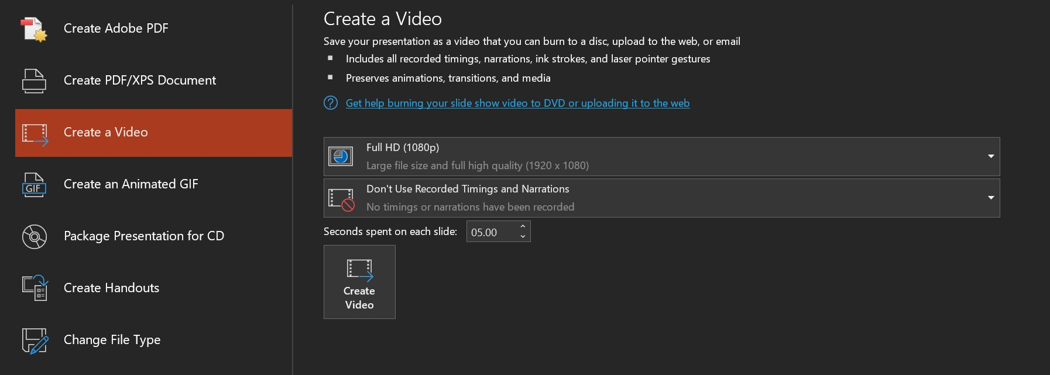

- On the bottom of the PowerPoint you can see the progress of your video exporting.

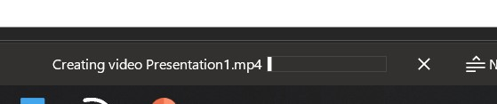

- Your video is now complete and ready to be uploaded to MS Stream (for instructions on that process please look at the “How to Upload Your Videos to Microsoft Stream” document).

Attached here are some Best Practices Tips when recording videos (some options vary):
- Make sure your laptop setting have the camera and microphone enabled
- Turn off notifications on your laptop, otherwise it will show up in the video
- Record in a quiet room and avoid outside interruptions
- When ON CAMERA:
  - Use a room with adequate lighting- don't film in front of a bright window and make sure your face is lit up (so no filming in an extremely dark room)
  - Keep your clothing in mind- be careful of what words or phrases that may be on your clothing
  - Check the room- make sure there is no inappropriate content in the background
- Try and keep your videos to UNDER 20 MINUTES as this will save on processing time and be easier for you to export and upload these files to Stream. If your content takes longer than that then consider splitting up your presentations into a few parts.

