D2L Online Rooms – Instructor Use

Objectives:
  - List reasons for creating a live session (video conference).
  - Create an online room to collaborate with students.
Reasons to Create an Online Room:
- Offer virtual office hours.
- Conduct private tutoring sessions (individual or group).
- Provide mini-lectures.
- Hold a Question-and-Answer session.
To Create an Online Room:
- Click Accounts tab and select New Personal Account.
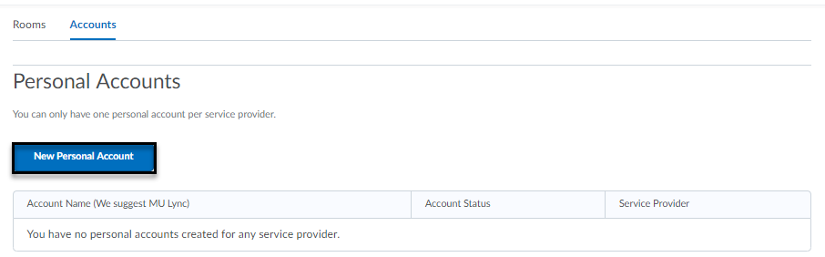
Select Lync Service Provider and enter Account Name (MU Lync) and eMarq/Outlook username and password. Note: username ends in @marqnet

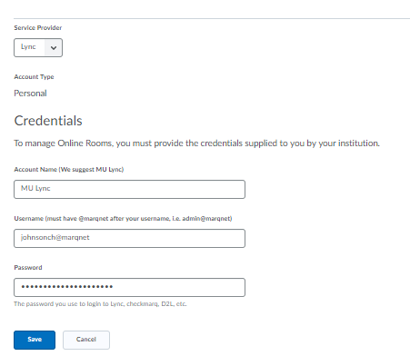
- After the account has been set up, click Rooms tab to select New Room.

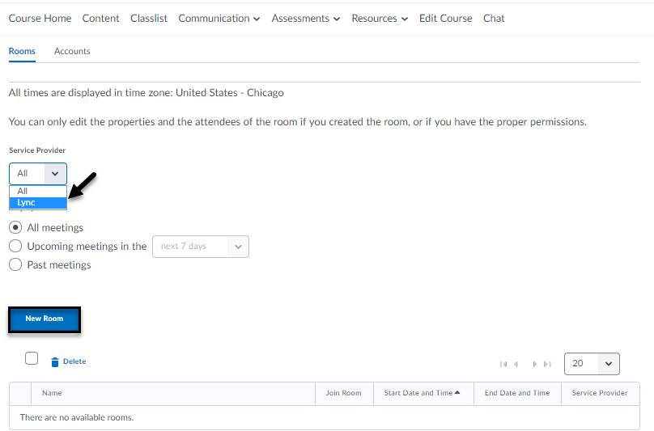

- Enter the New Room details. A room name is required [1]. Select Lync as Service Provider [2]. Select MU Lync for Account name [3]. A description of the online room is optional [4]. Choose whether you would prefer a private session created with a group of students or provide access to everyone in the course site [5]. Enter a start and end time it is visible [6]. If you would like to send an email notification to students, then click the checkbox [7]. Add attendees [8] and then click Save or Save and Join [9].

Note: If you click Show Advanced Properties, you can control who enters the meeting and see who enters and leaves a meeting with announcements enabled.

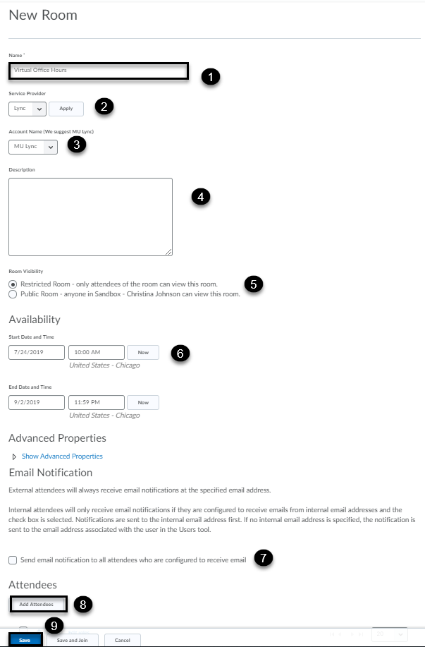
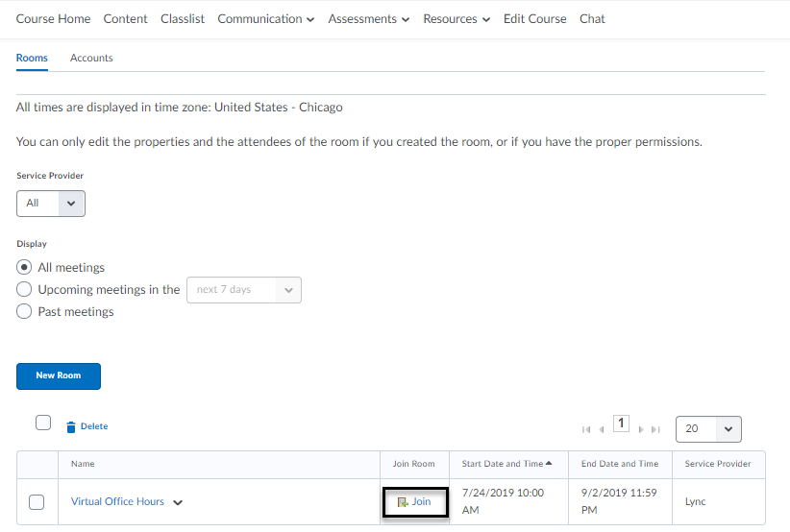
To Join:
- On the main navigation bar of your course site, click Communication > Online Rooms (a). Your students will receive an Outlook email with a session link (b).

a) 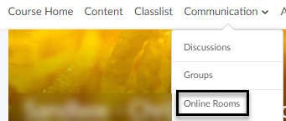

b) 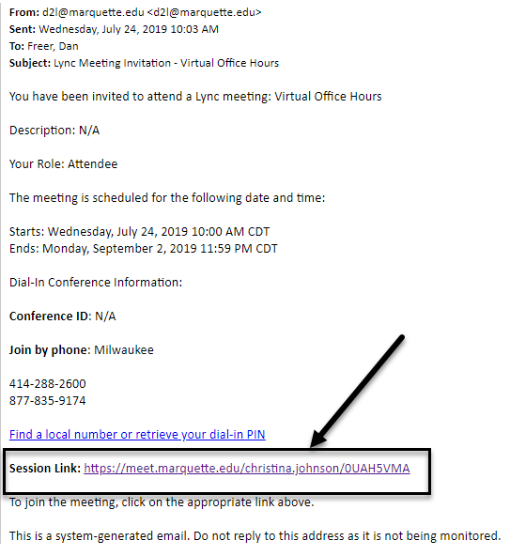

- Click Join.
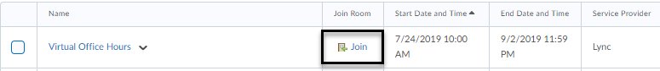

- Select Open Skype for Business. You may need to install and join with either Skype Meetings App (web) or join with Skype for Business (desktop). For further information on how to use Skype for Business, please click here.

