THURSDAY AFTERNOON RECORD CLUB
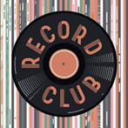

Music can be an effective pedagogical tool for student engagement and learning. Thursday Afternoon Record Club combines the intellectual atmosphere of a book club with the exciting and influential world of music. Created out of a pandemic as a respite for music lovers to gather to talk about music, we will explore important albums both past and present and the album’s significance on cultural, political, and artistic fronts. Attendees are encouraged to listen to the album before the session to provide for thoughtful dialogue. Brought to you by the Center for Teaching & Learning. Questions?
Contact Jennifer.maney@marquete.edu

SPECIAL 9/11 EDITION
September 16, 2021

Bruce Springsteen,
The Rising

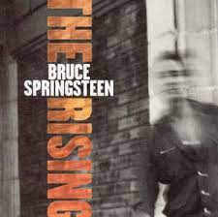

October 21, 2021

Santana,
Abraxas

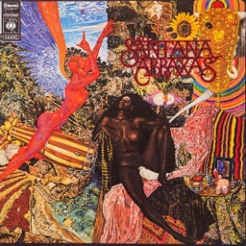

November 18, 2021

TLC,
Crazy, Sexy, Cool

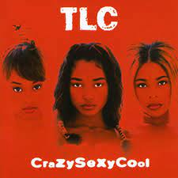

December 16, 2021

Gil Scott Heron,
Pieces of a Man

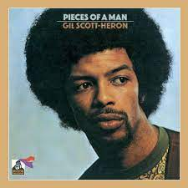

January 20, 2022

Carole King,
Tapestry

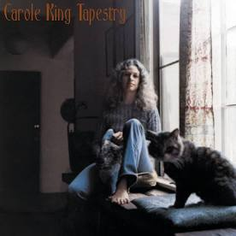

February 17, 2022

Queen,
A Night at the Opera

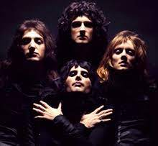

March 17, 2022

Amy Winehouse,
Back to Black

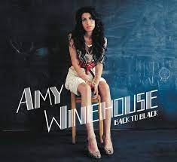

April 21, 2022

Nina Simone, At the Village Gate
May 19, 2022

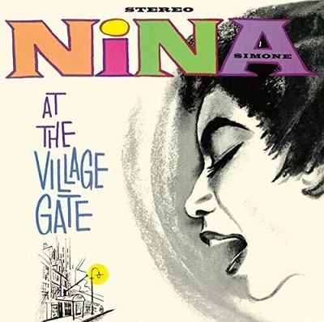

May 19, 2022
Prince, Purple Rain

