How to Record a Video using the Camera App on PC

- In the search bar type in CAMERA and the Camera App option will appear.

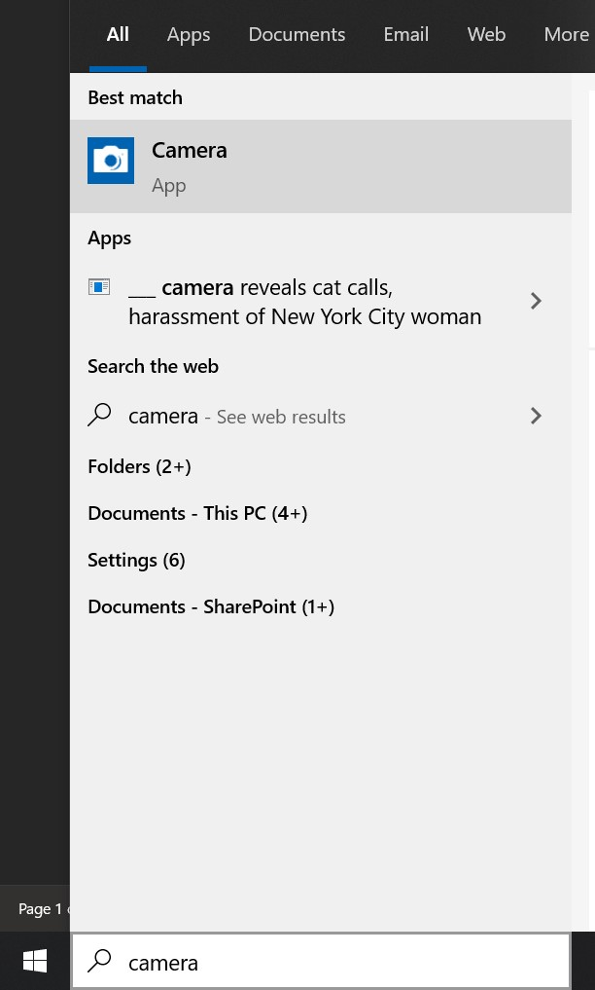

- Open this application and you will see yourself on the screen. It defaults to take a photo so you must change it to video mode by selecting the video camera button in the top to change.
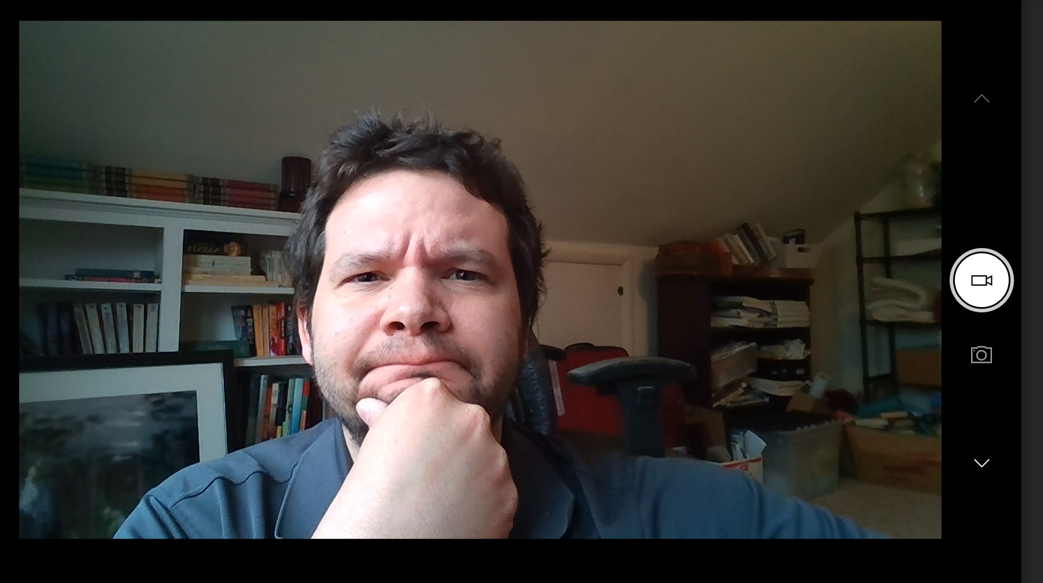

- Now that icon is inside the recording circle and you can click that button to start recording.

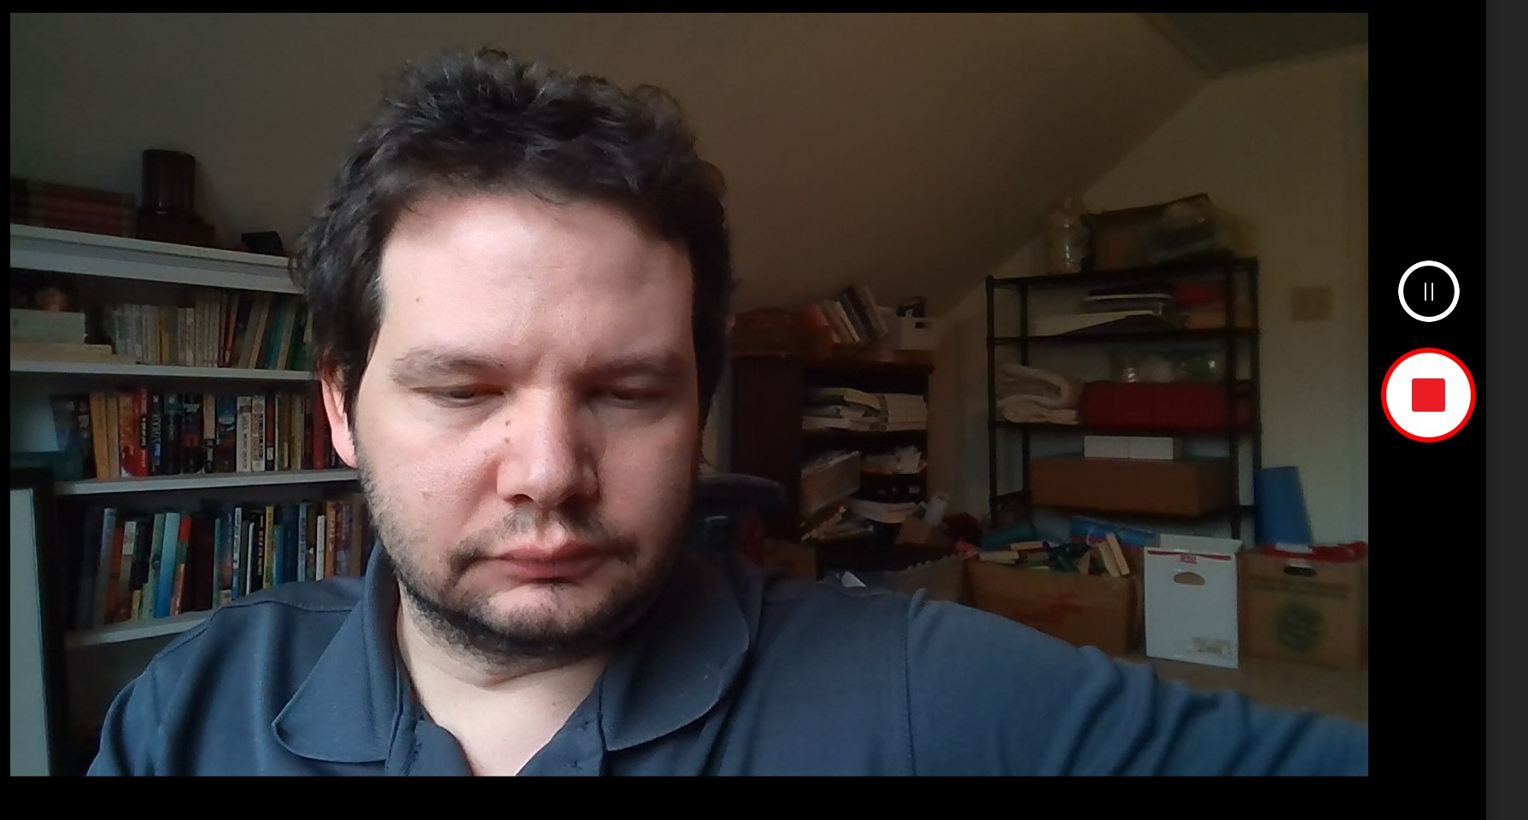

- When you’re done click that same button to STOP the recording.
- To navigate to where this video is located you must go to your file folder and go to PICTURES then CAMERA ROLL. There you will see your video located. If you’re wondering why it’s set up like this- the reason is that its supposed to model how a cellphone stores images and videos in one location.

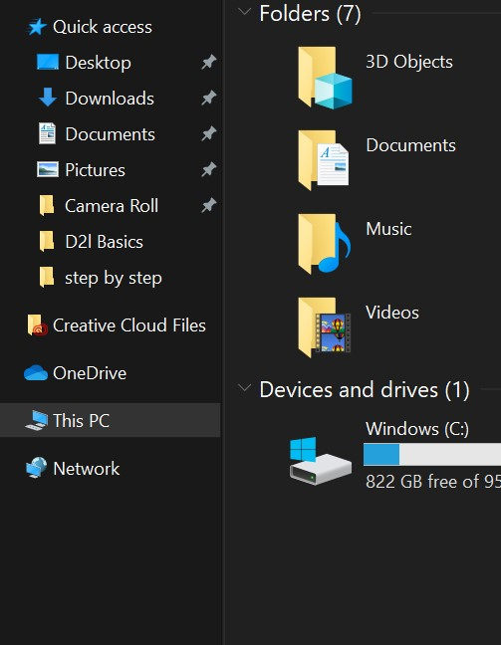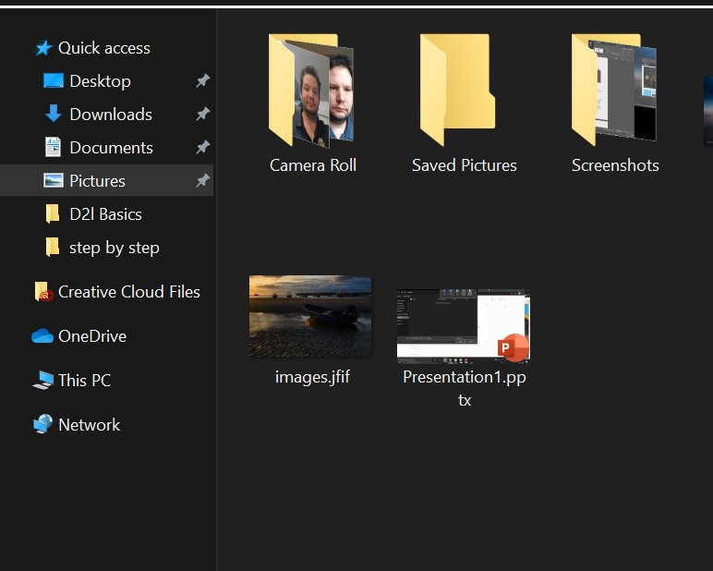

- Your video is now complete and ready to be uploaded to MS Stream (for instructions on that process please look at the “How to Upload Your Videos to Microsoft Stream” document).

Attached here are some Media Best Practices when recording videos (some options vary):
- Make sure your laptop setting have the camera and microphone enabled
- Turn off notifications on your laptop, otherwise it will show up in the video
- Record in a quiet room and avoid outside interruptions
- When ON CAMERA:
  - Use a room with adequate lighting- don't film in front of a bright window and make sure your face is lit up (so no filming in an extremely dark room)
  - Keep your clothing in mind- be careful of what words or phrases that may be on your clothing
  - Check the room- make sure there is no inappropriate content in the background
- Try and keep your videos to UNDER 20 MINUTES as this will save on processing and upload time when you’re creating the videos as well as when you add them to Stream. If your content takes longer than that then consider splitting up your presentations into a few parts.

