How to Create a Screen Recording with PowerPoint on PC

- Open a new PowerPoint presentation.

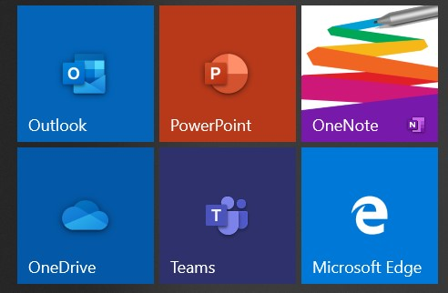

- Go to INSERT and then SCREEN RECORDING

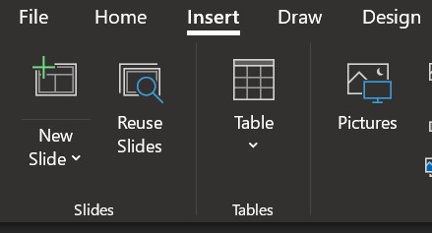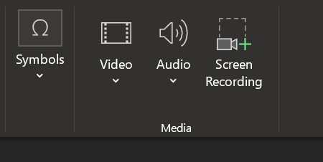

- A rectangle will appear at the top of the screen. You want to make sure that your pointer and microphone symbol are highlighted in a light grey which tells you that they are on.

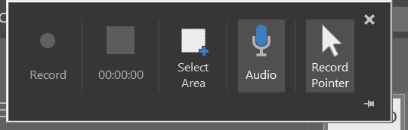

- Next you will click SELECT AREA and drag your cursor over what part of your screen you wish to record (we recommend doing the full screen to ensure nothing gets cut out).

- Once that is done then you can click RECORD and when you’re done with your video click STOP.
- Your video will appear on the slide you were on when you first opened the PowerPoint.

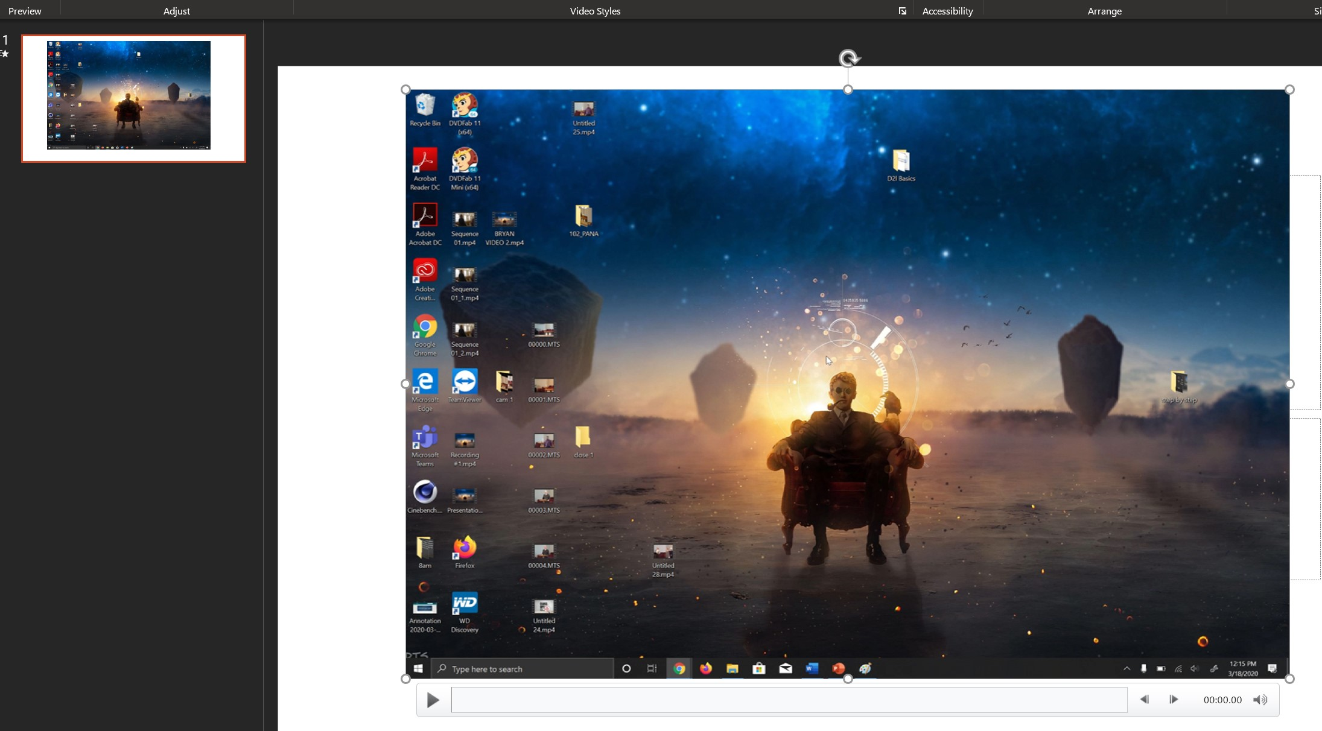

- To save this as a VIDEO in MP4 format you go to FILE then EXPORT then CREATE VIDEO and then you select the CREATE VIDEO button again and choose where to save it.

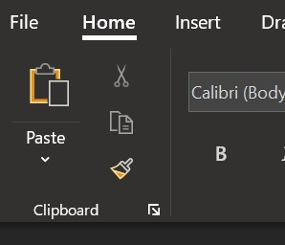
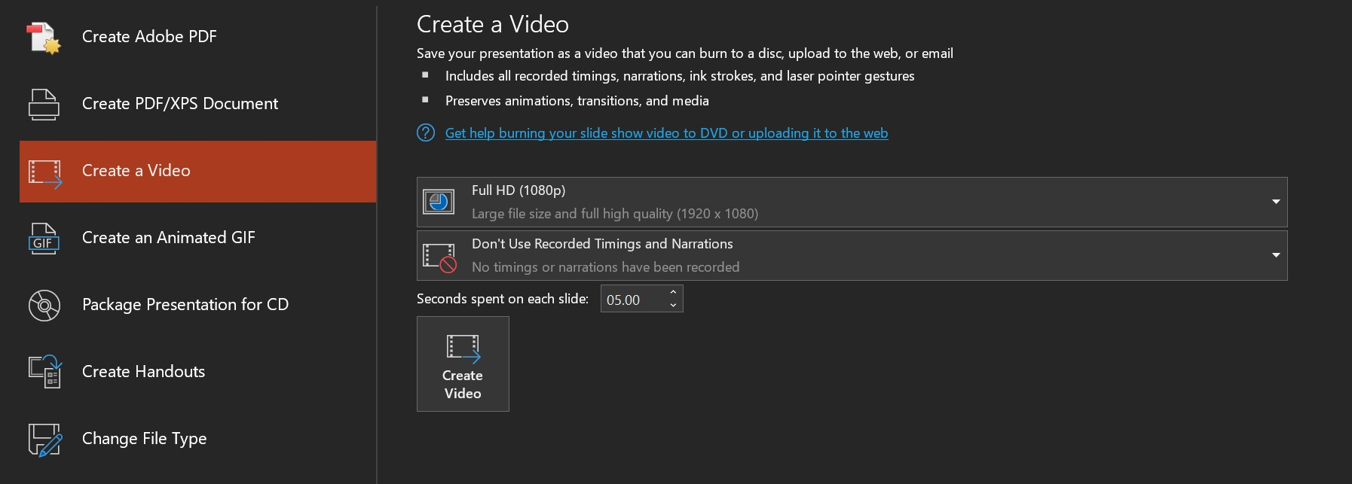

- On the bottom of the PowerPoint you can see the progress of your video exporting.

- Your video is now complete and ready to be uploaded to MS Stream (for instructions on that process please look at the “How to Upload Your Videos to Microsoft Stream” document).

Attached here are some Best Practices Tips when recording videos (some options vary):
- Make sure your laptop setting have the camera and microphone enabled
- Turn off notifications on your laptop, otherwise it will show up in the video
- Record in a quiet room and avoid outside interruptions
- When ON CAMERA:
  - Use a room with adequate lighting- don't film in front of a bright window and make sure your face is lit up (so no filming in an extremely dark room)
  - Keep your clothing in mind- be careful of what words or phrases that may be on your clothing
  - Check the room- make sure there is no inappropriate content in the background
- Try and keep your videos to UNDER 20 MINUTES as this will save on processing and upload time when you’re creating the videos as well as when you add them to Stream. If your content takes longer than that then consider splitting up your presentations into a few parts.

