How to Do a Screen Recording with QuickTime Player on MAC

- Open QuickTime Player by searching for it in your task bar on the upper right hand side.
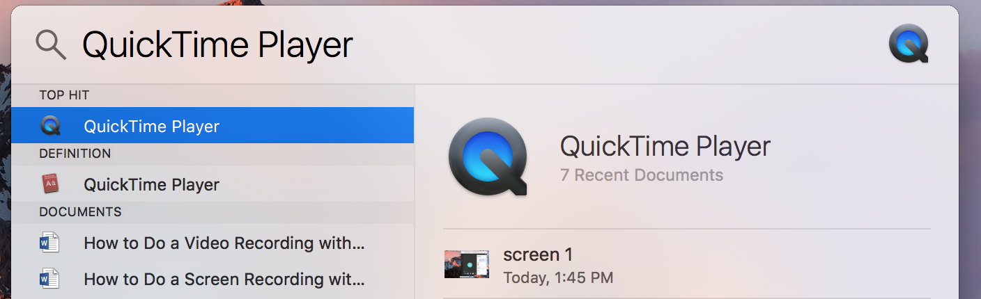

- On the left hand side of your task bar it shows that QuickTime is open with the following tabs listed (QuickTime Player, File, Edit, View, Window, and Help)

- Go to FILE then select NEW SCREEN RECORDING.
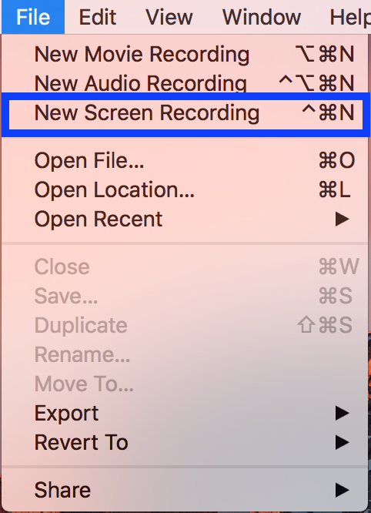

- A grey rectangle will pop up with a Record button (circle with red dot in the center) and a small arrow next to that button.
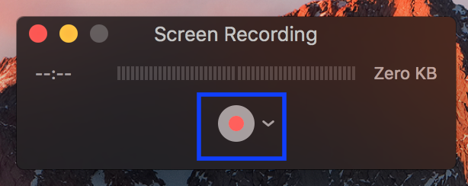

- To start click that arrow to make sure your Microphone is enabled to record your voice. You can click the internal microphone or if you have your own enable that one.
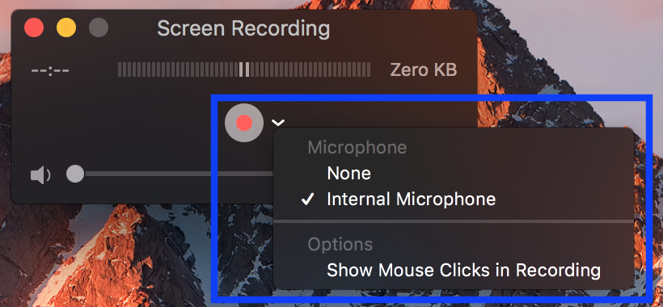

- Then click record and it will prompt you to select what part of the screen you would like to record.

- For this tutorial we are going to record the entire screen to ensure we don’t miss anything. Then we are going to click the START RECORDING button that pops up once we select our area. 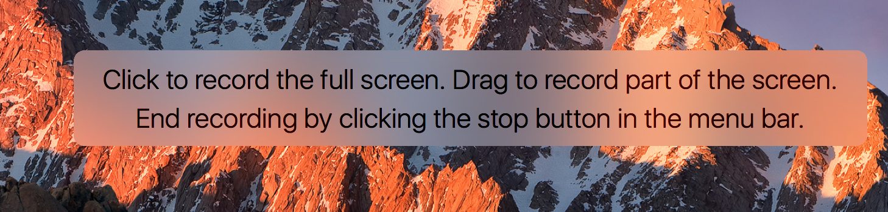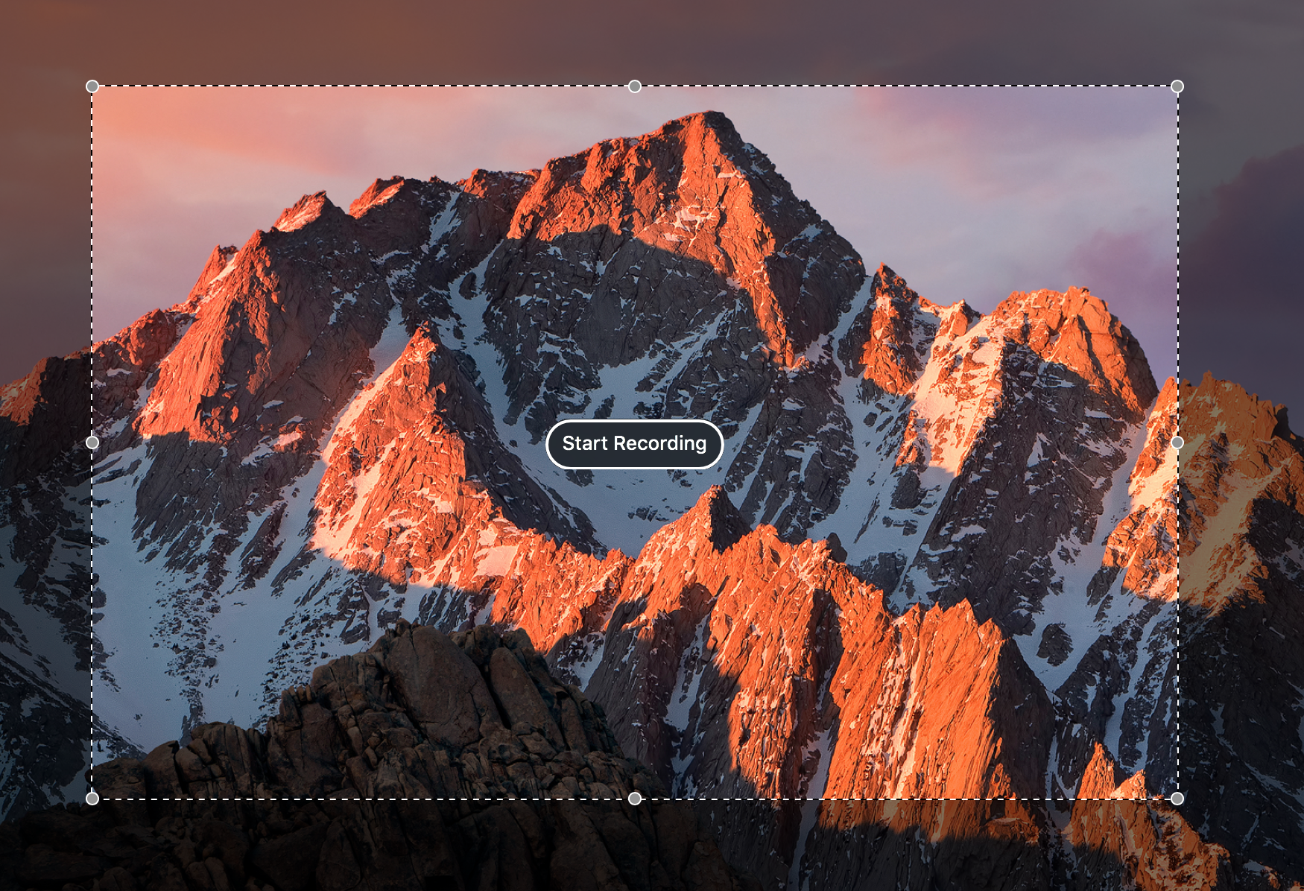

- You can record as needed and once completed you will go up to the task bar in the top right hand corner and click the STOP button (this is shown as a square inside of a circle).

- Your video has now shown up and you can look through it before you save it. 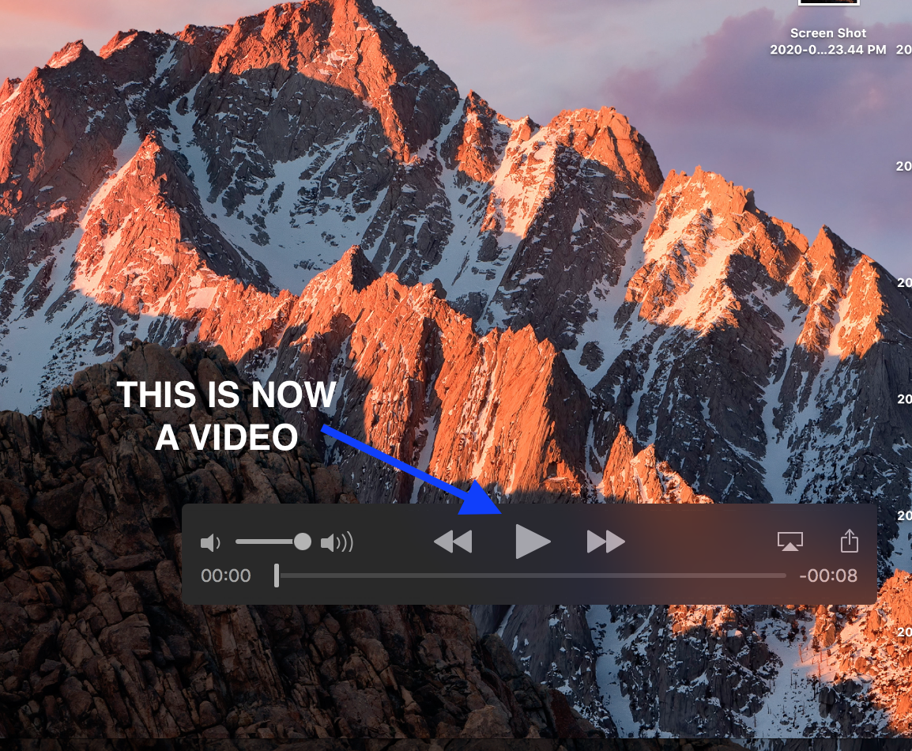

- To save it you will click the red X in the left corner and then it will prompt you on how to save it. 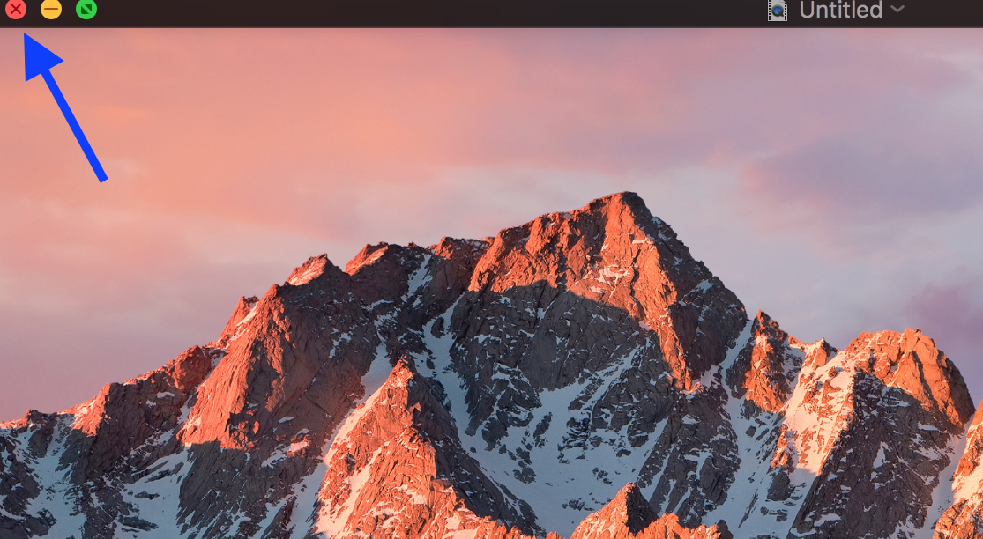

- Be sure to title the file and choose where you want it to be stored. Once that is done then you can click SAVE and it will save it as a video file. 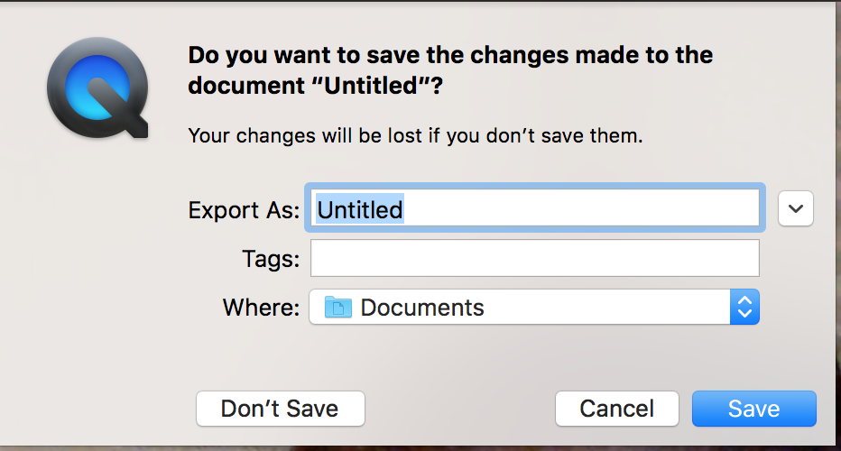

- Your video is now complete and ready to be uploaded to MS Stream (for instructions on that process please look at the “How to Upload Your Videos to Microsoft Stream” document).

Attached here are some Media Best Practices when recording videos (some options vary):
- Make sure your laptop setting have the camera and microphone enabled
- Turn off notifications on your laptop, otherwise it will show up in the video
- Record in a quiet room and avoid outside interruptions
- When ON CAMERA:
  - Use a room with adequate lighting- don't film in front of a bright window and make sure your face is lit up (so no filming in an extremely dark room)
  - Keep your clothing in mind- be careful of what words or phrases that may be on your clothing
  - Check the room- make sure there is no inappropriate content in the background

