How to Do a Screen Recording with QuickTime Player on MAC

Overview:
This guide is aimed at MAC users and covers the steps needed to do a Screen Recording using QuickTime, an app on all MACs.

Instructions:
- Open QuickTime Player by searching for it in the search task bar on the upper right-hand side of the computer.

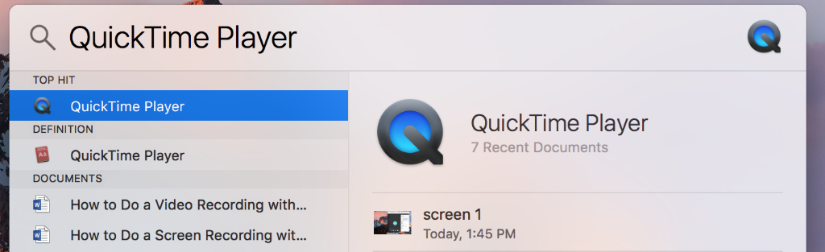

- On the left-hand side of the taskbar next to the Apple logo it shows that QuickTime is open with the following tabs listed- QuickTime Player, File, Edit, View, Window, and Help.

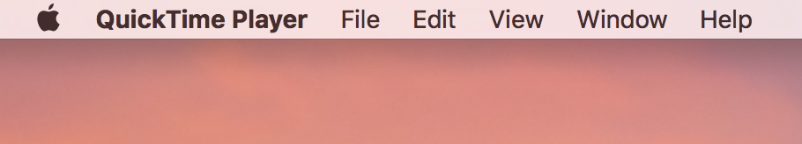

- In the taskbar select File then in the drop-down menu select New Screen Recording.

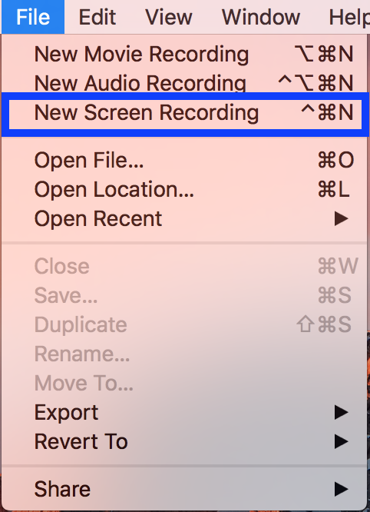

- A grey rectangle will pop up with a Record button in the center (a circle with red dot in the middle) and a small drop-down arrow next to that button.

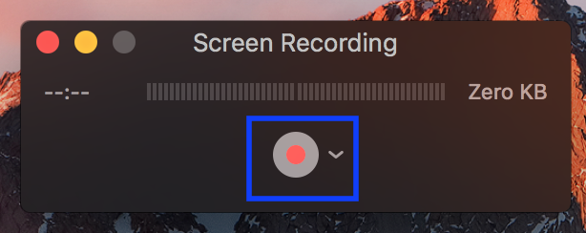

- First, click the arrow next to the record button so a drop-down menu appears. In this menu you will make sure your Microphone is enabled to record your voice. You can click the internal microphone or if you have your own enable that one instead (all options will show up under the Microphone list).

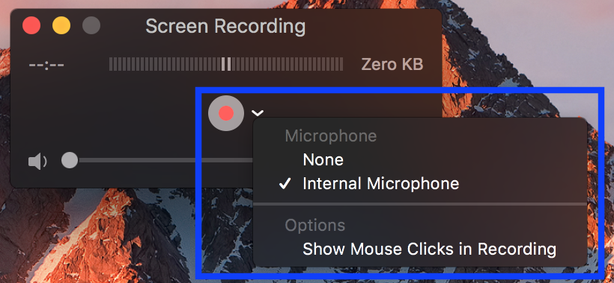

- Then select the Record button and you will be prompted to select what part of the screen you would like to record.
- In the center of the screen there will be a message that reads "Click to record the full screen. Drag to record part of the screen. End recording by clicking the stop button in the menu bar." You will either record your entire screen or indicate which area you want to record.

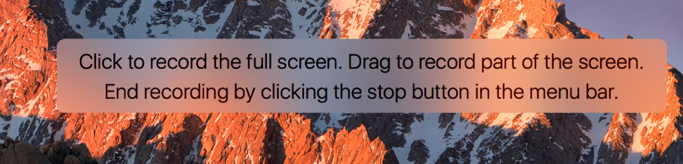

- Once the area you want to record is selected, click the Start Recording button that will appear in the center of the screen.

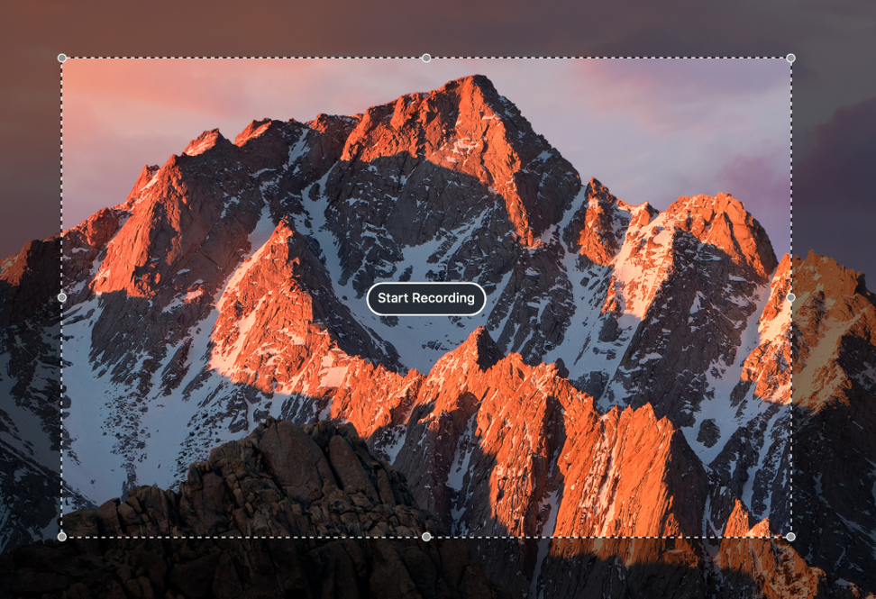

- You can record as needed and once completed you will go up to the task bar in the upper right-hand corner of the computer screen and click the Stop button (this is shown as a square inside of a circle).

- The recorded video will open in a new window with a taskbar on the bottom that has a play button and a time marker bar.

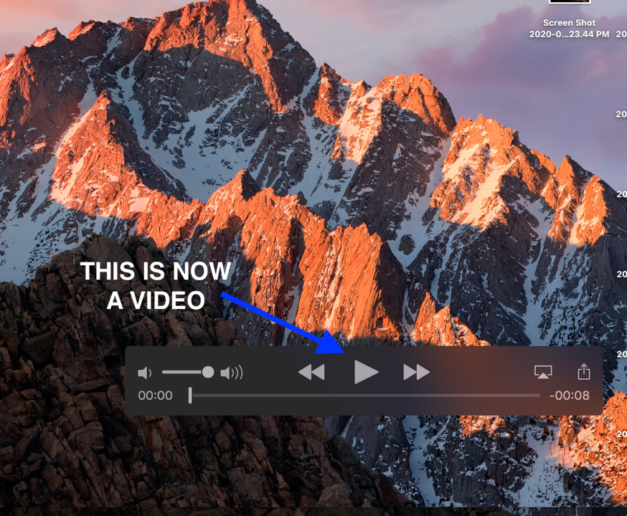

- To save the video, you will click the red X in the upper left corner of the video which will then prompt you on how to save it.

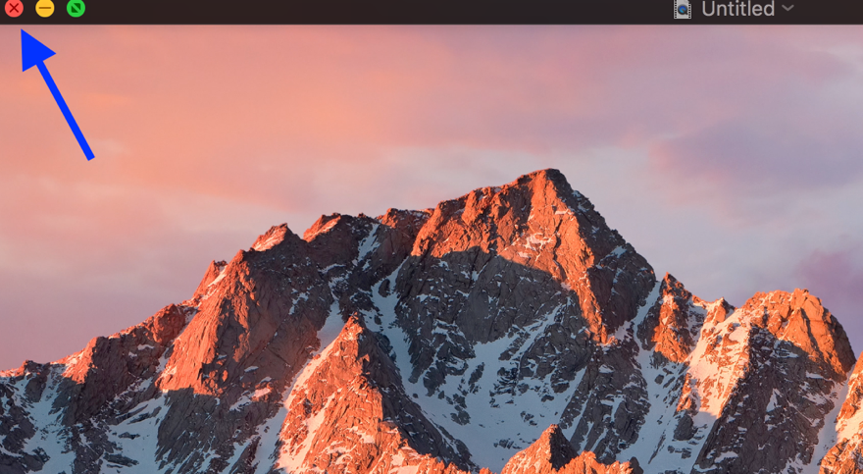

- A pop-up window will appear which will ask if you wish to save the video and then will ask what you want to type into Export As (title the video) and Where you want to save the video.
  - Once that is done then you can click Save in the bottom right corner and it will save it as a video file where you indicated.

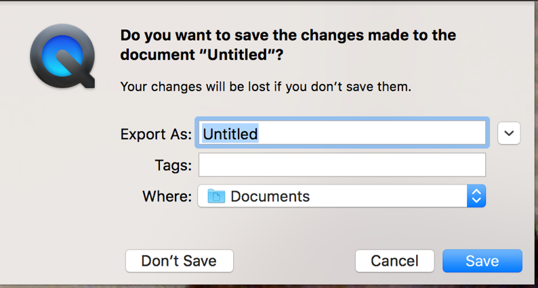

- Your video is now complete and ready to be uploaded to MS Stream.

Here are some Best Practice Tips when recording videos (some options vary):
- Make sure your laptop setting have the camera and microphone enabled
- Turn off notifications on your laptop, otherwise it will show up in the video
- Record in a quiet room and avoid outside interruptions
- When on camera:
  - Use a room with adequate lighting- don't film in front of a bright window and make sure your face is lit up (so no filming in an extremely dark room)
  - Keep your clothing in mind- be careful of what words or phrases that may be on your clothing
  - Check the room- make sure there is no inappropriate content in the background
- If recording on a cellphone always record Horizontally and not Vertically.
- Try and keep your videos to under 10 minutes as this will save on processing and upload time when you’re creating the videos as well as when you add them to Stream. If your content takes longer than that then consider splitting up your presentations into a few parts.

