How to Upload Your Videos to Microsoft Stream

- To navigate to Microsoft Stream you are going to log in to Office 365.
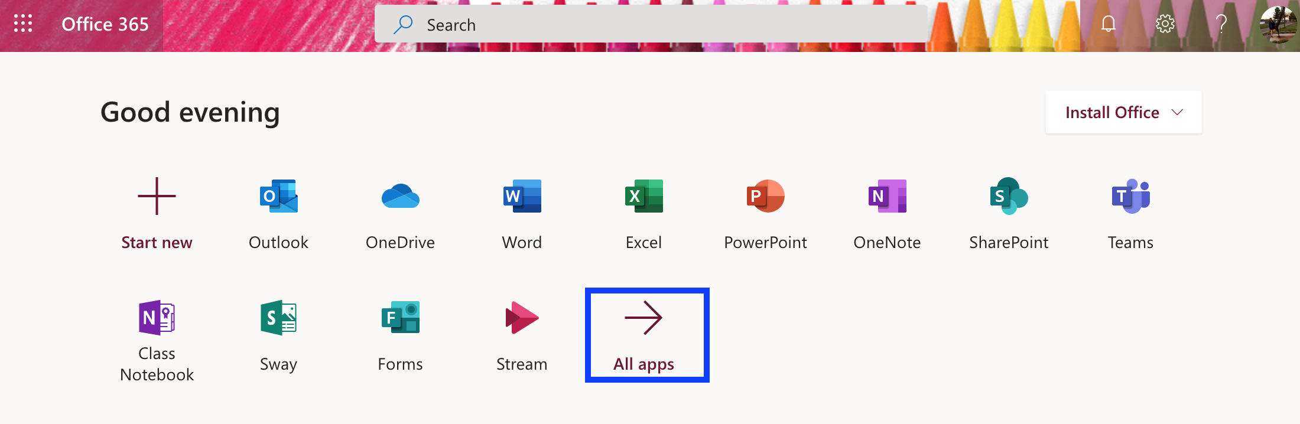

- You can see your most used apps listed but as this is a new application you will navigate to the ALL APPS button and then scroll through to find STREAM.
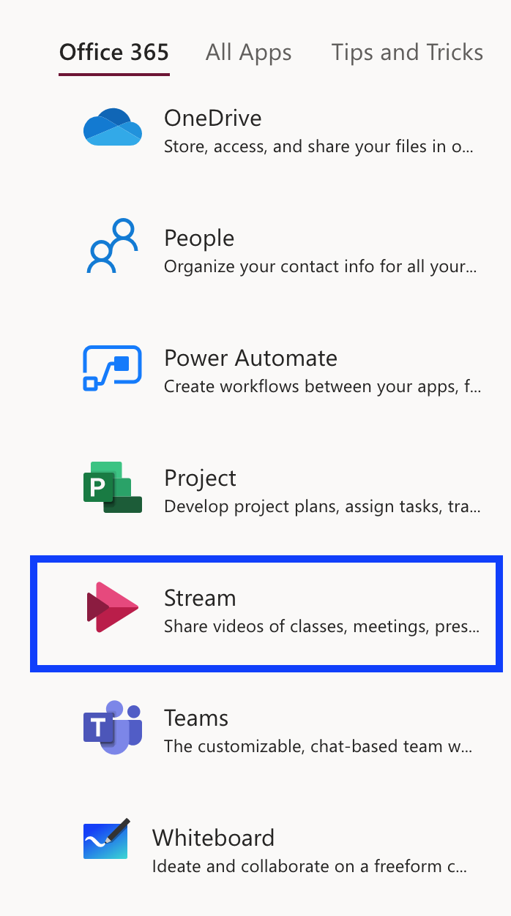
- Stream will open up and you will go to the drop-down menu under MY CONTENT and select VIDEOS.
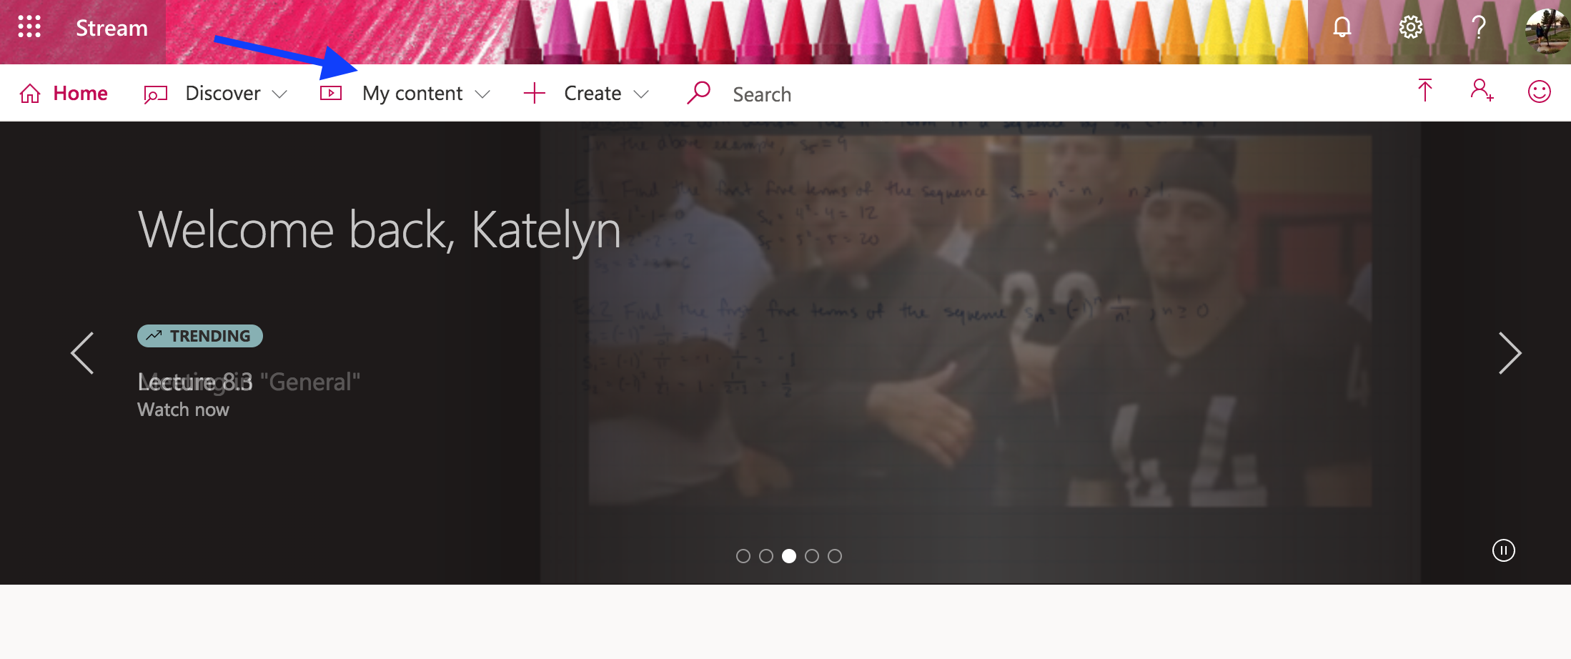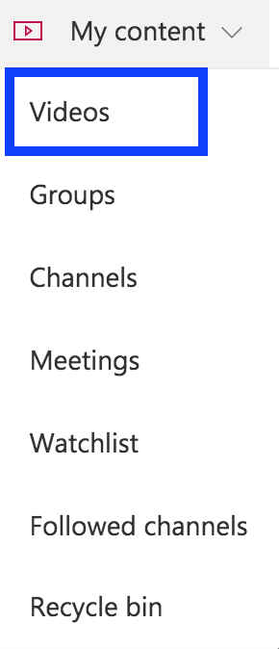

- To upload videos to Stream you will click the upload button which is an up arrow on the upper right hand screen.
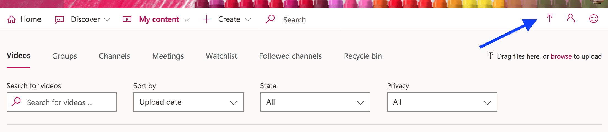
- Drag and drop OR click browse to add your videos for uploading.
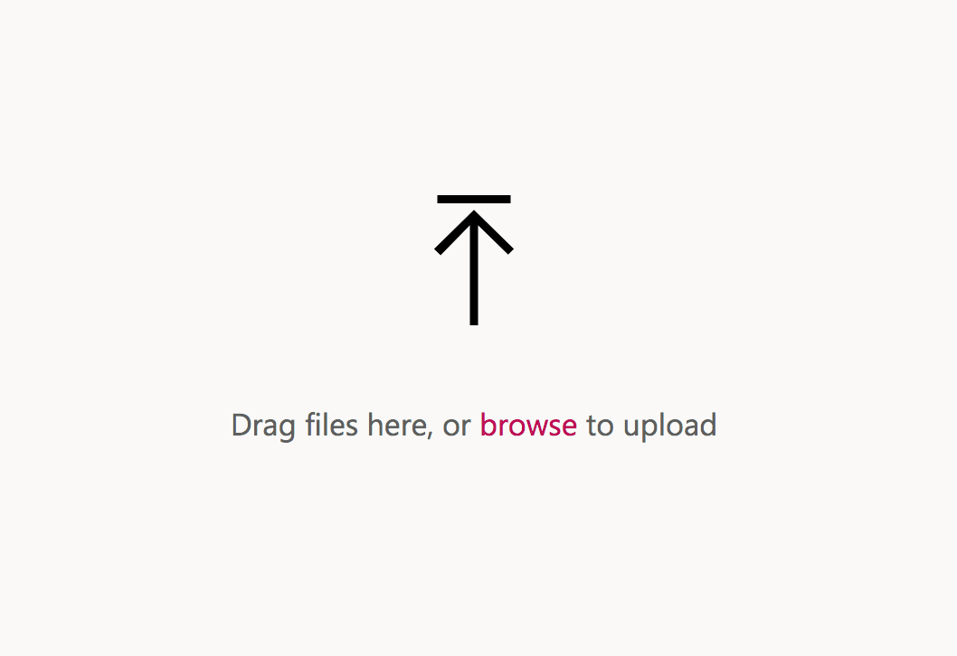

- You will Title your video and if you want add a description.
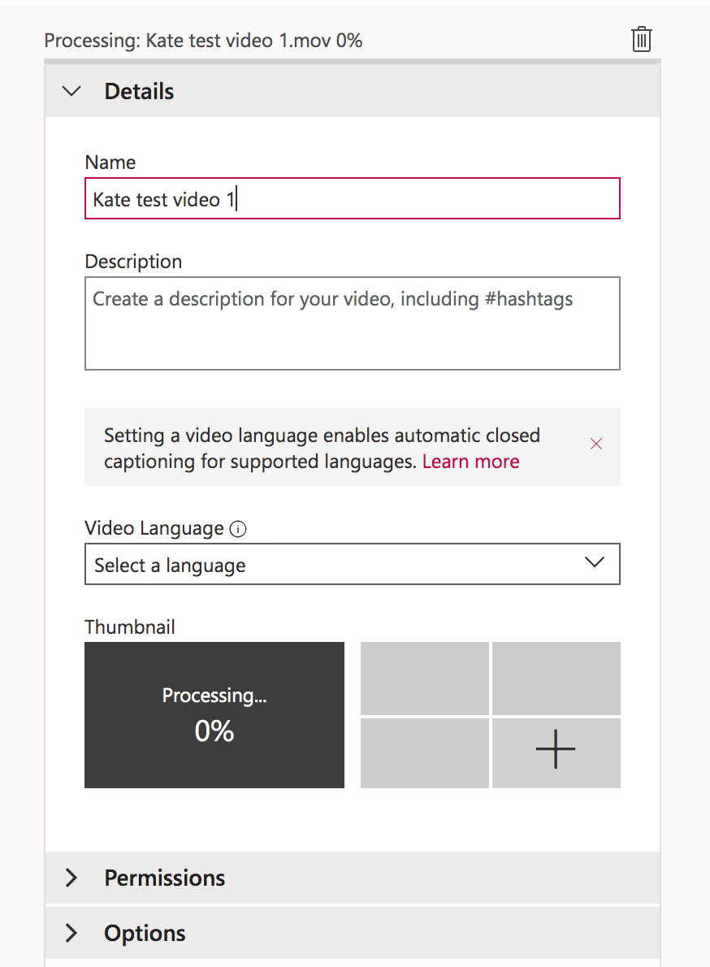

- When uploading a new video please leave the “allow everyone in your company to view this video” box checked under permissions. 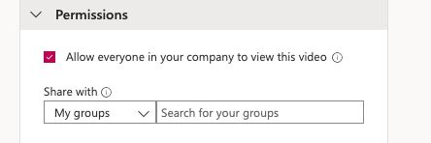

- Then publish the video. 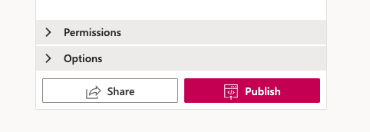

- To navigate back to your video you can go to My Content then VIDEOS and it will show in your list.

- In order to add this video onto D2L you are in need of a LINK. On the right hand side of each video is a MORE ACTIONS button with a symbol of 3 dots. Click that and then select the SHARE button.
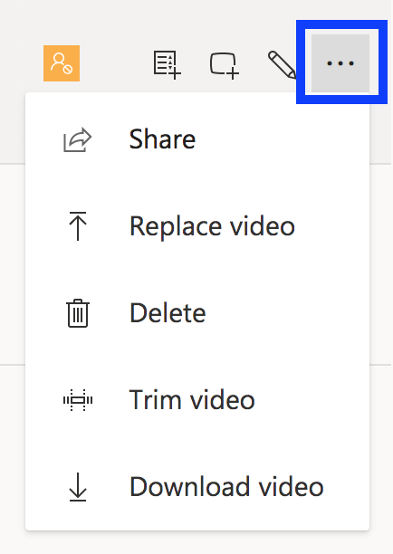

- There is a Direct link to video and to get this you will click the COPY button. Now you are free to paste that link into D2L (further instructions listed below).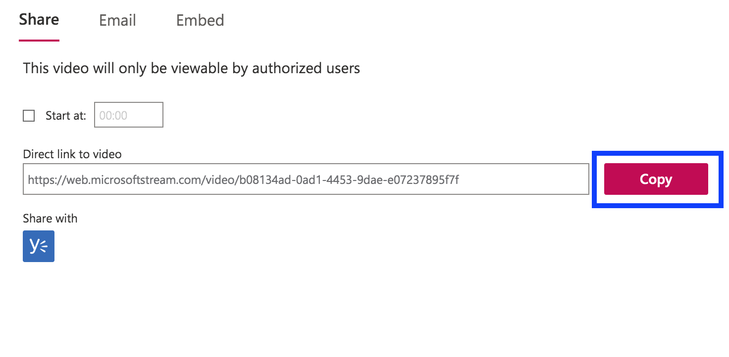
One Final Note: this is the ONLY way you should be storing your videos to post onto D2L. DO NOT directly upload video files into D2L as the program can NOT handle it.

Extra Instructions on Video Permissions: If you need to go back and CHANGE your Permissions on an already published video here is how you would proceed.

- Go to your existing videos, and click on the edit tool. 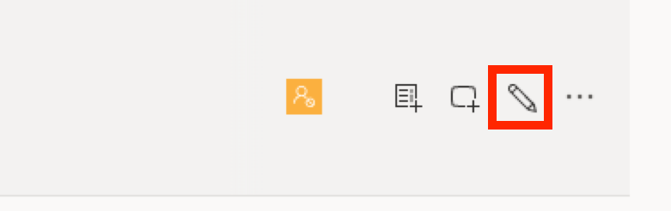

- Checking the “allow everyone in your company to view the video”.
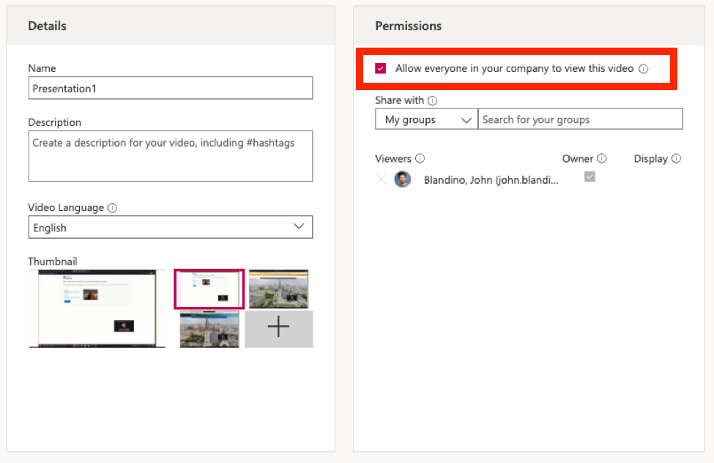

- And click APPLY.

- Then press the PUBLISH button on the bottom. 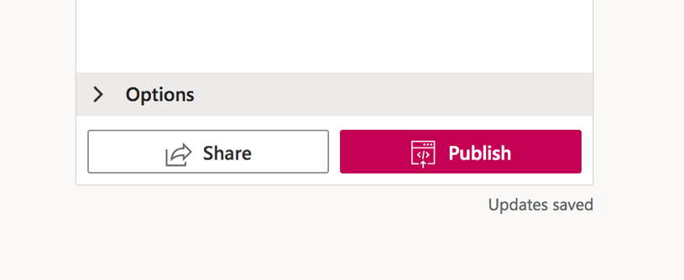

Steps on placing your Stream link into D2L.

- Navigate to the D2L Content module where you want to share the video link.

- In that Content module select NEW.

- Then CREATE A LINK.
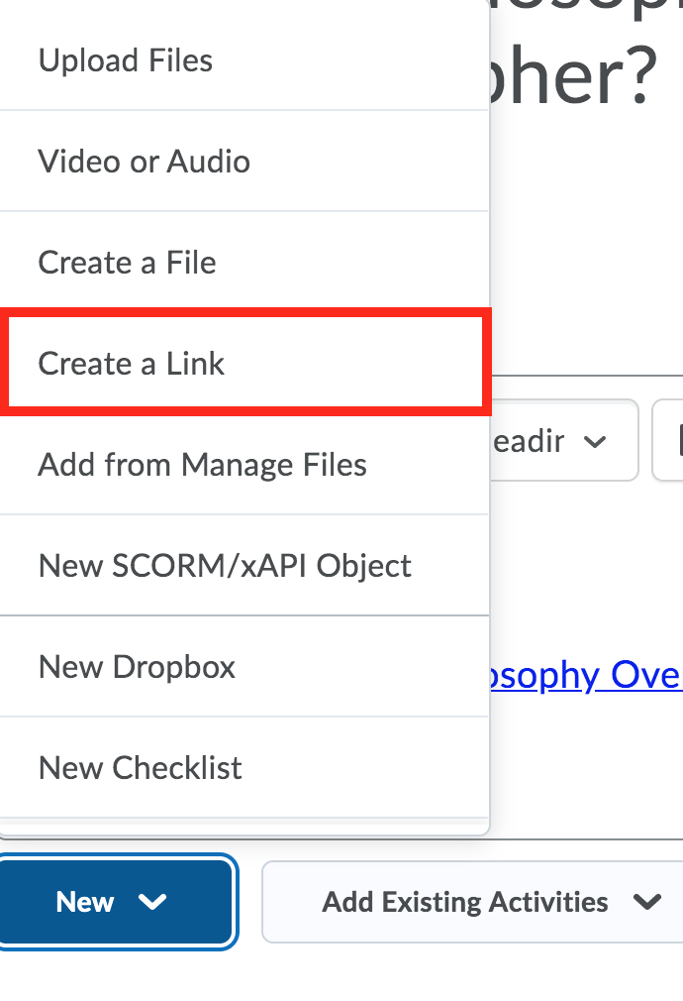

- You will then TITLE your video, PASTE the Stream Link and select the box for OPEN AS EXTERNAL RESOURCE. And then click CREATE. 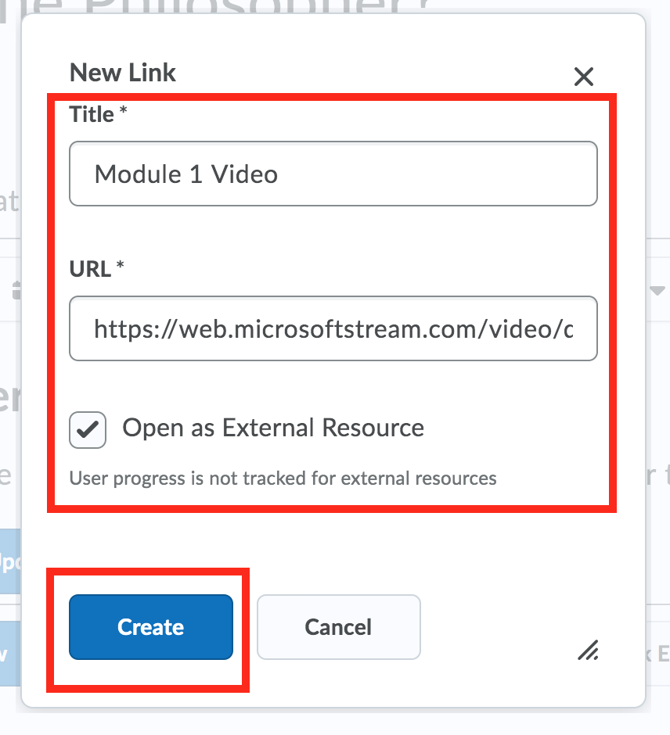

- Your link will show in the Content section.
