Welcome to D2L Daylight!
Objectives
- View the new appearance of the D2L homepage
- Learn the new View Courses functionality
- Familiarize yourself with the new Main Navigation Bar

Contents
Welcome to D2L Daylight! 1
New Homepage 2
Filter 5
Course Name 5
Change Your Course Image 6
Pining a Course 7
Course Home 8
Main Navigation Bar 9

Daylight is the new, more accessible version for the Desire2Learn (D2L) Learning Management System. The change will result in a more responsive platform that will allow users to access their course information on their mobile devices. The layout will also be more conducive to the needs of people with varying physical and cognitive abilities.

*Note: All materials from previous D2L courses will be automatically converted into the new Daylight appearance.

New Homepage

Log into D2L at http://d2l.mu.edu, using your Checkmarq username and password. Once logged into Daylight, there will be a new homepage.

On Homepage you will find:
- Academic Integrity Quizzes for Undergraduate and Graduate students.
- Your courses will be listed where you the nine blocks are located.
- Minibar.
- Up to 12 courses can be viewed on homepage.
  - View All Courses.
  - The number in the boxes indicates the number of updates (i.e. new discussion posts or dropbox submissions) in the course.

Academic Integrity Quizzes for Undergraduate and Graduate students.
Your courses will be listed here.
Minibar

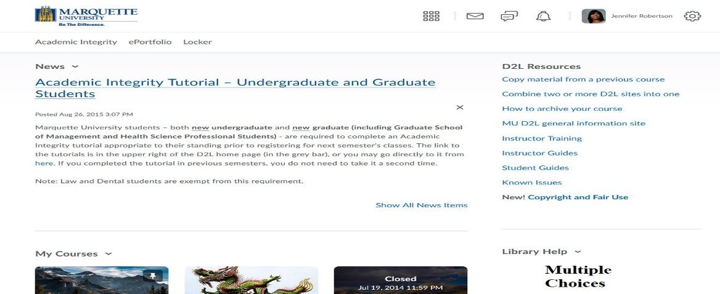

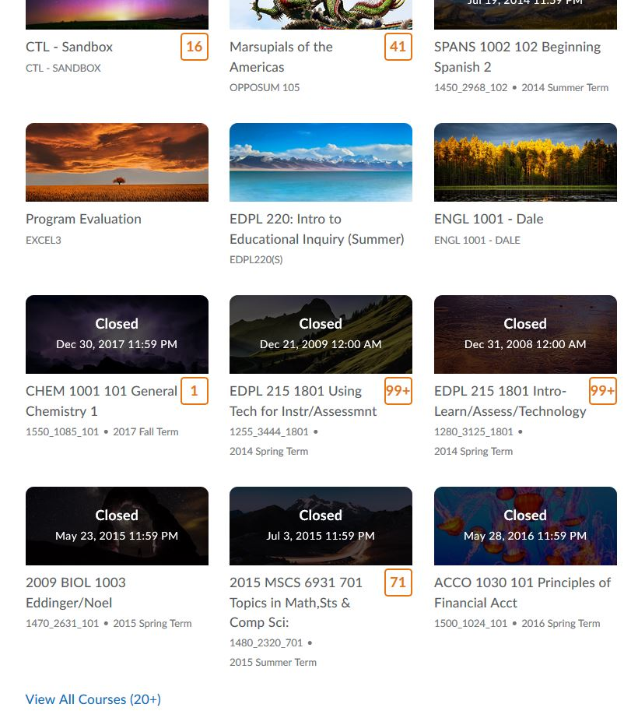
Up to 12 courses can be viewed at one time.
Click to view all your courses
Number of updates

Searching for Courses

When you click View All Courses, a new window will appear
- Find a course allows you to find a specific course with the courses name, number and section.
- Filter allow you to select the terms to be viewed on the home page.
- Course name allows you to order the appearance of the courses in order of the course name, course code, date pinned or last accessed.

Course Name: Arranges the order that the courses are shown
Find a course: Type in course name, number and section
Filter: allows you to select the term

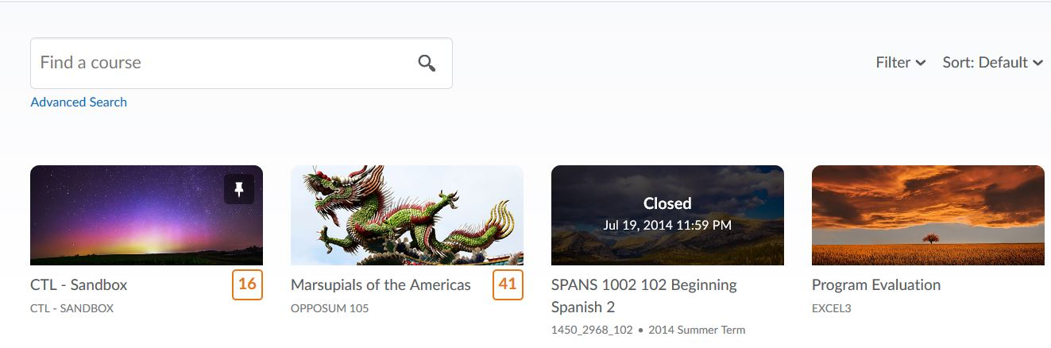

Filter

Allows user to select the term to view.

Course Name

Allows the user to change the order in which they will see their courses.

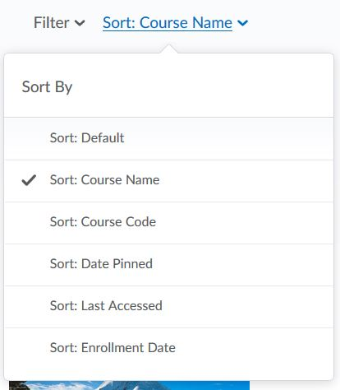

Change Your Course Image

- Hover over the right-hand corner of the present image and click the box with three dots inside.
- Select Change Image

- A window will open to give you options to change from a library of images or to upload an image.
  - Enter a general name in the Search box (i.e. outdoors).
    - General pictures will appear to select.
- Select Upload to add a personal computer from your device.

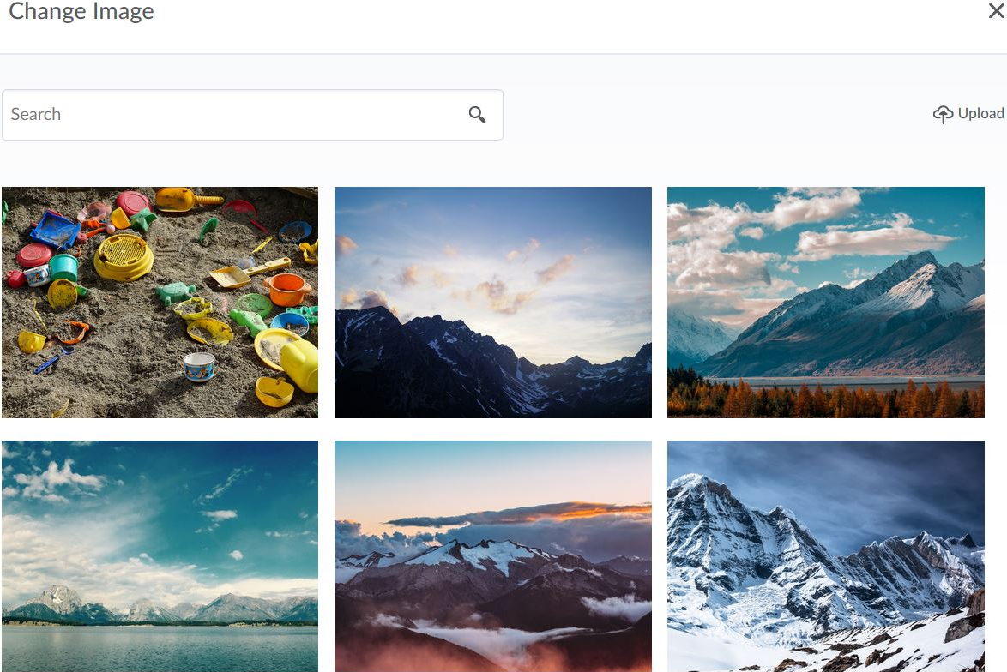
Upload a personal image
Sample images offered
Search for a type of image

Pining a Course

Pining a course allows the user to see this course on the homepage without the need to search for the course. Pinned courses will only be shown if there are less than 12 recent classes on the homepage. However, in the My Courses icon , the course will be shown as pinned.

Course Home

There are several features in the Course Home that were updated. Most of the new features are in the Main Navigation Bar. Located at the top of the Main Navigation Bar there is the:
- Home: takes you your D2L Homepage
- Courses: lists your courses
- Minibar: email, notifications, alerts, profile information, settings
- Main Navigation Bar: contains Course Home, Content, Communication, Assessments, Resources and Edit Course
- Course Home Banner
  - Course banner and course tile have the same image.
  - Option to change Banner

Your courses will be listed here.
Minibar
Course Home
Homepage
Main Navigation Bar
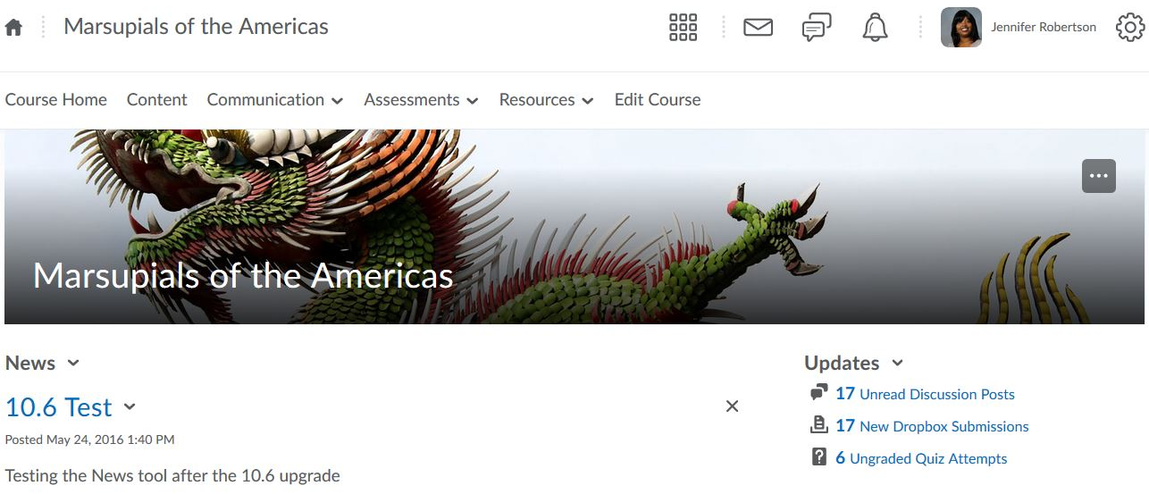
Course News Items
Course Updates
Course Home Banner
Option to remove banner or change image

Main Navigation Bar

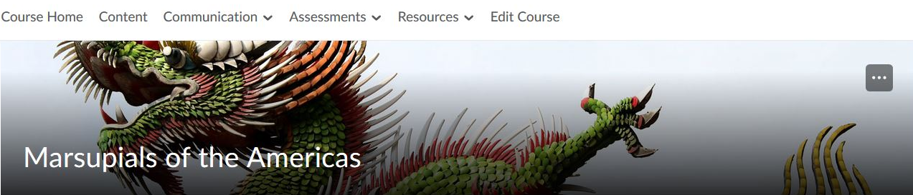

The Main Navigation Bar has rearranged tabs and place them in drop down menus.
Course Home returns the user the course homepage
Content takes the user to the content page
Communication contains Discussions, Groups, Classlist and Online Rooms
Assessments contains Dropbox, Quizzes, Grades, Rubrics, Surveys and Competencies.
Resources contains Calendar, Attendance, ePortofolio and Locker
Edit course takes the user to the course administration page.

