Process Mapping
Continuous Improvement Toolkit
Process Mapping: is a technique to visualize the tasks, activities and steps necessary to produce a product or a service.
Reasons for creating a Process Map
- Helps all process members understand their part in the process and how their process fits into the bigger picture.
- Describes how activities are performed and how the work effort flows.
- Can be used as an aid in training new people.
- Will show you where you can take measurements that will help you to run the process better.
- Will help you understand where problems occur and what some of the causes may be.
- Leverages other analytical tools by providing a source of data and inputs into these tools.
- Identifies and leads you to many important characteristics you will need as you strive to make improvements.
Walk the Process: removes the unknowns related to initial high-level process map and helps team understand enterprise level perspective of process
Benefits of using Walk the Process:
- Creates an opportunity to build up good will and acceptance associated with process improvement project
- Helps team identify important stakeholders that may have not been identified in the VOC analysis
- Helps team identify some of the hidden costs the process currently has. Those hidden costs can help build the business case for the project
- Provides information needed for detailed process maps
- Stakeholders may provide insightful solutions to yet to be determined root causes that could be valuable during Improve phase. Note: often they provide solutions that don’t address root causes so beware.

Direction of flow
Process Step
Decision Point
Document
Connector
Start / End
Common Shapes used in a Process Map

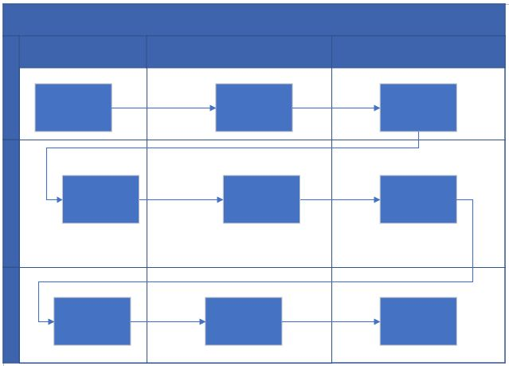
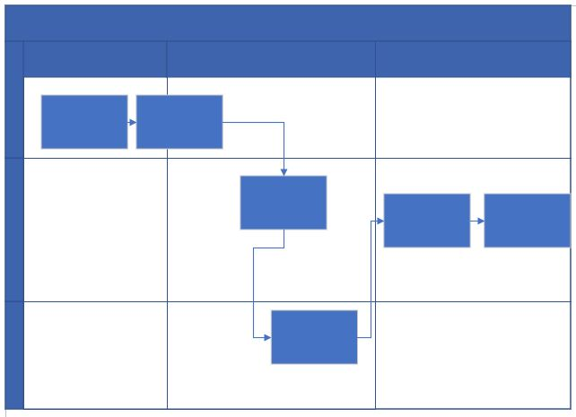
Example of a Good Process Map
Example of a Bad Process Map

