How to Create a Microsoft Form in a Teams Tab

Overview:
This guide covers the steps necessary to create and share a Form through a tab in your Teams site. It also covers the different questions types and features available in Forms. Do not use this as a replacement to D2l Quizzes or Tests.

Getting Started
- Navigate to the Add a Tab button, which resembles a plus sign, in the options bar at the top of the meeting chat room. Click it.
- Locate the Microsoft Forms tab and click it. If you are having trouble locating this button, you can always use the search bar to find it quickly.
  - Once you locate the app, click on it.
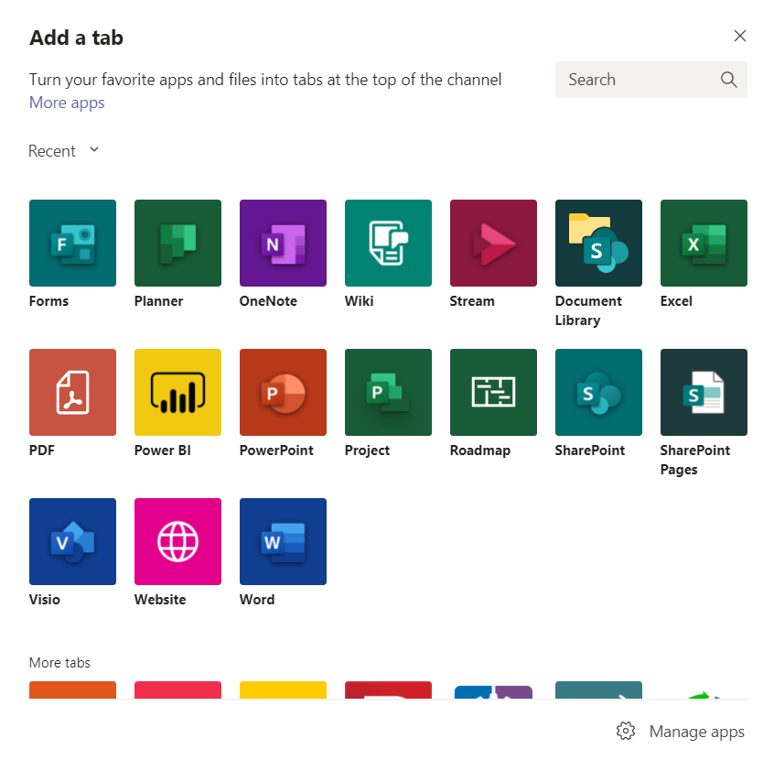

- Here it will give you the option to Create a shared form that your team can edit and see results or Add an existing form

- Click Create a shared form that your team can edit and see results.

  - Keep in mind that with this option, although you are able to create the survey or quiz in the class Team Site, your students will be able to edit the Form and results from other students. This is because they are members of the Team.
  - This tool would be best used for simple questions like rating how helpful a video was or asking what dates students would be available for a project.

- Next, give your Form a name and check the Post to the channel about this tab if you would like for the Form link to automatically be posted in the Team Chat.
  - It will post as you are still editing the survey so if you don’t want others working on it then we recommend not checking it.
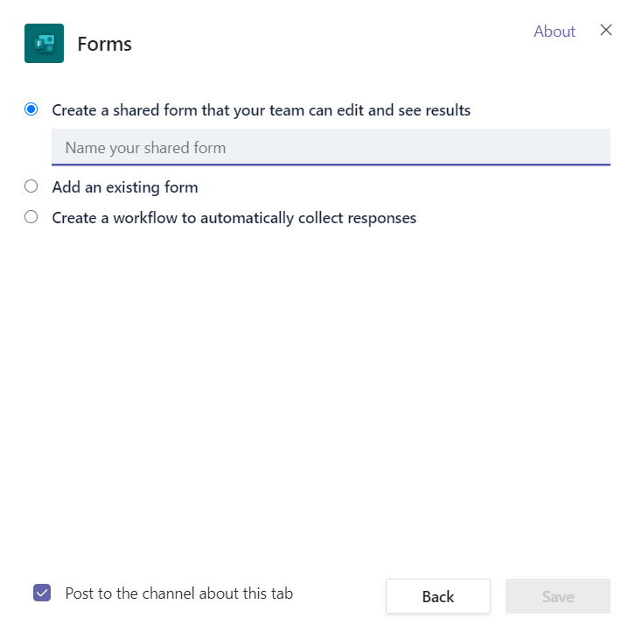

- Once you click Save you will begin to customize and edit your Form.

Adding Questions
- Select the Add New button to add a question.
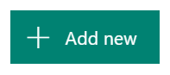
- You will have a list of options to select as your question type.
  - The question types consist of Choice, Text, Rating, and Date and multiple other options when you click the down arrow.

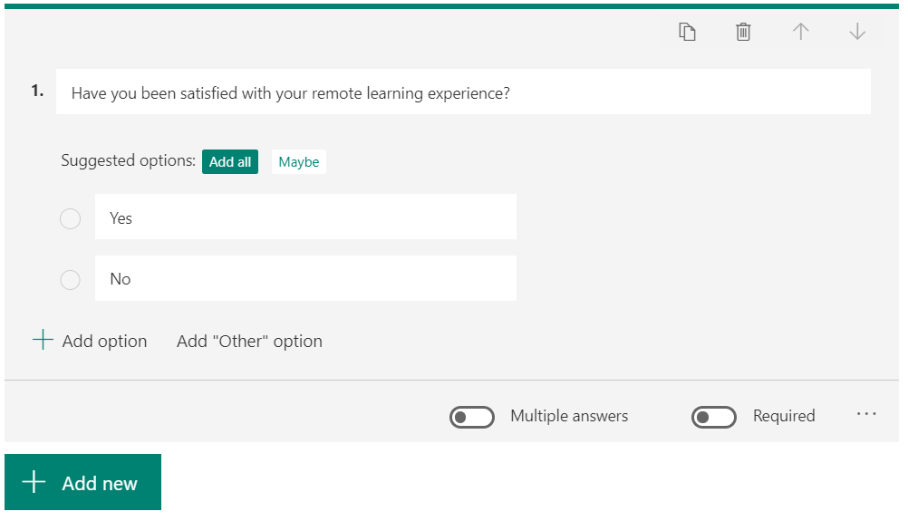
Choice Questions: These questions allow for multiple choice answers.

- You can click Add Option to add more answers to your question for students to select.

  - On the bottom right you may also turn on the Multiple Answers Button to allow for students to select multiple answers, or the Required Button to make the question required in the submission of the quiz.

  - There are also more options if you click on the three dots next to these buttons. We will go over those after the other question types.

Text Questions: These questions are used for short answer. Turning on the Long Answer function at the bottom right, will allow students to type answers more than 4,000 words.
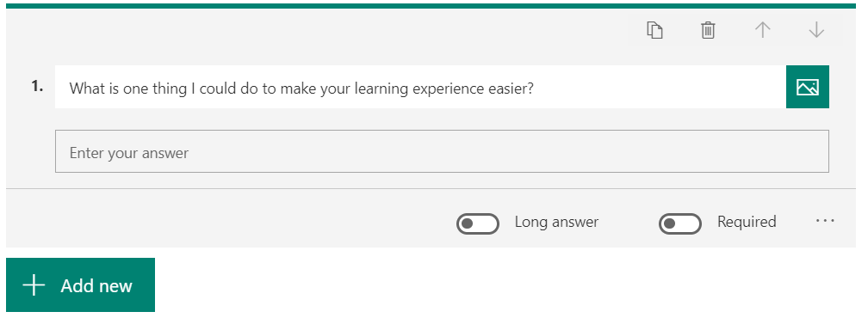

Rating Questions: These questions allow students to give a rating to something by stars or numbers with levels ranging from 2 to 10.
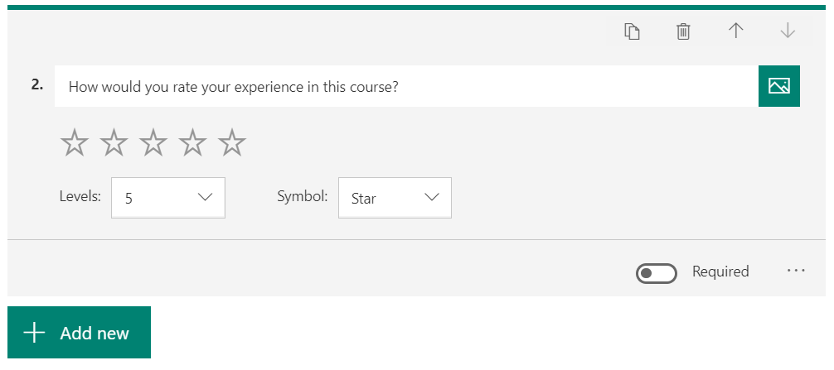

Date Questions: These allow students to pick dates from a calendar. This option works great when wanting to survey students for their availability.
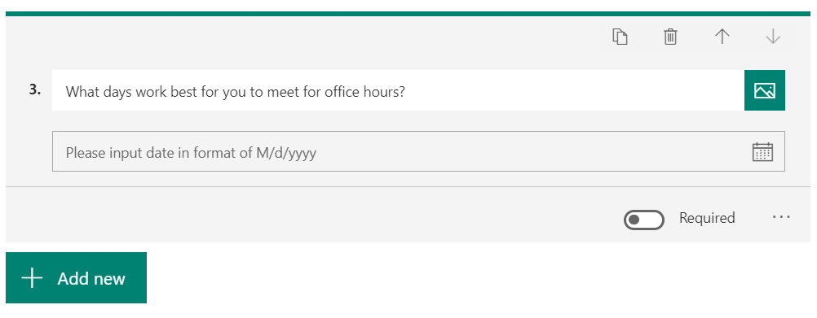

The following options are available by clicking the down arrow
Ranking Questions: These allow students to rank answers in order of their importance, chronological order, etc.
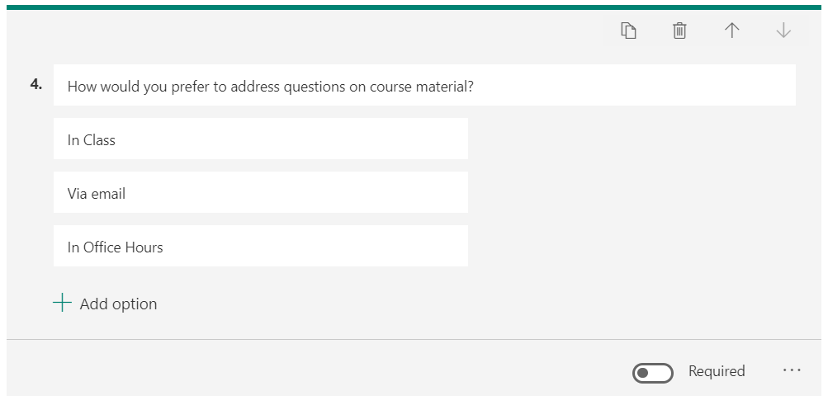

Likert Questions: These are used to gauge students’ attitudes or opinions on topics.
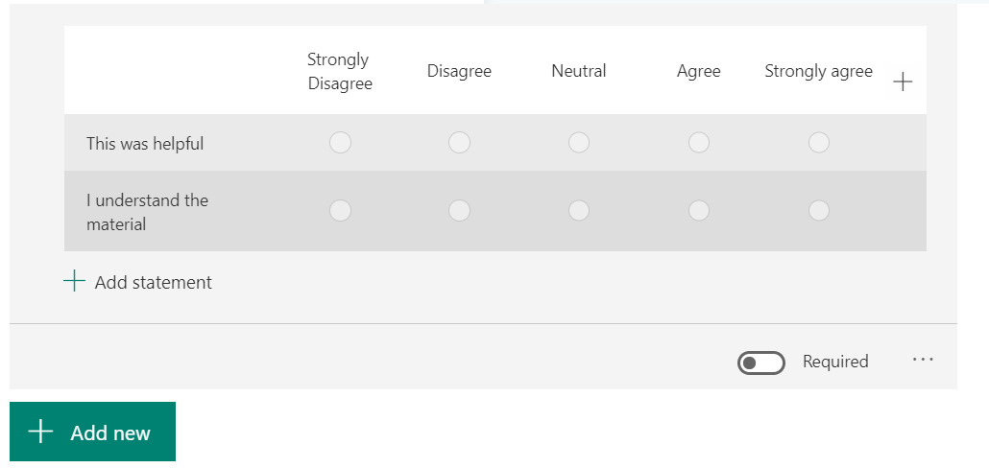

File Uploads: This allows students to upload files from their computer to the quiz.
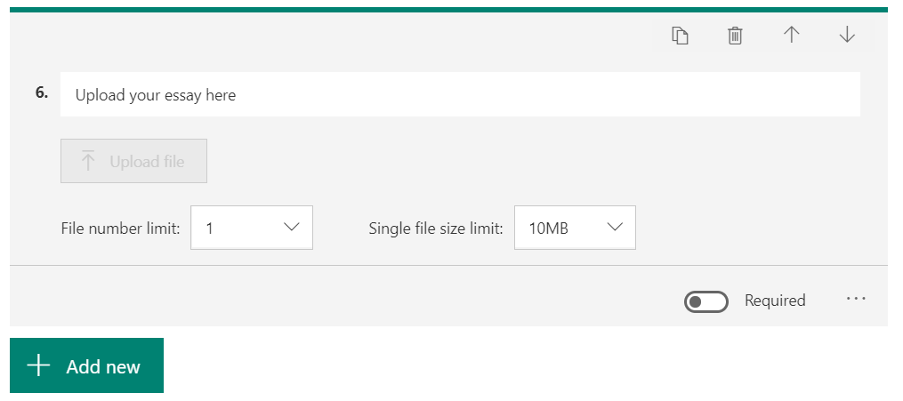

Sections: This option allows you to break up the quiz or survey into different parts or sections.
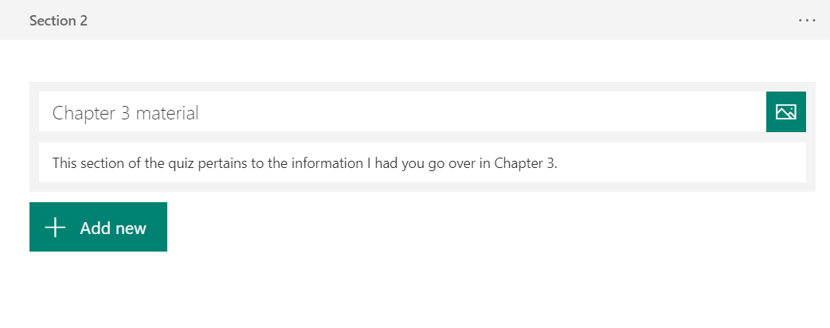
- If you were to click the ellipsis in any of these questions you would be presented with these options to customize the questions on your Form.
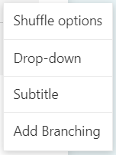

Shuffle Options: This randomizes the order of answers that your students will be selecting.

Drop Down: This option will insert your answers into a drop down list, which may be more convenient for questions with lots of answer options.
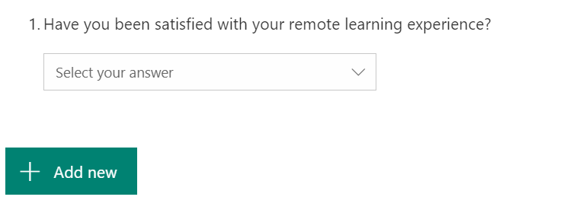

Subtitle: This will allow you to expand on your question so that students can answer more accurately.
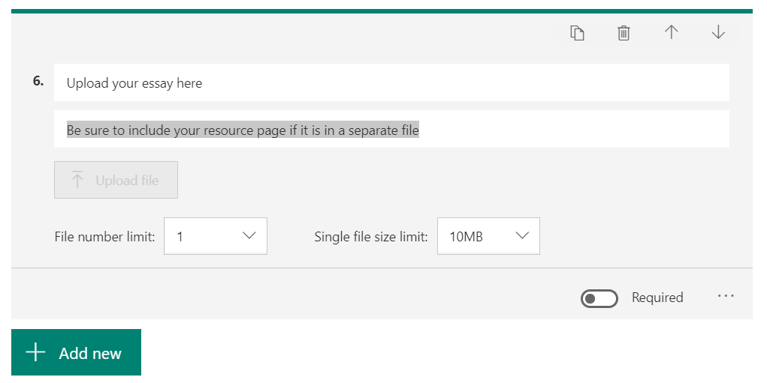

Branching: This allows you to connect certain questions or even have students jump to the end of the Form.
  - For example: if a student marked down that they were satisfied with the course, they would be taken to the next set of questions. However, if they marked down that they weren’t, you might want a follow up question asking why. So, upon their answer “no” the question as to why would appear next.

After Creating Questions
- After you have set all of the questions and question settings for your quiz or survey, you can preview the finished product as if you were filling it out by clicking the Preview button at the top right of the page.

- When previewing the survey or quiz you can see how it looks for users on both computers or mobile devices by selecting your view in the top right.
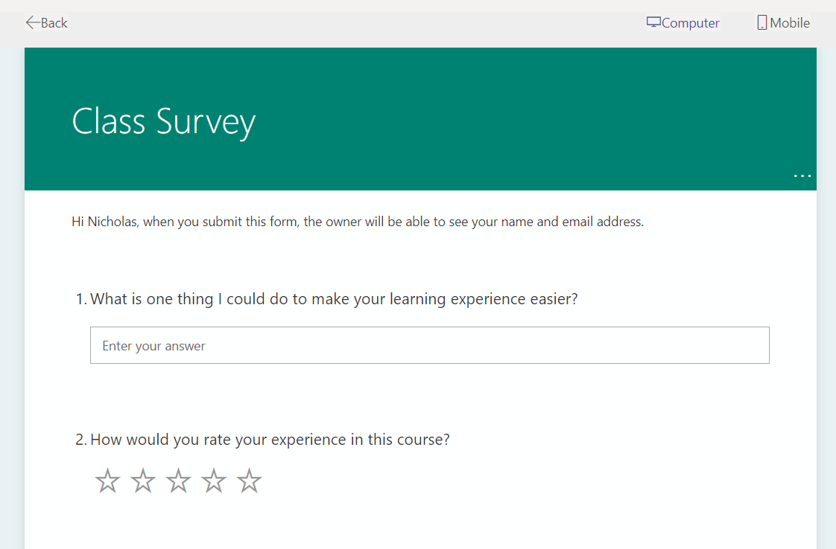
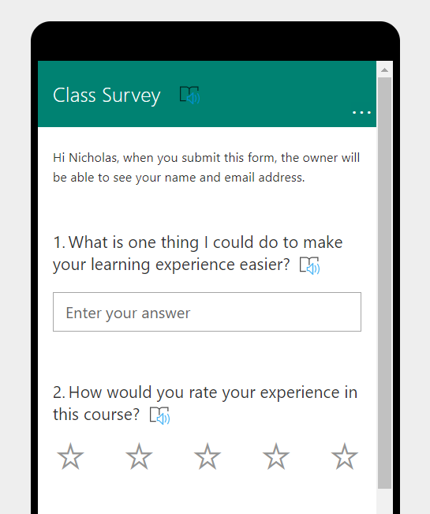

- There are also several different themes you can use to customize the look of your quiz or survey even further by clicking the Theme button.
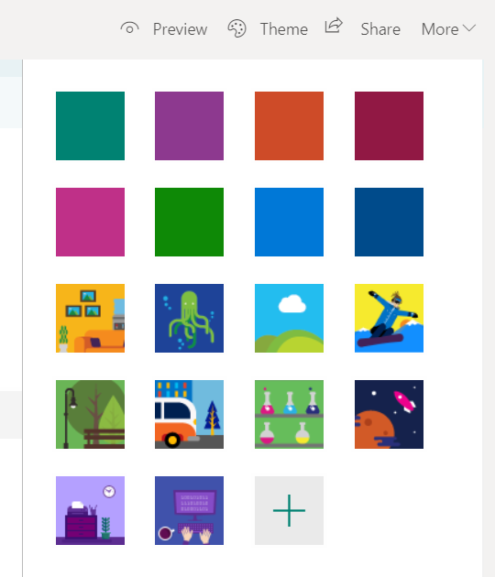
- If you click on the More button in the top right, you will be given even more options.
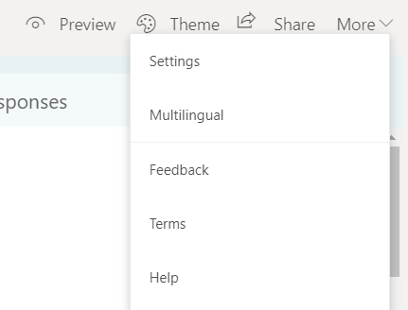
- By going into your settings, you will be given a list of options to utilize on this form.
  - Options go as far as who can fill out the form, options for different responses, and notifications after completion.
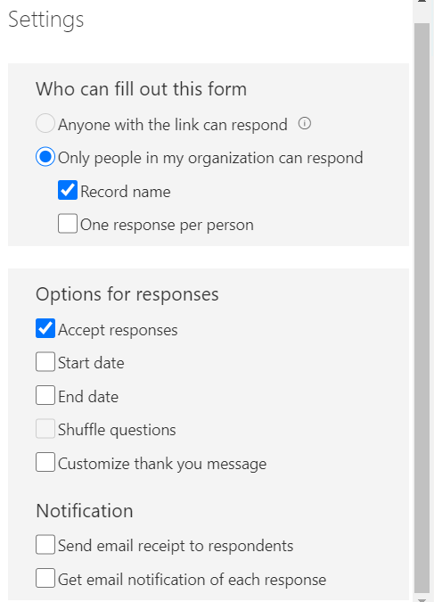

- You can also click the Multilingual button under More.
  - This allows you to add another language for students fill out this form in. You will have to enter in the translations for questions that you wrote.
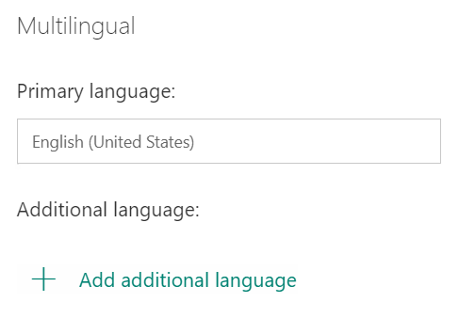
- Lastly to share your Form with everyone click the Share button.
  - You will be given a list of different options to use. The Options include sharing a link to the Form, getting the QR code to the Form, getting the Embed code to the Form, and lastly just emailing the Form.

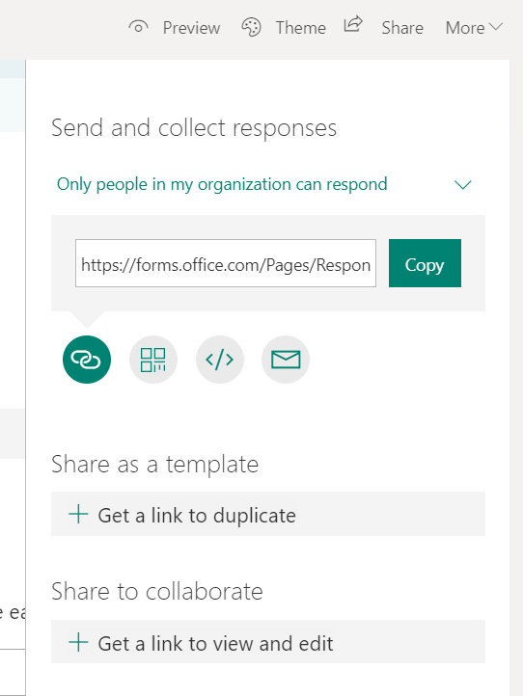
- To share the Form with your students in your Teams Site, simply click the Copy Link button and past it into your Team Chat.

- As students complete the form you will be able to view their responses.
  - Keep in mind, with this option of creating the form in Teams they all have the chance to edit the form and view other students’ responses.
  - We only recommend using this option for quick general opinions. For any weighted quiz or survey, please use D2L to ensure student privacy.
