How to Create a Narrated PowerPoint on MAC

Overview:
This guide is aimed at MAC users and covers the steps needed to record narration on PowerPoint slides as well as exporting narrated PowerPoints into videos.

Instructions:
- Open your PowerPoint presentation by opening the PowerPoint program and then either creating a new slide show or opening a pre-made slideshow.
  - Make sure all of your PowerPoint content is prepared before you begin recording your slideshow so you are ready to present all of the information.

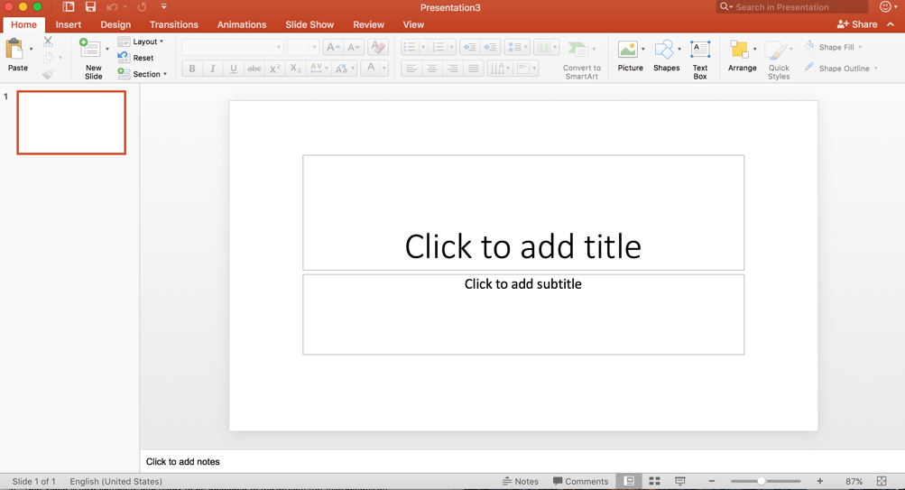

- Go to the Slide Show tab on the top of PowerPoint and then select Record Slide Show. It is indicated by an icon that has a stop watch and a red record button. Immediately to the right of the icon are a series of three check box options- play narrations, use timings, show media controls- which you will check all of those boxes before clicking the Record Slide Show button.

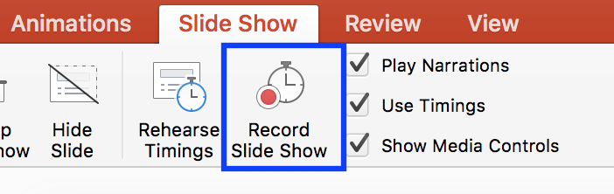

- Presenter view will begin presenting your PowerPoint and along with it your audio will automatically start recording on your slideshow. There is no count down or another indicator to check that the audio is recording. The slideshow will preview the current slide you are on, the upcoming slide, and then also the length of time that has passed will be indicated on the top of the screen.
  - Feel free to give yourself a breath and then start diving into your topic. As you navigate between slides remember to give yourself a breath between each so that the audio does not cut out any words (this can be an issue when recording in PowerPoint).

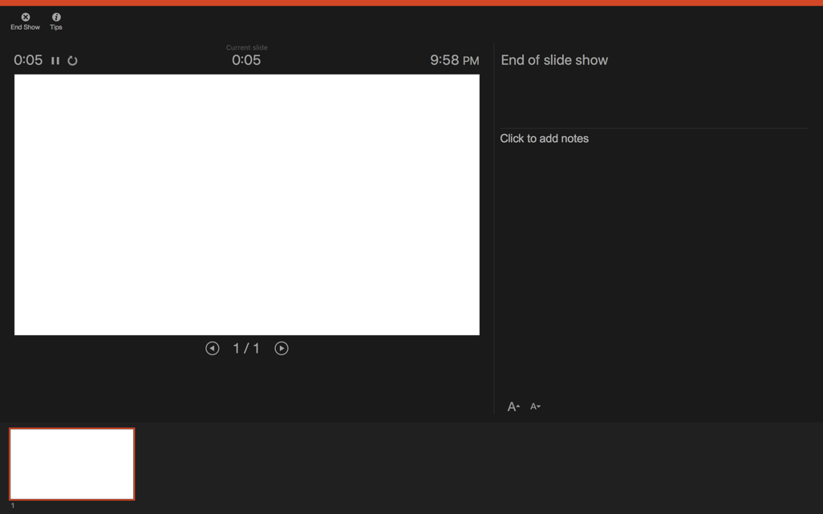

- When you are done recording, click the End Show option in the upper left-hand corner of your screen which is also indicated by an icon of a circle with an X in the center.

- The program will then have a window appear that will ask you to save your timings. You will select Yes on the lower right side.

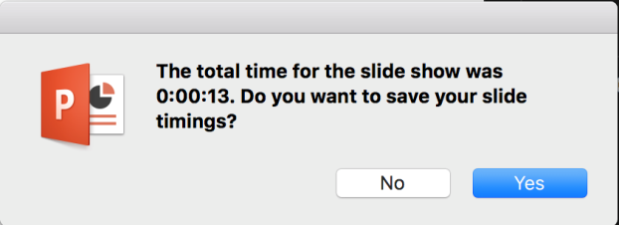

- Navigate back to your normal view by going to the lower right side of the PowerPoint window and selecting the icon that looks like a book cover.

- Now in the lower right-hand corner of each of your slides will be an audio symbol icon showing that there is an audio recording on each of those slides.

- To export this as an MP4 video you will go to File in the upper left corner of your task bar at the top of your computer screen. In the File drop-down menu you will select Export.

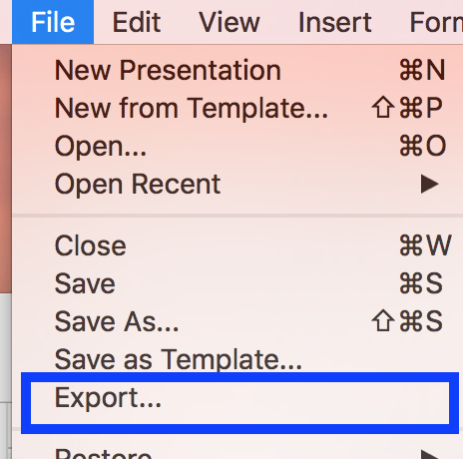

- A menu screen will come up for you to export your PowerPoint. You will name your video file in the Export As section, as well as where you want it stored on your computer. Then the most important change you will make is under File Format which is located in the center of the screen. You will select MP4 and select Export in the bottom right corner of the screen.

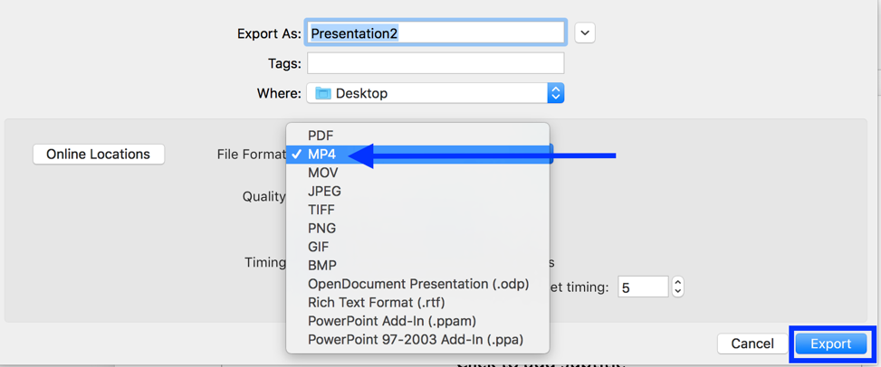

- On the bottom of the PowerPoint you can see the progress of your video exporting. There is no time indication of how long this process will take. When the video is complete the progress, bar will disappear.

- Your video is now complete.

What if I want to redo a slides voice recording?
This can be done in the same way you record the PowerPoint but you should remember to select the slide you want to record and then go into the Record Slide Show option. You can then redo that slide but know that if you move to the next slide it will rewrite that one as well. So, please stop when you are done with what you want to cover.

