How to Create a Narrated PowerPoint on PC

Overview:
This guide is aimed at PC users and covers the steps needed to make a narrated PowerPoint and export it as a video.

Instructions:
- Open the PowerPoint presentation that you want to narrate.

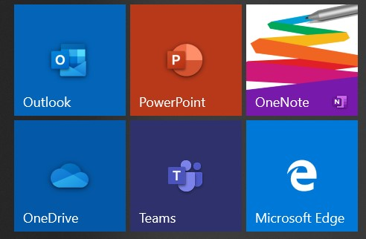

- Once the presentation is open go to the tab options and go to Slide Show.

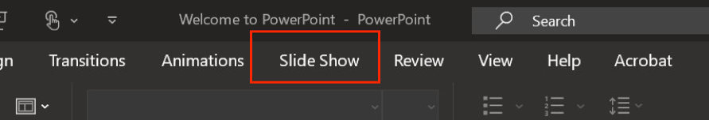

- Under Insert are a series of different options. There are a series of options labeled with Set Up, select the Record Slide Show button (indicated with a box and red circle).

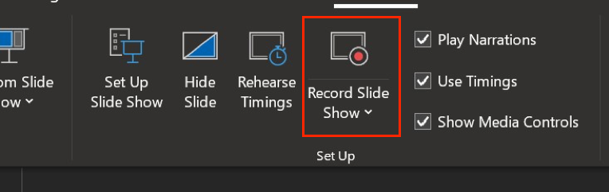

- Your screen will navigate to a presentation mode with a variety of options for you to choose from before you start recording your presentation.

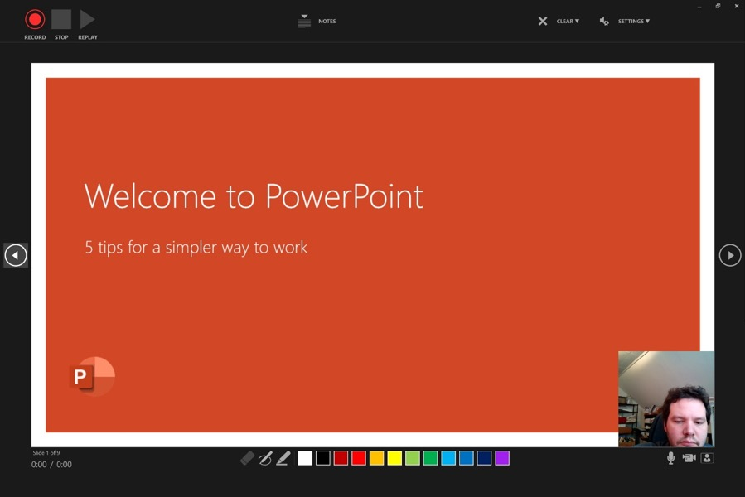

- In the bottom left corner of the screen are different options for how to record your PowerPoint presentation.
  - The first is the microphone option. Ensure that its on by by making sure the icon does not have a slash in it. A slash across any of the icons means it is not enabled.
  - The second is the video option which you can turn on and off depending on if you want the presentation to record a video of you in the corner of the presentation.

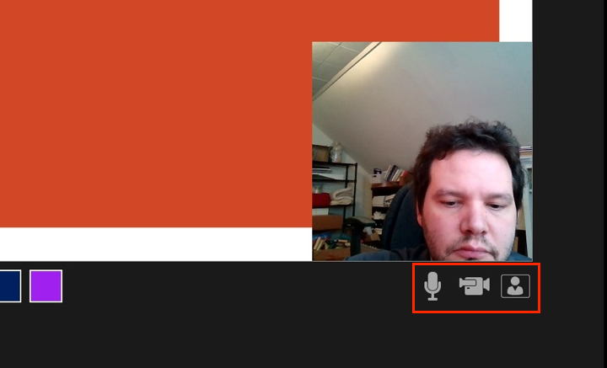

- In the upper right-hand corner are your options to begin recording. The first is the Record button (a red circle) followed by the Stop and Replay options. Hit the Record button when you are ready to start.
  - The screen will count down 3 seconds before it begins recording.

- Navigate through your slides and record your presentation.
  - Be sure to give yourself a breath in between transitioning to a new slide.

- While you are recording you can take a break by pressing the Pause button which is in the upper right-hand corner (it has replaced the Record option).
  - When you want you can click that same button to resume recording.

- When you are done recording you can select the Stop button in the upper right corner (indicated as a box icon). Then you can leave presentation view and you will be directed back to the editing version of PowerPoint.
- In the lower right-hand corner of each of your slides is an Audio Symbol showing that there is an audio recording on each of those slides.
  - If you recorded video with your PowerPoint there will instead be the video in the lower right hand corner.

- If you need to rerecord one slide you can navigate back to the Slide Show tab and then select the drop down menu next to the Record Slide Show option. That drop down menu will offer you the option to select Record from Current Slide.
  - You can then record the slide you need and exit back to the editing version of PowerPoint so you do not mess up the other slides.

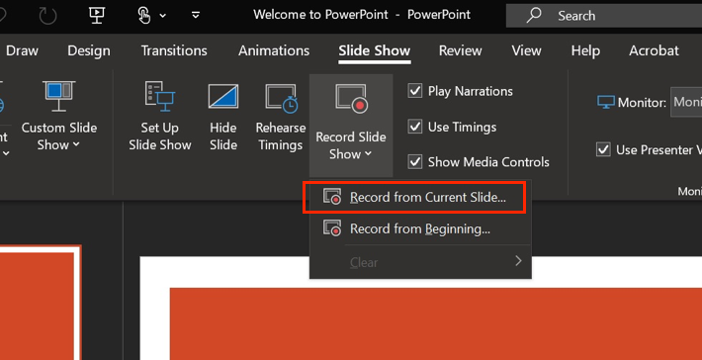

- To save your screen recording as a video in an MP4 format you will first go to the File tab on the top right.

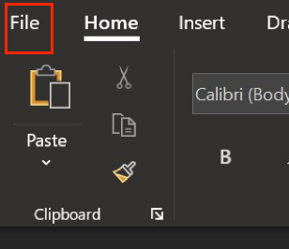

- Next you will select Export that has appeared in the File options menu.

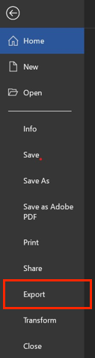

- There will be a series of options on the left-hand side, select the Create a Video option.

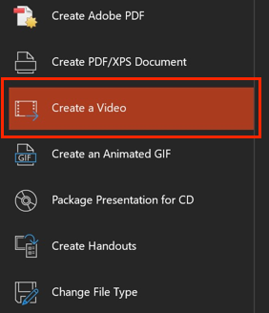

- Under the Create a Video tab there are a series of options you have to check.
  - The first to appear in the window is file size and quality. When selected there are a series of options that appear for the video quality you want to export, it is best practice to use the default which appears which is Full HD (1080p).
    - If you are having a lot of issues with exporting time you can take it down to 720p but this should be a last resort option.
  - The second option directly below deals with timing. It is crucial that you make sure that Use Recorded Timings and Narrations is selected before reaching the next step.

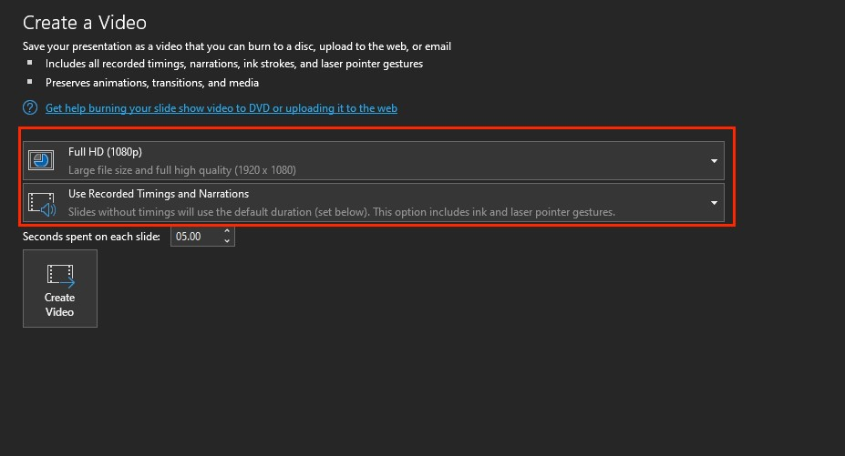

- The final option is a Create Video button on the bottom which when selected will start the exporting process.

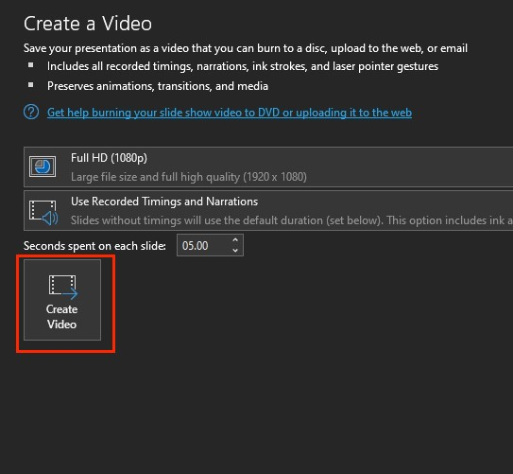

- On the bottom of the PowerPoint program is a progress bar which displays the progress of the video exporting from PowerPoint. When the video is done this bar will disappear.

- Your video is now complete.

