D2L Rubrics

Objectives:
- Differentiate between the two types of rubrics.
- Identify components of a rubric.
- Create, edit, delete and attach a rubric to an assignment, discussion and gradebook.

Contents
Overview 2
Types of Rubrics 2
What are Levels and Criteria? 2
Creating Rubrics 3
Analytic Rubrics: 3
Holistic Rubrics: 10
Editing and Deleting Rubrics 14
Attach a Rubric to Assignments and Discussions 14
Opt-in New Rubric Experience 17

Overview

Analytic and holistic rubrics are used to assess student performance. Well-written descriptions of the levels for each criterion is important to avoid confusion regarding expectations and to clarify how to approach assignments.
This guide will provide information on the types of rubrics available in D2L along with instruction on how to create, edit, delete rubrics as well as attach rubrics to assignments in the drop box, discussion forums and grade items.
Note: Rubrics cannot be added to quizzes or surveys.

Types of Rubrics

There are two types of rubrics in D2L: analytic (the most commonly used) and holistic.

Holistic: (One-dimensional rubric) Holistic rubrics only has levels. Students’ overall performance is assessed with one single criteria used based on predefined achievement levels. Uses percentage or text scoring method.

Analytic: (Two-dimensional rubric) Student performance is assessed based on multiple criteria with different levels of achievement. You assess each criterion separately, resulting in an overall assessment score. Analytic rubrics can use points, custom points, and text as a scoring method. If using points or custom points the overall score is calculated based on the total number of points achieved in the rubric.

What are Levels and Criteria?
- Criteria: Are categories in which you will evaluate students. For instance, Format, Appropriate Focus, Critical Thinking and Language Use.

- Levels: Represent students’ level of performance in a category (i.e., criterion). A level’s description should reflect what students are required to do to achieve the level. Example of a rubric’s levels: Proficient / Basic / Below average / Unacceptable

To Access the Rubrics tool:
- Click Assessments on the Main Navigation Bar.
- Select Rubrics from the drop-down menu.
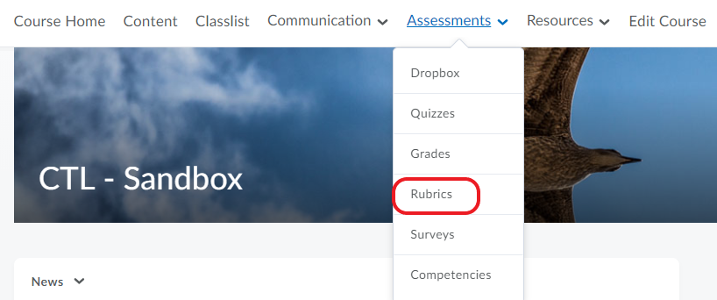

Creating Rubrics

Analytic Rubrics:
- Click on Assessments on the Main Navigation Bar.
- Select Rubrics from the drop-down menu.
- Click on New Rubric and drop-down menu to access the new rubric creation turn on or off buttons. See page 17, for more information on the new rubric experience.
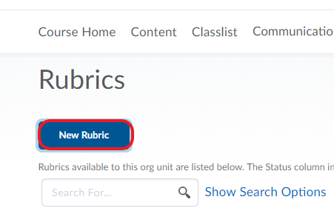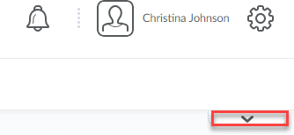

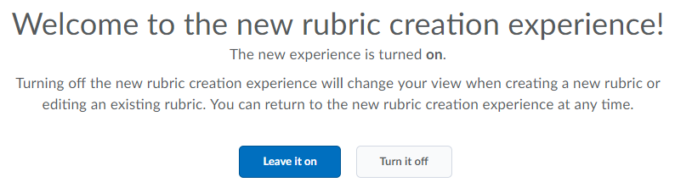

- On the New Rubric page, enter the information and settings for the
rubric under the Properties Tab.
- See page 5 for a detailed description of the Properties tab.
- Click Save.
5. What is a rubric status?
  - Draft
    - Default setting of a new rubric.
    - The rubric cannot be associated with items in D2L.
    - It is not visible for students.
  - Published
    - The rubric can be associated with items in D2L.
    - It is visible for students.
  - Archived
    - Rubrics do not appear in default search results.
    - Not available for new associations.

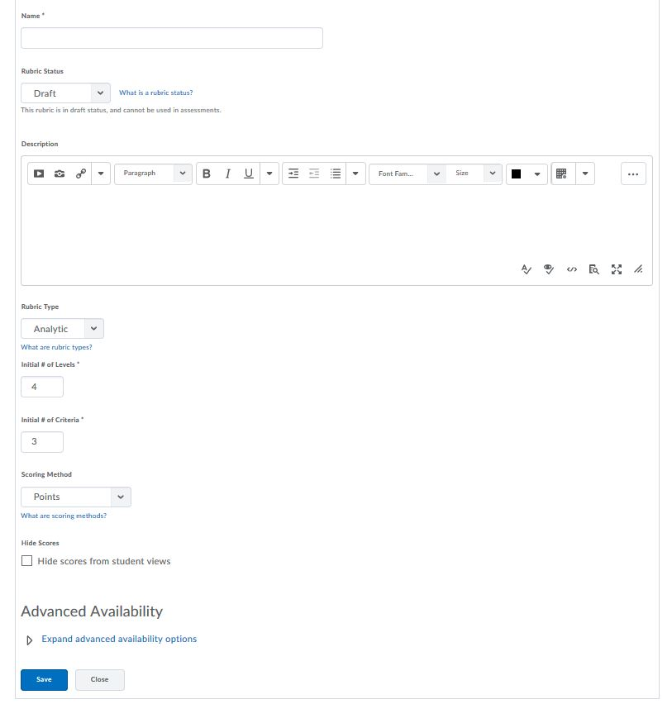
Click Save.
Text Only: No points. e.g., Poor, Good, Excellent.
Points: Combines text and points to assess performance. E.g., Poor (2 points), Good (5 points), etc. Each level is given the same point value.
Custom Points: Customize the points given for each criterion. E.g., if levels are "Poor", "Good", and "Excellent", then the criterion "Spelling and Grammar" can be worth 0 points, 10 points, and 20 points for each level.

See page 2 for an explanation of analytic rubrics.
You can associate a rubric with Competencies or an ePortfolio to assess items created in those tools.
Draft: Leave your rubric as draft until you are ready to Publish for student view.

Recommend display scores.

Enter a name for your rubric.
Enter a description of the rubric. This will be visible in the Rubric List.
Analytic Rubric
Choose the number of levels and criteria. You can add more later, if needed. (See page 2 for an explanation of levels).

Editing an Analytic Rubric:

- To edit the criteria for an analytic rubric, click the drop-down menu to click on Edit Options.

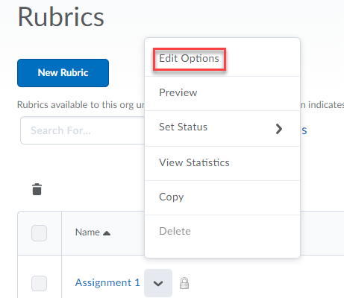
- Enter the name of the criterion by clicking the drop-down menu to select Edit Criterion. This is a category in which
students will be evaluated (e.g., creativity, grammar, etc) and will show up under the Criteria column of your rubric.
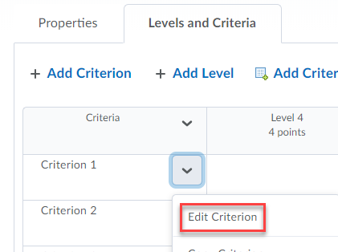

- Click Save. (This will take you back to the Edit Rubric page).
- Repeat steps 1-3 to edit each criterion of your rubric.
- To edit levels, click Edit Level from the drop-down menu.
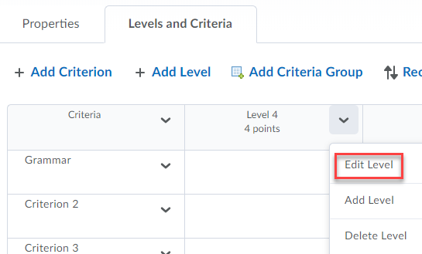
- Enter a name for the level (e.g., Advanced).
- If you’re using points or custom points as the scoring method,
type in the points.
- Under Description, write the explanation of what the students
need to achieve for each level of the criterion; e.g., “What does the student have to do to perform at an Advanced level for Grammar criterion?”
- If desired, type the standard feedback that you want students to see
when they achieve this level.
- Click Save.

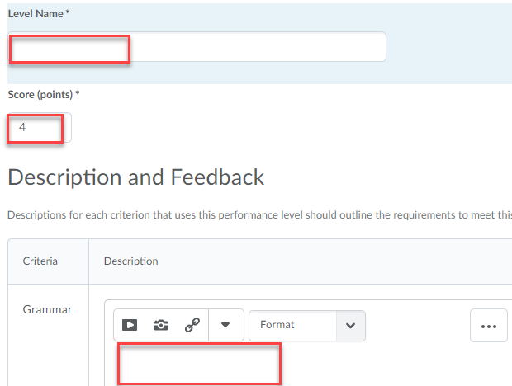
- Repeat steps 5-10 to edit each Level of your rubric.
- The Overall Score row at the bottom of your rubric automatically tallies
the highest score a student can achieve and leaves space to add students’ score and feedback. Click the drop-down menu to edit the
Overall Score.

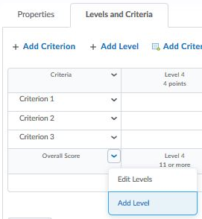
- Click Close when you’re done creating the rubric. This will take you
back to the Rubric List page.
- To change your rubric from Draft to Published, click on the rubric from
the Rubrics List Page. This will take you to the Edit Rubric page, on the
Properties tab.
- Under Status, change it to Published.
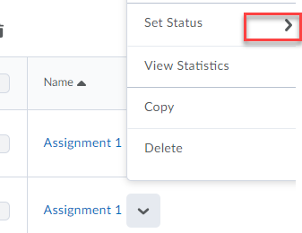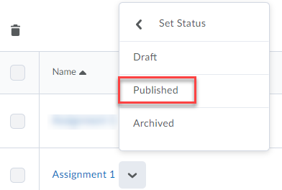
- Click Save.

Note: Only published rubrics can be associated to items in the dropbox and discussions. Once a rubric has an association, the rubric’s name, description, levels and criteria cannot be changed. It is possible to associate rubrics to grade items in the new rubric experience (opt-in), see page 17.

Example of Analytic Rubric with Points:
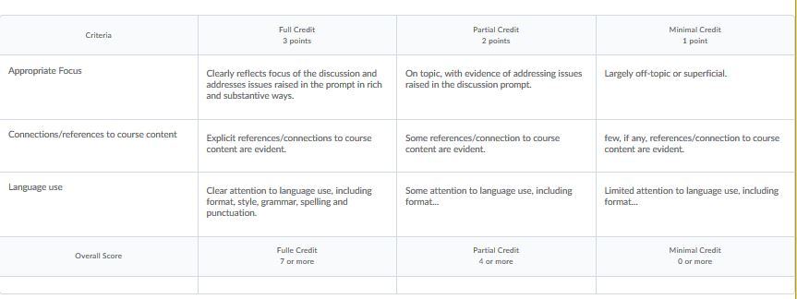

Example of Analytic Rubric with Custom Points:
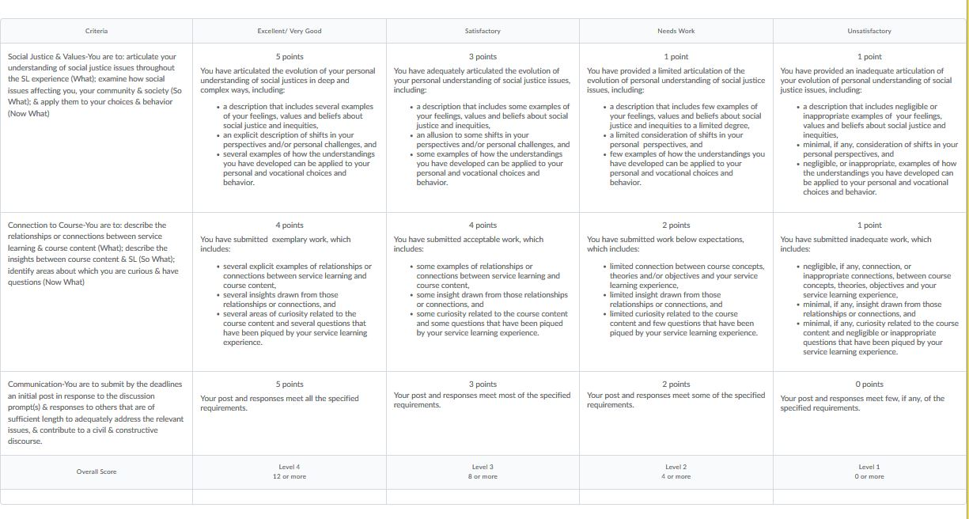

Holistic Rubrics:
- Click Assessments on the Main Navigation Bar.
- Select Rubrics from the drop-down menu.
- Click on New Rubric.
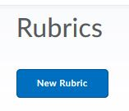
- On the New Rubric page, enter the information and settings for the
Rubric using the Properties Tab. See page 11 for a detailed
description of the Properties tab.
5. Click Save.

Note: Once you save, you won’t be able to change the type of rubric or the scoring method unless you opt-in to the new rubric experience, see page 17.

Example of a Holistic Rubric:
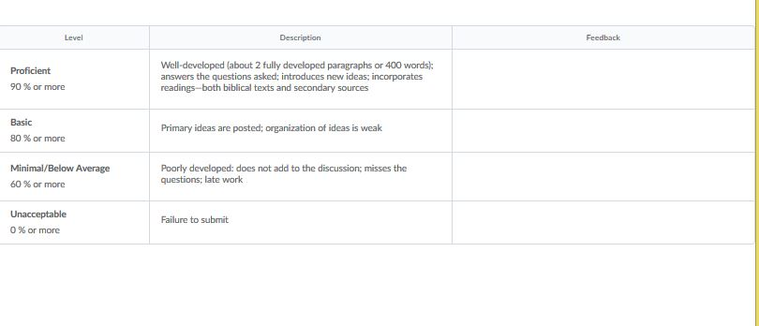

Holistic rubric
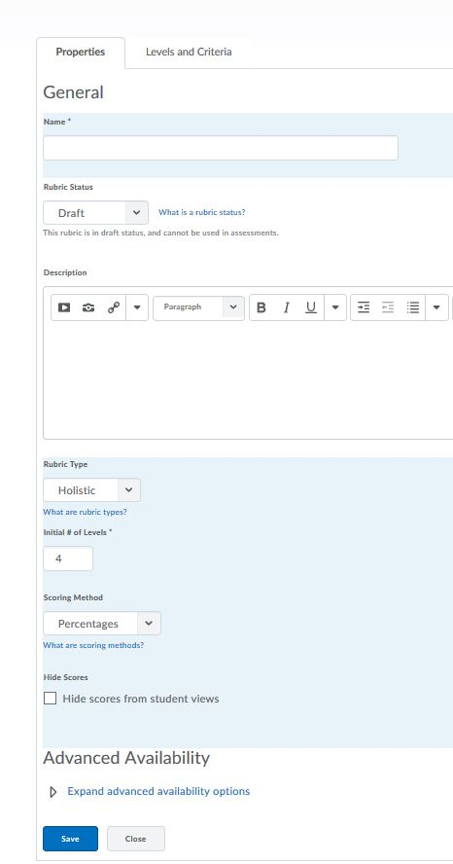
You can associate a rubric with Competencies or an ePortfolio to assess items created in those tools.
Recommend display scores.
Choose amount of levels. You can add more later, if needed. (See page 2 for an explanation of levels).
See page 2 for an explanation of holistic rubrics.
Text Only: No points. e.g., Poor, Good, Excellent.
Percentages: A holistic rubric using Percentages can be automatically assessed based on the score of its associated item (for example, a Grade item).

Draft: Leave your rubric as draft until you are ready to Publish for student view.

Enter a description of the Rubric. This will be visible in the Rubric List.
Enter a name for your Rubric.

Click Save.

Editing a Holistic Rubric:

- To edit the levels for a holistic rubric, click the drop-down menu to select Edit.
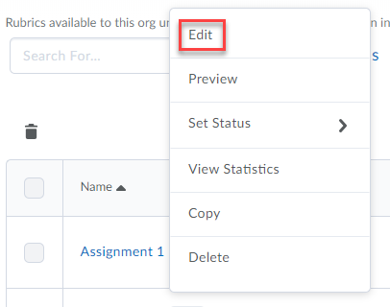

- Enter a name for the level (e.g., Advanced) by selecting the drop-down menu to select Edit Level.
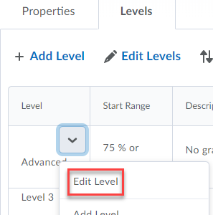
- If you’re using a scoring method of percentages, enter a Start Range. The start range for your lowest achievement level is automatically set to 0%. The start range for other levels should be the lowest percentage acceptable for the level. The highest percentage is determined by the start range for the level above.
- Under Description, write the explanation of what the students
need to achieve for each level of the criterion; e.g., “What does the student have to do to perform at an Advanced level for Grammar criterion?”
- If desired, type the standard feedback that you want students to see
when they achieve this level.
- Click Save.
- Repeat steps 1-6 to edit each Level of your rubric.
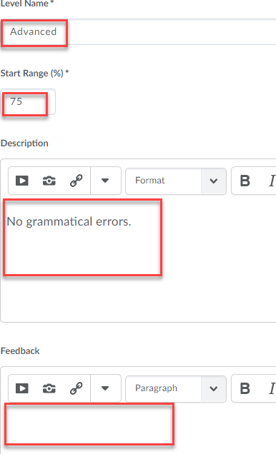
- Click Close when you’re done creating the rubric. This will take you
back to the Rubric List page.
- To change your rubric from Draft to Published, click on the rubric from
the Rubrics List Page. This will take you to the Edit Rubric page, on the
Properties tab.
- Under Status, change it to Published.
- Click Save.

Editing and Deleting Rubrics

Editing Rubrics:

- Click Assessments on the Main Navigation Bar.
- Select Rubrics from the drop-down menu.
- From the Rubrics List Page, click on the drop-down menu next
to the name of the rubric you want to edit.
- Click Edit Options (analytic rubric) or Edit (holistic rubric), to access the selections for editing Levels and Criteria (analytic rubric) or Edit Levels (holistic rubric).
- Make your changes and click Save.

Deleting Rubrics:
- Click Assessments on the Main Navigation Bar.
- Select Rubrics from the drop-down menu.
- From the Rubrics List Page, click on the drop-down menu next
to the name of the rubric you want to delete.
- Select Delete.

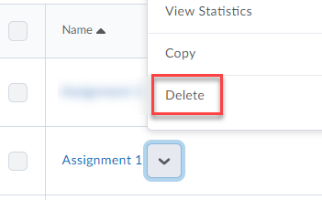

Attach a Rubric to Assignments and Discussions
Attach to Assignments:

- Click drop-down menu next to the assignment in the dropbox folders page under Assessments > Dropbox to select Edit Folder.
2. Scroll down under the Properties tab to click on Add Rubric.

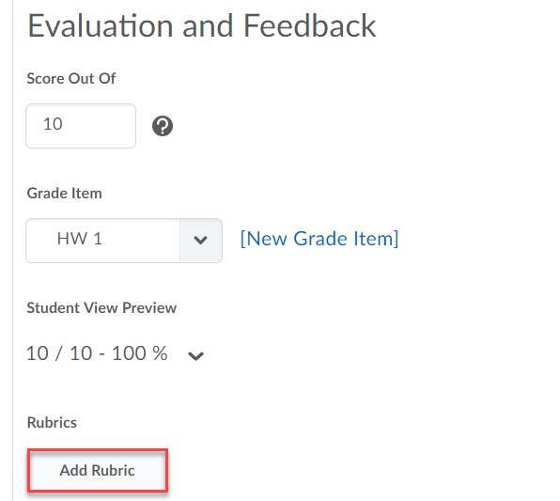

3. Select the rubric by clicking the checkbox [1] next to the desired rubric and click the Add Selected [2] button. Save and Close.

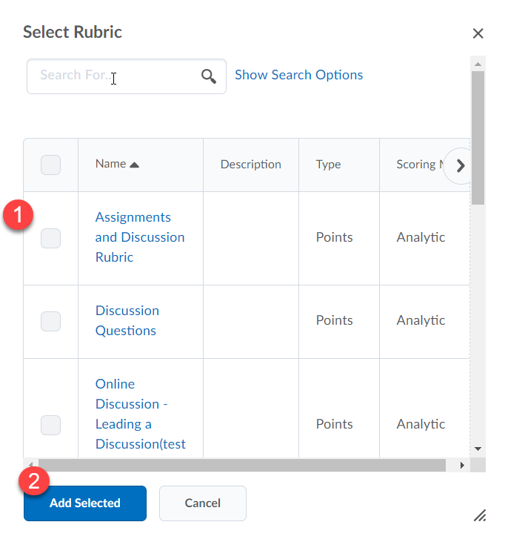

Attach to Discussions:
- Under Communications > Discussions, select the discussion forum to add the rubric by clicking the drop-down menu to select Edit Topic.
- Click Assessment tab and Add Rubric.
- Select the rubric by clicking the checkbox [1] next to the desired rubric and click the Add Selected [2] button. Save and Close.

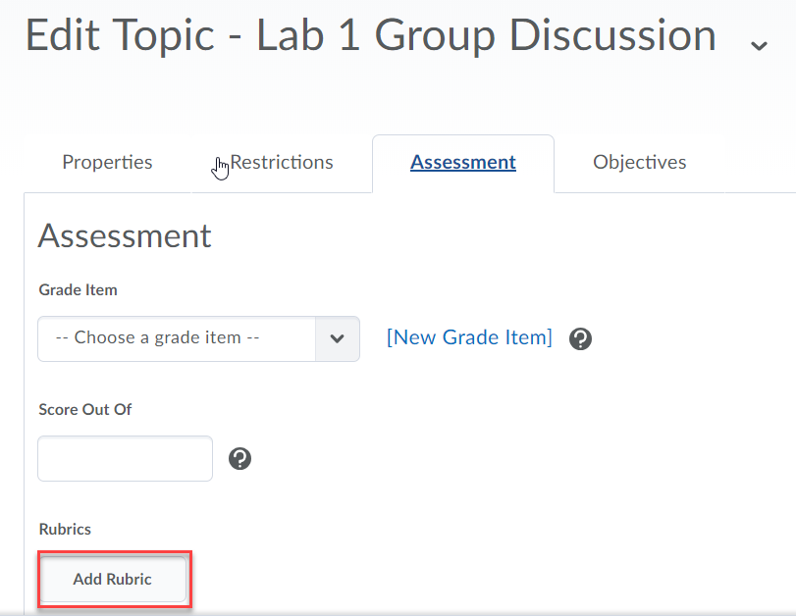

Note: When you create an association for a rubric, you cannot edit or delete the rubric.

Opt-in New Rubric Experience
Instructors can opt-in to the new rubric experience by clicking the Leave it on button, which allows for flexibility when editing. For example, the type of rubric and scoring method can now be changed.

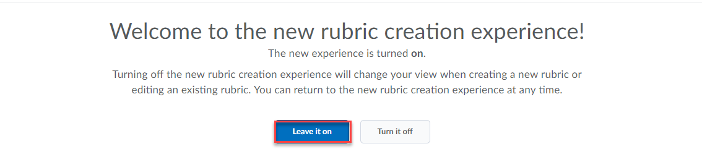
- Click the drop-down menu to change the type of rubric – Analytic vs. Holistic.
- The scoring methods (no score, points, custom points) can be changed during editing.
- Instructors can add levels with clicking the (+) button.
- Criteria can be rearranged using drag and drop by clicking and holding the handle to move to a new position.
- Change the rubric status to either draft, published or archived. Only the published mode is visible to students. Archiving a rubric will not make it available for future associations.

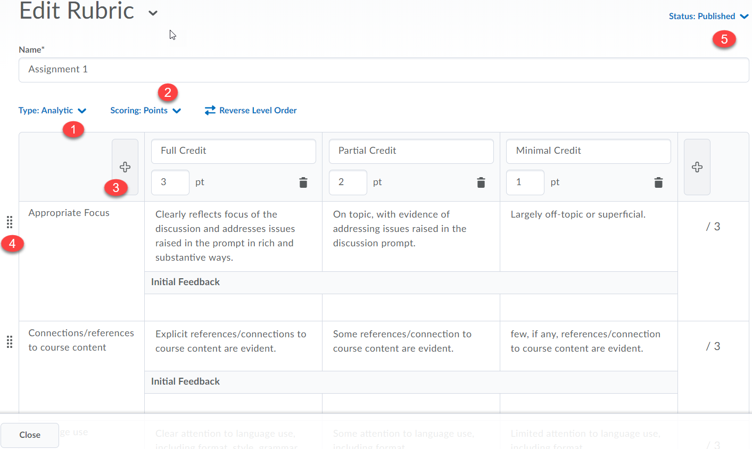

Attach a Rubric

The features to attach the rubric to assignments and discussions are the same for opt-in experience with the addition of attaching rubrics under Grades.

1. Under Assessments > Grades > Manage Grades, select Edit Grade Item.

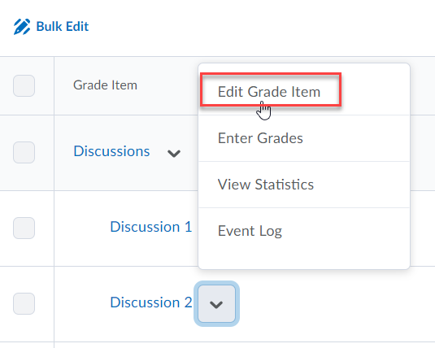
2. Scroll down under the Properties tab to click on Add Rubric.

3. Select the rubric by clicking the checkbox [1] next to the desired rubric and click the Add Selected [2] button. Save and Close.

Using a Rubric to Grade

While providing student feedback, D2L automatically saves in draft mode. The Publish button will allow students to view instructor feedback. Assess the student by clicking on their name in the dropbox folder to access the Evaluate Submission page or under Grades, select the drop-down menu to Grade All.

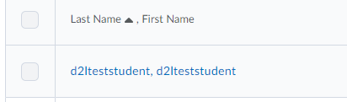

- Grade by clicking the criterion that fits the student’s performance. Points should appear in the right-hand column.
- Criterion feedback is available. Click Done after you enter feedback.
- General Feedback is available for an overall summary of the student’s performance.

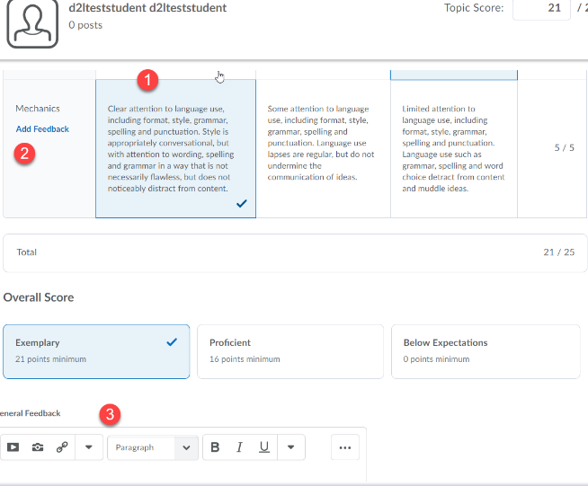

Access the rubric under Grades and click on the Assessment icon to access the rubric for grading.

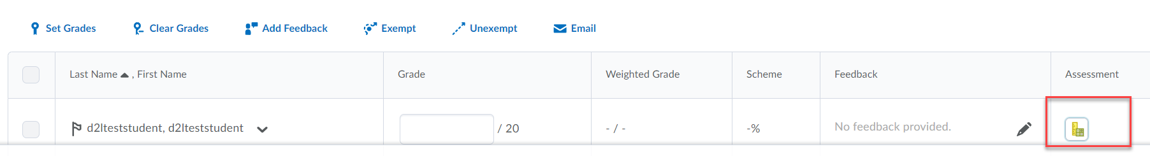

Save Draft or Publish if it is ready for student view.

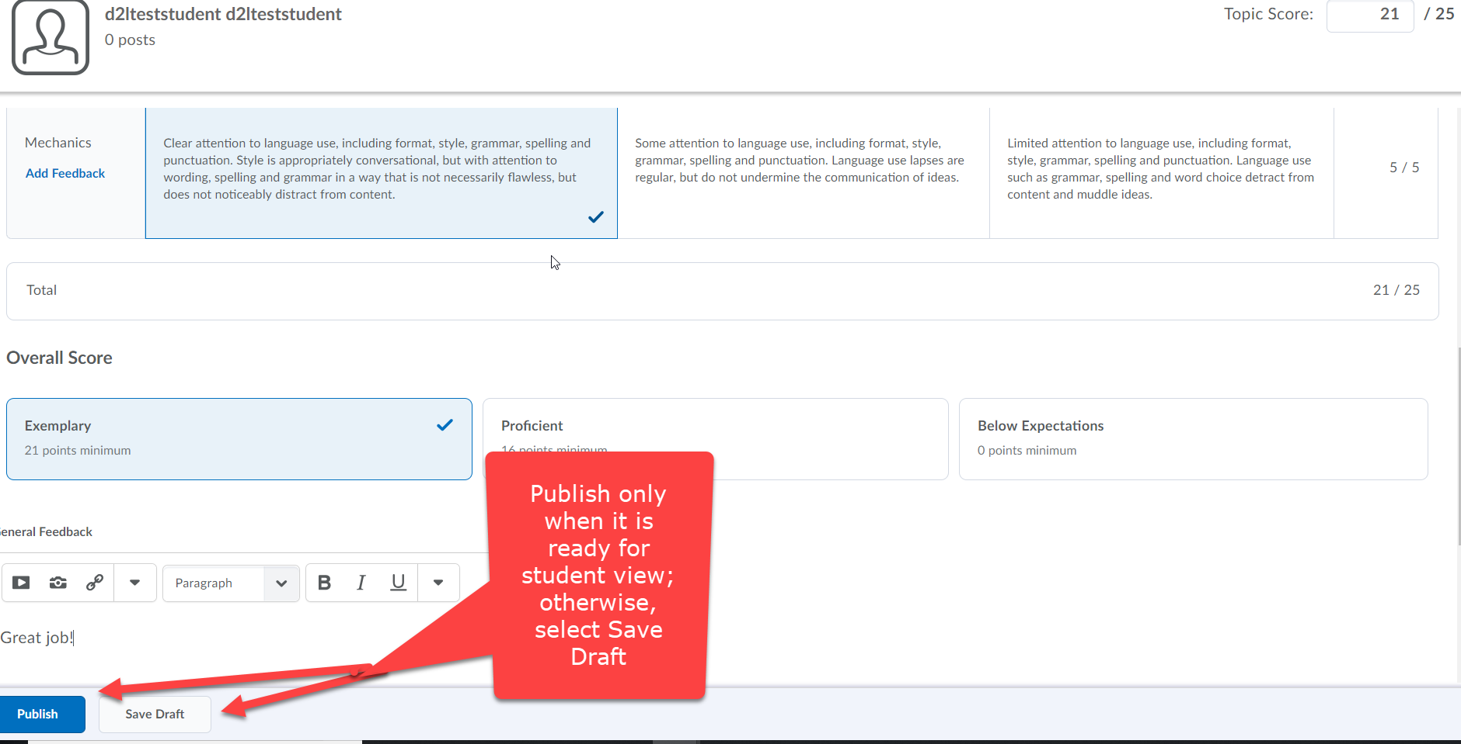

Click Retract, if you need to change a student’s grade and remove published feedback and score from the grade book.

Click Yes to confirm you would like to retract feedback and change student’s grade.
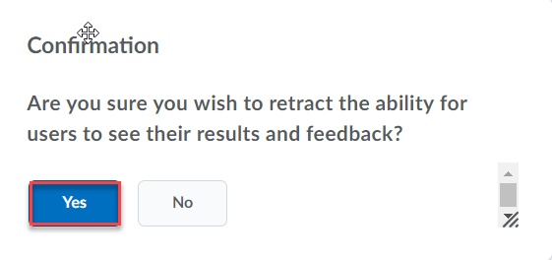
I
If you no longer prefer to work in the new rubric experience, under Assessments > Rubrics, click New Rubric to access the drop-down arrow in the upper right-hand corner to select Turn it off.

