Hello Students,

This semester we will be using Microsoft Teams as a virtual option to meet and discuss. When you open Teams you will navigate to the Teams group titled [INSERT TEAMS NAME HERE], when you select that group you will be directed to our groups General channel. In this channel I will be posting a scheduled meeting that coincides with our Face to Face class time. Below is an example of what this scheduled meeting would look like, it is indicated by a new text box with the text “Scheduled a Meeting” and below that a purple rectangle with the meeting title, date, and time which you will click on to Join the meeting. This Teams meeting will be used in replace of our face to face sessions should we be moved to a fully online schedule. In addition, should a student not be present in the Face to Face class due to quarantine restrictions, this is also the meeting invite you would select to stream our live course session. Prior to that, all quarantined students not available for class should contact me directly if they need to attend the live session via Teams or need the Teams session recorded for the student to watch later. When a session is recorded, a link to the recording will show up in the General Channel of the Teams group. Should the class you are missing contain other supplement material that can be covered in replace of attending the Teams session, I will send you that for you to review.

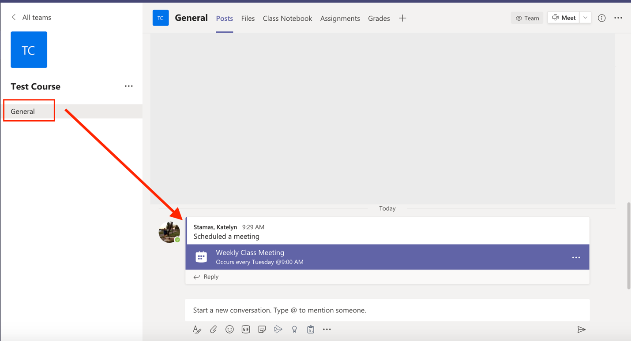

If you have any questions, please feel free to reach out to me via e-mail. As stated in the syllabus, my office hours will be held virtually, and we can schedule a Teams meeting through Outlook to have a one on one.

