How to Record a Video using the Camera App on PC

Overview:
This guide is aimed at PC users and covers the steps needed to create a video using the Camera App.

Instructions:
- Open the Camera App by searching for it in the search task bar on the lower left-hand side of the computer.

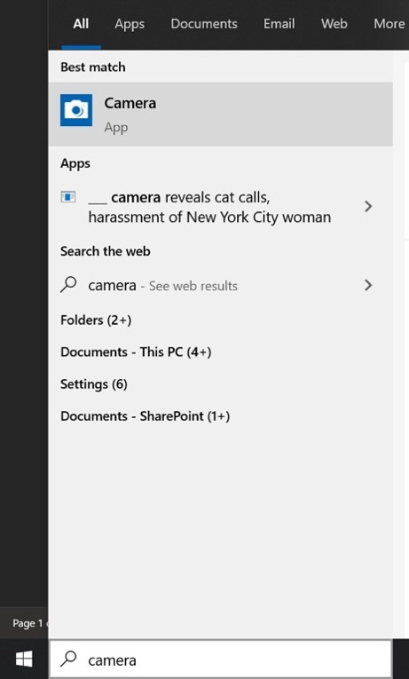

- Open the application and a video screen will appear and you will see yourself on the screen. The application defaults to take photos and not videos so you must change to video mode by selecting the video button on the right side of the screen.

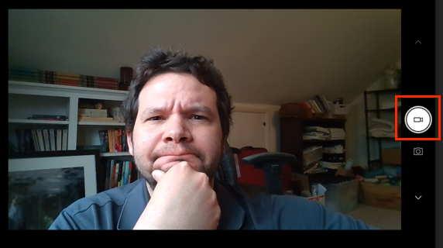

- Once the video button is highlighted in the circle you can select the button to begin recording. The button will automatically transition into a circle outlined in red with a red square in the center indicating that it is now the Stop Recording button. When you are done select the Stop Recording button.

- To navigate to the video, which is automatically saving in the background on your computer, you will open your files folder. In the files folder you will go to Pictures and then Camera Roll where all your videos will be located.
  - If you’re wondering why it’s set up like this- the reason is that it's supposed to model how a cellphone stores images and videos in one location.

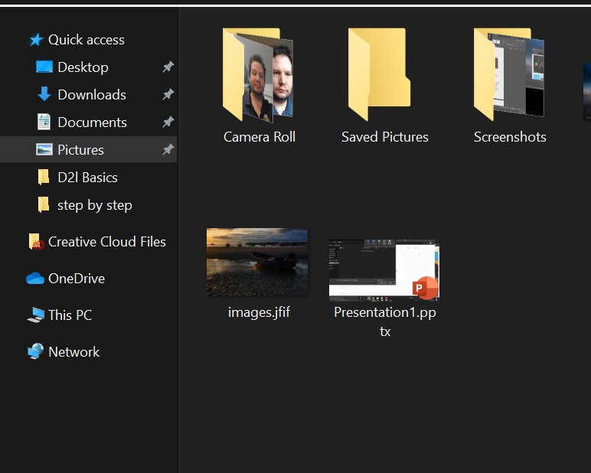

- Your video is now complete.

