How to Do a Video Recording with QuickTime Player on MAC

Overview:
This guide is aimed at MAC users and covers the steps needed to do a Video Recording using QuickTime, an app on all MACs.

Instructions:
- Open QuickTime Player by searching for it in the search task bar on the upper right-hand side of the computer.

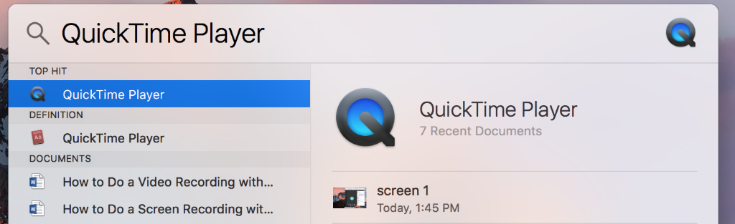

- On the left-hand side of the taskbar next to the Apple logo it shows that QuickTime is open with the following tabs listed- QuickTime Player, File, Edit, View, Window, and Help.

- In the taskbar select File then in the drop-down menu select New Movie Recording.

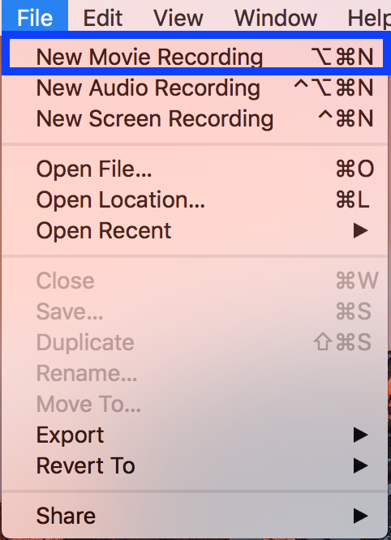

- A video window will pop-up and should automatically have you on screen. On the bottom center of the window is a task bar with a Record button (circle with red dot in the center) and a small down arrow next to record.

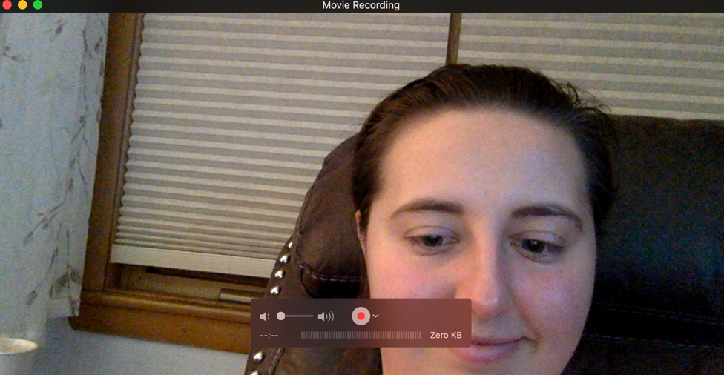

- To start lets focus on the task bar in the video window. Click the down arrow which opens up a drop-down menu and shows the Camera and Microphone options available to enable for your recording purposes.
  - On MACs the default to use the built-in webcam is titled FaceTime but you can direct the program to use other recognized cameras you have connected to the computer.
  - The Microphone should also be enabled to record your voice. You can click the internal microphone option or if you have your own external option.
    - To check the audio you can see the audio waves move left and right on the task bar as you talk.

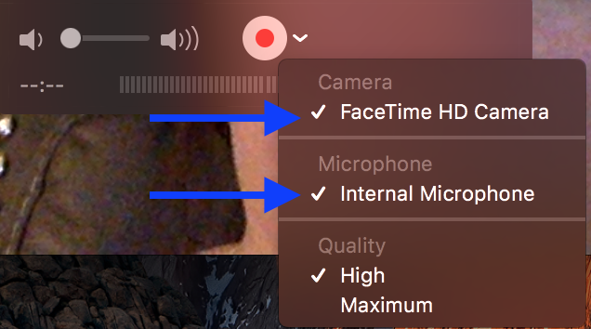

- Back to the task bar. When you are ready to record select the Record button in the center (circle with red dot in the middle).

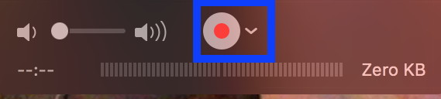

- You can record as needed and once completed you will click that same center button which is now the Stop button shown as a circle with a square in the center.

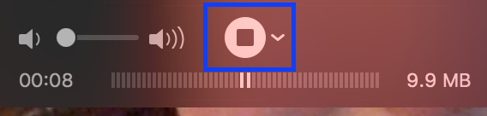

- Your video has now shown up on screen and can be viewed using the play bar in the bottom center. Once you have watched your video you can click the red X in the upper left corner of the video to be prompted to save the video.

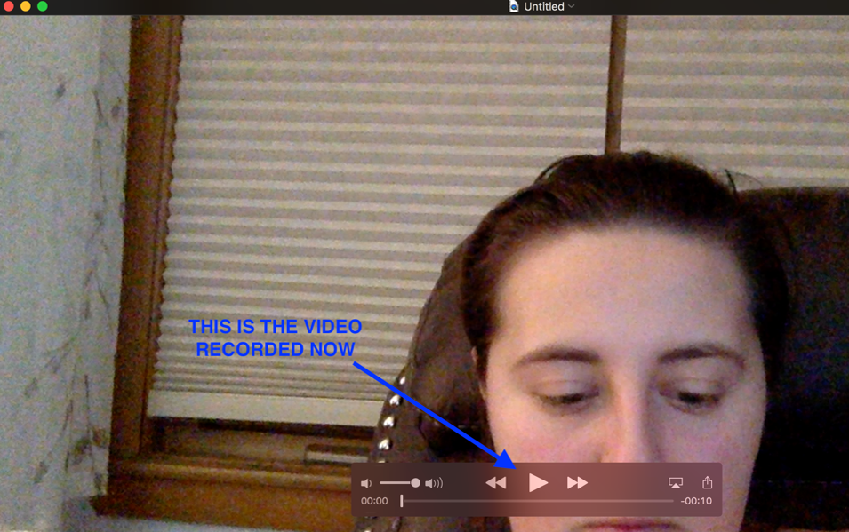

- A pop-up window will appear which will ask if you wish to save the video and then will ask what you want to type into Export As (title the video) and Where you want to save the video.
  - Once that is done then you can click Save in the bottom right corner and it will save it as a video file where you indicated.

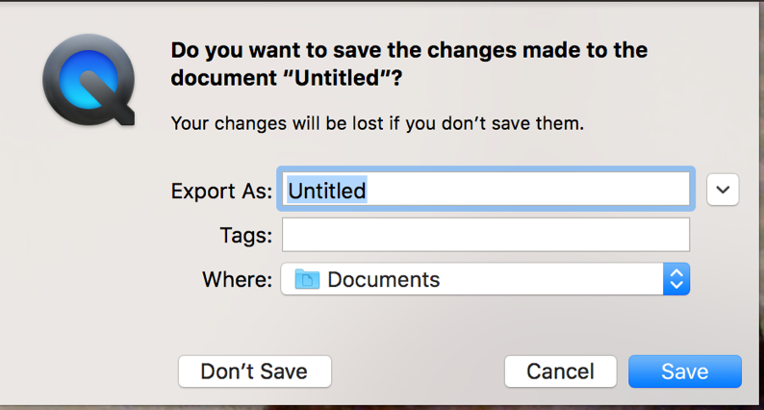

- Your video is now complete.

