Hello Students,

This semester we will be using Microsoft Teams as a virtual option to meet and discuss. When you open Teams you will navigate to the Teams group titled [INSERT TEAMS NAME HERE], when you select that group you will be directed to our groups General channel. In this channel I will be posting a scheduled meeting that coincides with our scheduled class time. Below is an example of what this scheduled meeting would look like, it is indicated by a new text box with the text “Scheduled a Meeting” and below that a purple rectangle with the meeting title, date, and time which you will click on to Join the meeting.

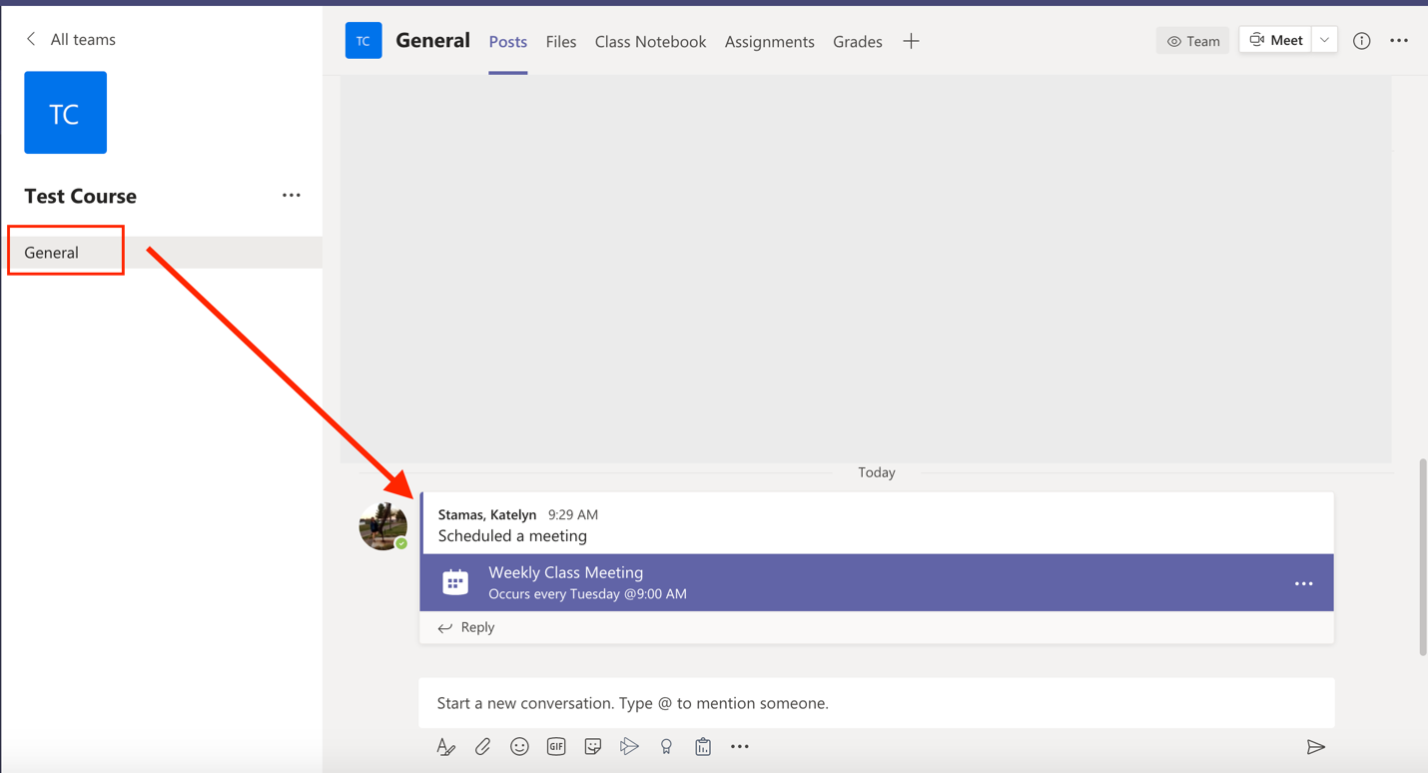

If you have any questions, please feel free to reach out to me via e-mail. As stated in the syllabus, my office hours will be held virtually, and we can schedule a Teams meeting through Outlook to have a one on one.

