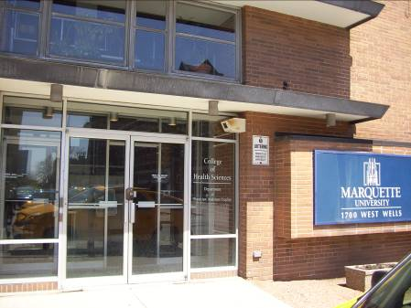
College of Health Sciences

The Department of Physician Assistant Studies combines Marquette's Jesuit tradition of cura personalis ("care for the whole person") with the College of Health Sciences' Jesuit ideals of concern for the spiritual, emotional and physical development of the individual.

Accessibility

Entrance
South Entrance – automatic door, doorbell to gain access
(South view, arrow points north)

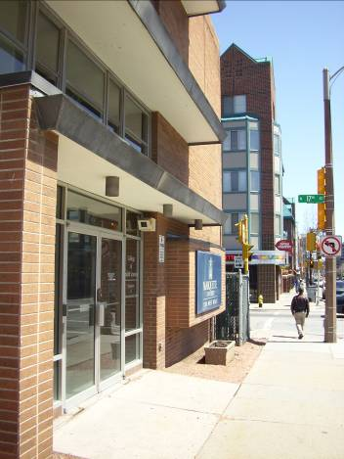
Women’s Bathrooms
Room 012
Room 254

Men’s Bathrooms
Room 014
Room 229

Shared bathroom – Room 212

Elevator Location
1st Floor, through doors

Wheelchair lift located inside doors

(View of Wells Street)

Department of Physician Assistant Studies
College of Health Sciences
1700 W. Wells
P.O. Box 1881
Milwaukee, WI 53201-1881
(414) 288-5688 | (414) 288-7951 (FAX)

