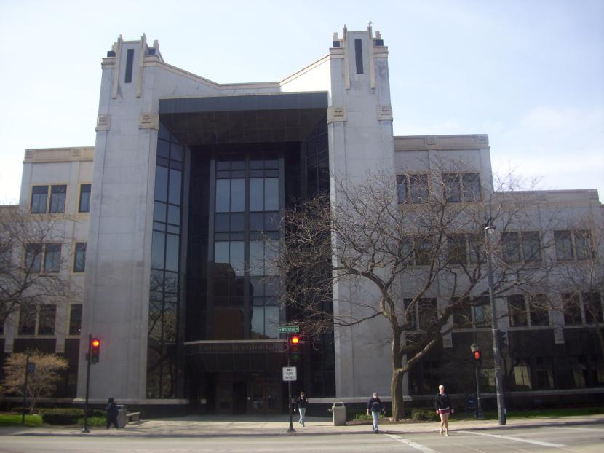
Cudahy Hall
Information Technology Services is headquartered on the second floor of Katharine Reed Cudahy Hall as well as the Department of Mathematics, Statistics and Computer Science.

Accessibility

Entrances
North Entrance – accessible with automatic doors
South Entrance – accessible with automatic doors
(North entrance, arrow points north)

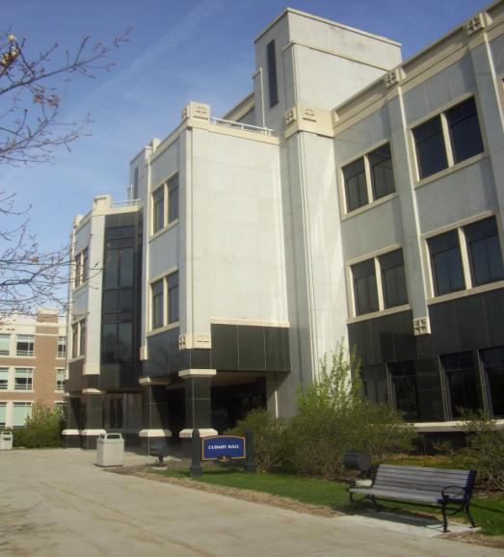

Women’s Bathrooms Men’s Bathrooms
Room 095 Room 097
Room 132 Room 136
Room 298 Room 298
Room 398 Room 398
Room 424 Room 422

Elevator
Yes – 2, no key
Between main doors
Across room 115

(South view)

Katherine R. Cudahy Hall
1313 W. Wisconsin Avenue
Milwaukee WI 53233
(South view)

