Haggerty Art Museum

Hagerty Art Museum houses both Marquette’s permanent and limited time art exhibits.

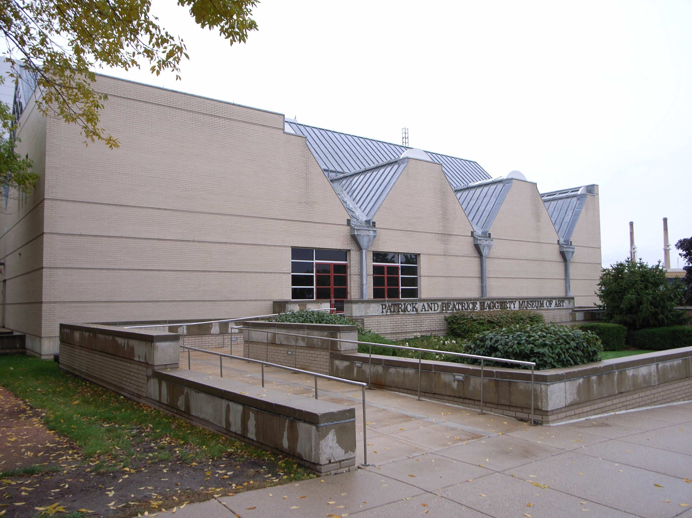
(Arrow points North)

Accessibility

Entrance
Wheelchair accessible, Manual Doors
(Pictured)

Women’s Bathrooms
Located on the main floor opposite the elevator
Men’s Bathrooms
Located on the main floor opposite the elevator
Elevator Location
Located through the main entrance in the center of the museum

