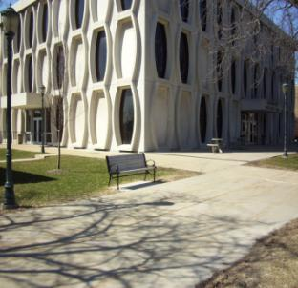
Lalumiere Language Hall

Lalumiere Language Hall houses the Departments of Foreign Languages and Literatures and Social and Cultural Sciences.

First through third floors are academic, fourth floor are offices. Bathrooms there are staff only.

Accessibility

Entrances
*North Entrance –automatic door
**South Entrance– automatic door

*opens to 2nd floor
** opens to 1st floor, in back of building

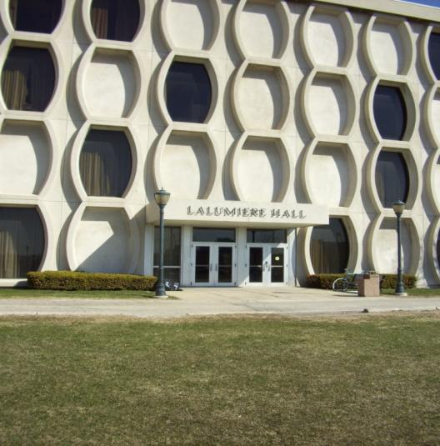
Women’s Bathrooms
Room 202 – accessible
Room 302 – accessible

Men’s Bathrooms
Room 206 – accessible
Room 306 – accessible

Elevator Location
Across room 296

(South view, back of building)

Lalumiere Language Hall
P.O. Box 1881
Milwaukee, WI 53201-1881
(414) 288-7063 | (414) 288-7653 (FAX)

