Raynor Library and Memorial Library

Raynor Library houses computer work stations for students, faculty, and approved guests of the University, as well as the university archives, meeting/group-study rooms and the periodicals section of the library. Access is controlled with card-swipe activated turnstiles as well as a staffed auxiliary gate that is wheelchair accessible. Memorial Library is accessed through Raynor Library on the second floor.

Memorial Library is accessible only through Raynor Library’s main entrance. Memorial library houses the University’s physical book collection along with study stations for students.
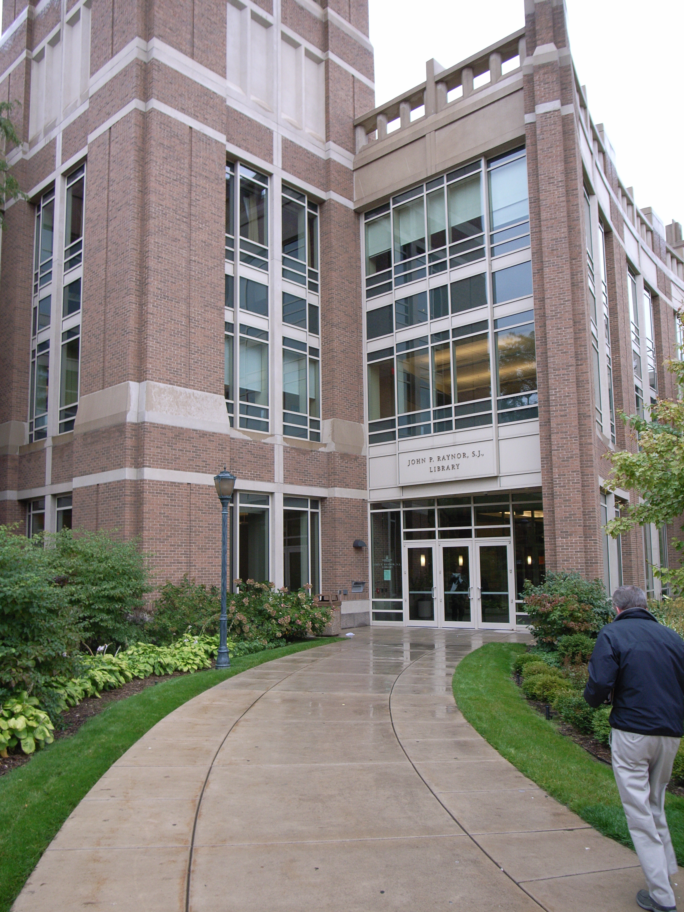

(Arrow points North)

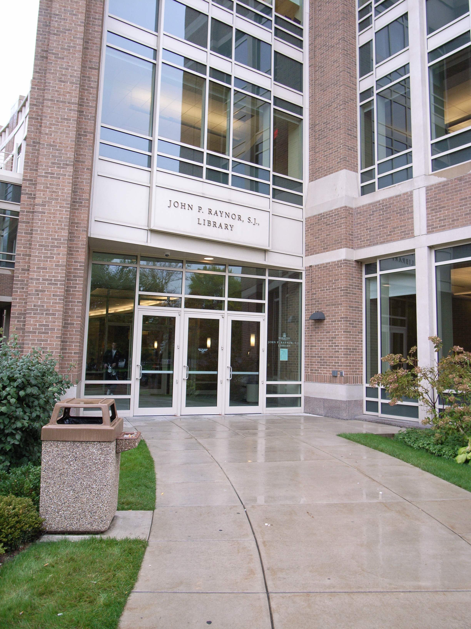
(Arrow points North)

Accessibility
Entrance
Wheelchair Accessible, Automatic Doors
Turnstiles through main doors with accessible auxiliary gate

Women’s Bathrooms
Raynor: To the left of the elevators
Memorial: Located adjacent to the circulation desk on the second floor. Bathrooms are located on either side of the west elevator on the remaining floors
Men’s Bathrooms
Raynor: To the left of the elevators
Memorial: Located adjacent to the circulation desk on the second floor. Bathrooms are located on either side of the west elevator on the remaining floors
Elevator Location
Raynor: Through the turnstiles to the right
Memorial: East: Located along the East wall of the Memorial Library Building, across from the Memorial circulation desk. West: Located through the stacks on the second floor (no 1st floor access)

