Rec Plex

The Rec Plex is the second fitness center on campus. It is located in the David Straz dormitory building. It has assorted ball courts, a free weight room, a fitness room, a suspended running track, locker rooms, as well as other physical fitness services.

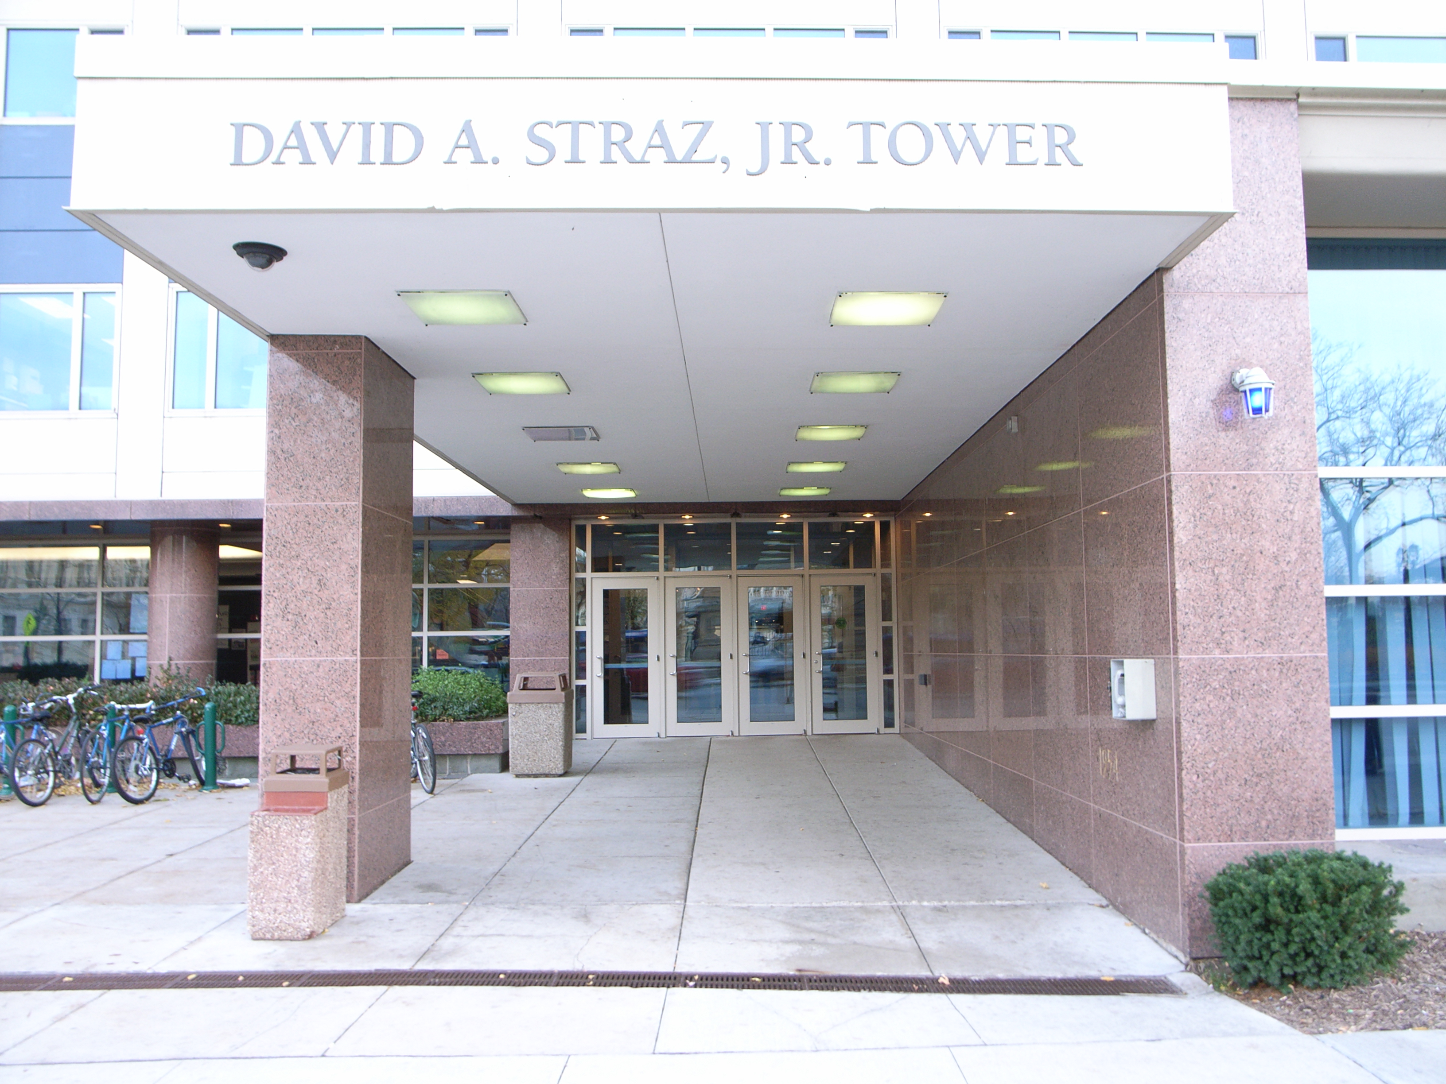

(Arrow points North)

Accessibility

Entrance
Wheel Chair Accessible, Automatic doors
(Pictured)

