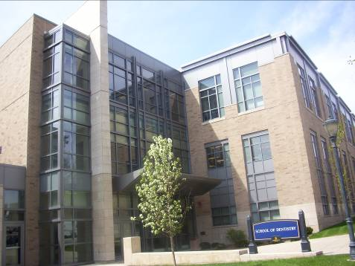
School of Dentistry

Wisconsin's only 120,000 square-foot dental school and clinic offers the most advanced clinical resources and instructional technology available.

Accessibility

Entrances
South Entrance – automatic door

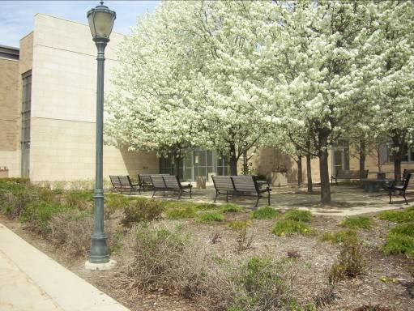
(North view, arrow points north)

Bathrooms
Basement – behind elevator
1st Floor – left hall, near Radiology
2nd Floor – across from Clinic Administration
3rd Floor – across from Room 306

Elevator Location
Located by North doors

(South view)

School of Dentistry
1801 West Wisconsin Avenue
P.O. Box 1881
Milwaukee, WI 53201-1881
(414) 288.6928

