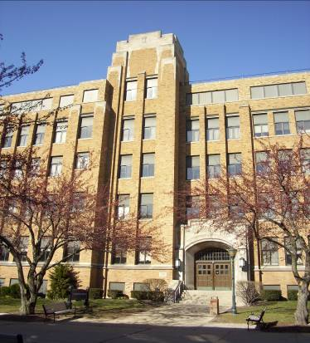
Schroeder Complex
The complex, originally built in 1932 and renovated in 1981, houses the departments of Research Compliance and Women’s Studies.

5th floor is locked; library (located on all floors) is locked.

Connected to Cramer Hall.

Accessibility

Entrances
*West Entrance – automatic door through driveway

*opens to ground floor

(East view, arrow points north)

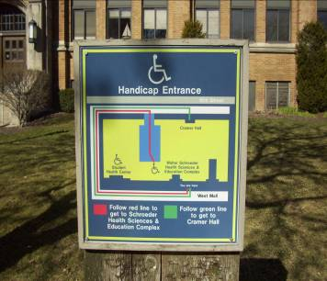
Women’s Bathrooms Men’s Bathrooms
Room 065 Room 068
Room 139 Room 141
Room 253 Room 251
Room 353 Room 351
Room 439 Room 441

(All bathrooms are accessible)
Women’s Changing Rooms
Room 047
Adjacent to Room 371

Men’s Changing Room
Adjacent to Room 371

(All changing rooms are accessible)

(Map to handicap entrance in front of east entrance)

Elevator Location
Immediate right by ground floor entrance
Across east entrance on 1st floor (access to handicap parking lot)
Between bathrooms

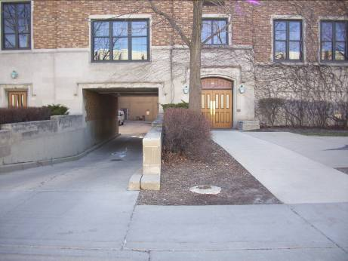
Other
On 3rd floor a ramp is located for entrance to room 306.

Accessible water fountains are located between bathrooms.

Emergency showers located in hallways.

(West view, accessible entrance down driveway)

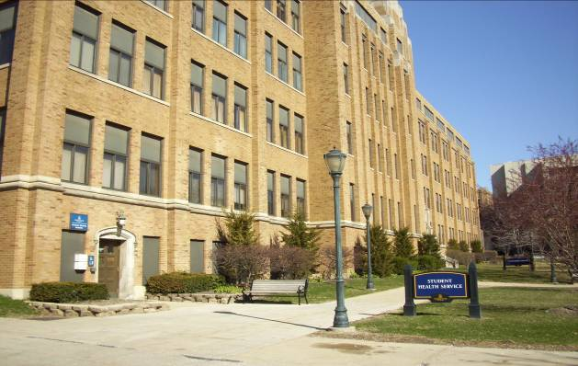
[Type a quote from the document or the summary of an interesting point. You can position the text box anywhere in the document. Use the Text Box Tools tab to change the formatting of the pull quote text box.]

(South-East view of Student Health Services, left, and Schroeder Complex east entrance, right)

Schroeder Complex
P.O. Box 1881
Milwaukee, WI 53201-1881
Women’s Studies (414) 228-7308
Office of Research Compliance (414) 288-7570 | (414) 288-6281 (FAX)

