Parking Structure 1

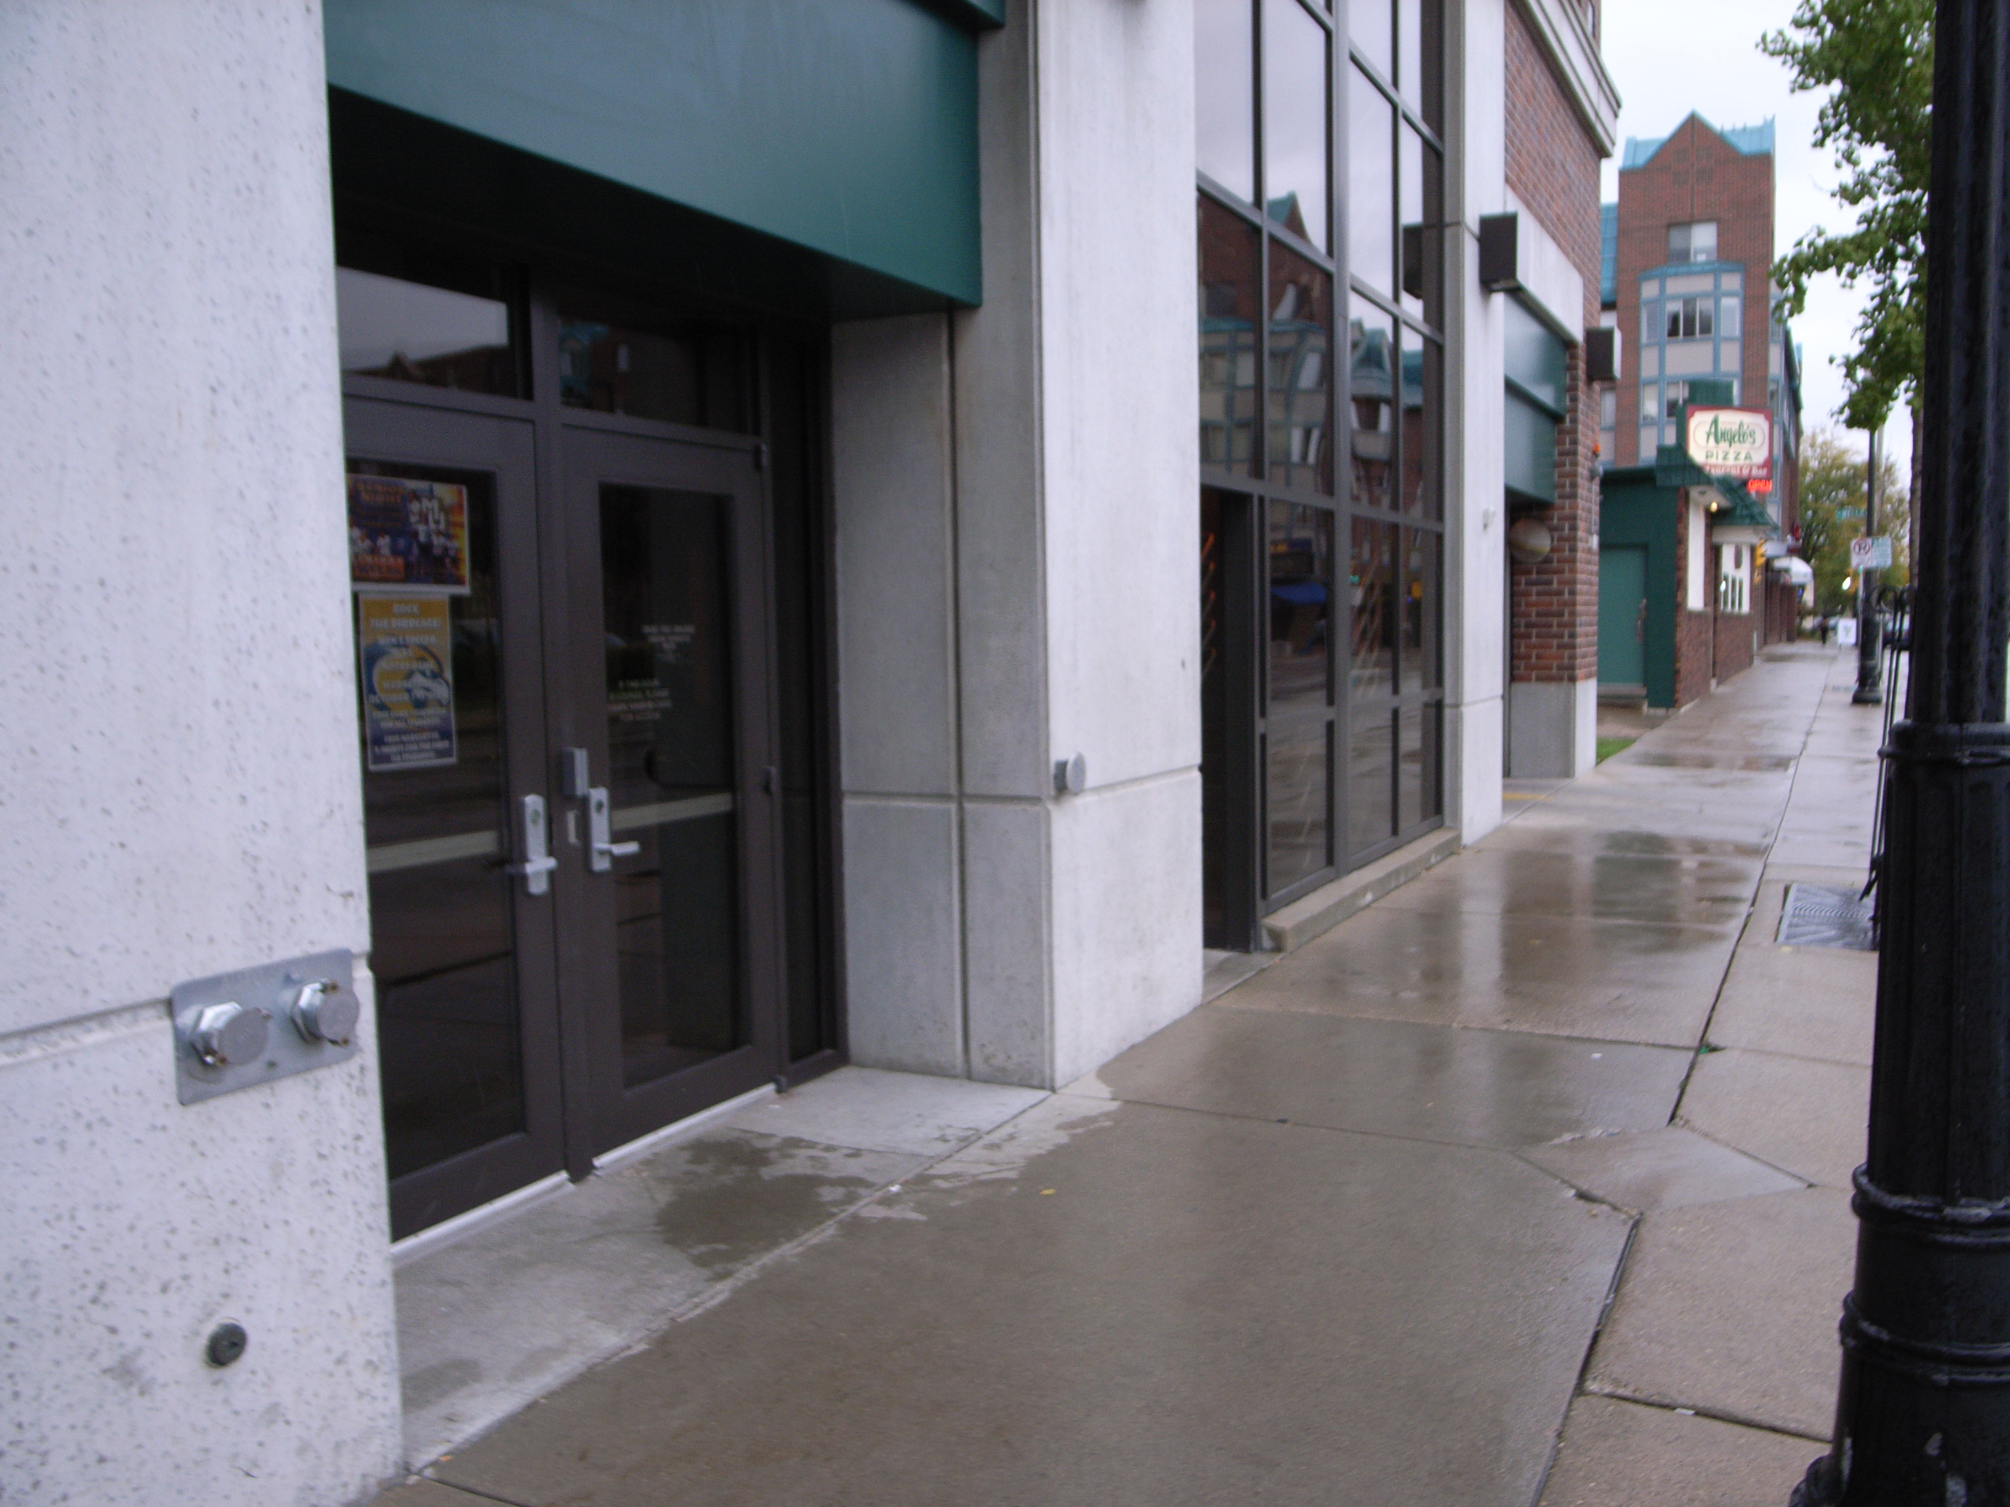
(Arrow points North)

Accessibility

Entrance
Wheelchair accessible, Automatic Door
(Pictured)

Women’s Bathrooms
N/A

Men’s Bathrooms
N/A

Elevator Location
Through the doors pictured and to the left

